Small Sheep 1

DK yarn for the head, body, legs and ears and size 2.75 mm needles (US size 2).
Different yarns vary in the way they knit up. Please adjust if necessary to suit your own requirements.

Body-Cast on 14 stitches, knit 16 rows. With a large sewing needle take the stitches off onto a length of yarn and draw up. With wrong sides facing stitch the long edges together. You should now have a tube. Turn to the right side, stuff and draw up the open end to make a fat sausage shape.

Legs (knit 4) -Cast on 6 stitches and knit 8 rows. Cast off. Roll up the knitted piece as tightly as you can to form a tiny sausage shape and stitch down the open edge (no stuffing required). Stitch the tops of the legs to the body.

Head-Cast on 9 stitches and knit 10 rows. Take stitches off onto a sewing needle and draw up. With right side facing (because head is too small to turn inside-out) neatly over-sew the long edges together. Lightly stuff the head and gather the open end. To give the head a realistic curved shape push the threaded needle from the nose end through the head and out of the top. Pull until you have the required curved shape then fasten off
Decide which end is better for the nose and stitch the head to the body.

Ears (knit 2) -Cast on 3 stitches and knit 2 or 3 rows. Remove stitches onto sewing needle and draw up, this makes the pointed end of the ear. Over-sew down the ear to the base and stitch it to the top of the head (see picture above).
Now you can give the sheep a face with some embroidery thread or thinner wool.

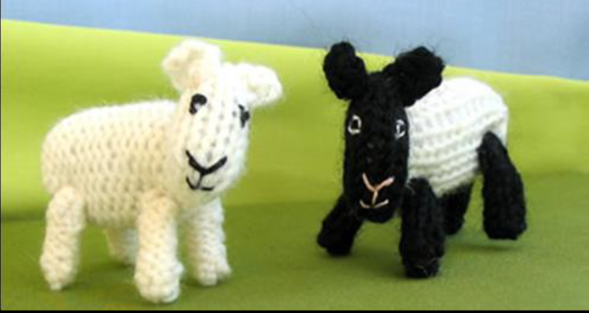
Knitting Pattern Small Sheep 2

You will need: Size 10 knitting needles Double knitting wool
Knitting pattern for sheep Copyright D. Males 2008
Note: each time you cast on leave a long end as you will need it.

Body Cast on 9 stitches and knit 12 rows in stocking stitch. Knit 2 together, knit to the last 2 stitches, knit 2 together (this will leave you with 7 stitches).Cut the wool leaving a long end. Thread the long piece of wool through a large eyed sewing needle and thread it through the 7 stitches on the needle, lifting each one off the needle as you do so. Pull the thread to gather one end (this will form the head end).Turn the knitting so that the purl side (bumpy side) is on the outside and sew up the seam to form a tube. Leave the other end (tail end) open and add stuffing until firm. Sew up the tail end and fasten off.

Head Cast on 7 stitches. Knit 5 rows of stocking stitch. Knit 2 together 3 times, then knit 1.Cut the wool and leave a long end, then thread the wool through the stitches on the needle as before. Pull up tight to form the sheep’s face and then sew along the seam of the tiny tube leaving the other end (neck end) open. Stuff the tube lightly and sew up the back seam (neck end).Sew the head onto the body (make sure you sew it to the head end).

Ears (x2) Cast on two stitches. Knit one row. Cut the wool leaving a long end and thread it back through the stitches as before. Take the two ends and tie into a knot. Sew to the head.

Legs (x4) Cast on 3 stitches. Knit 3 rows. Cut the wool leaving a long end and thread it back through the stitches as before. Tie the two ends tightly and sew into place (they should be ball shaped).

Tail Tie a knot in the centre a double length of wool (30cm long).Cut the wool about 1 cm below the knot and fringe it to form a tail. Use the long ends to sew the tail to the body with the knot next to the body.

