Come and visit the diverse, stunning and agricultural country of Uganda, located directly on the earth’s equator line. With many iconic attractions, you will not be disappointed to discover the wonderful animals.


Weather
The weather in Uganda it is warmer this the UK.
The climate is the climate is tropical generally rainy with two dry seasons.
In the rainy season it rainy sometimes but when it rainy it so hot.

Food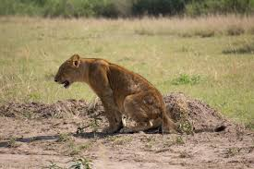
In Uganda, they grow Mango, Water melon, Banana.
You can buy food from a local Markets.
Local people make and grow Salads, fruit and veg.
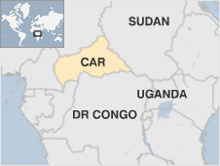
Safari
You will see animals such as African Elephants
Come and explore the 600 species of birds.
Enjoy the wonderful animals you see.
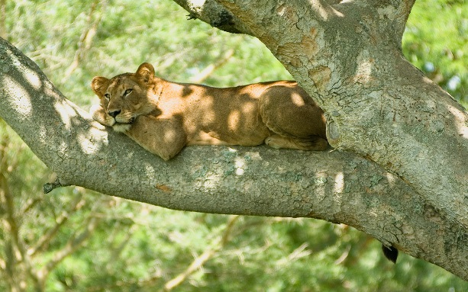
Culture
Have a go at wearing the baggy clothes.
Discover the purses they made out of palm leaves
Witness the Ugandan people all the people can speak and are taught English from a young age.

Welcome to Uganda 

