Parents: surviving having them at home all day!
Having a child or children at home, all day, day after day, is challenging to say the least!
Here are some ideas that you may find helpful in adjusting to a different way of living. A little bit of work and thinking really pays off in the end!
Maintain a routine
This is one of the most important areas. Children (and adults) thrive off routine. Create a daily timetable and do your best to stick to it. Each day can have different activities, but it still needs a routine. And involve them in the process! Below is an example of a possible time table, but remember that every family’s circumstances are different. Set a timetable that works for you.
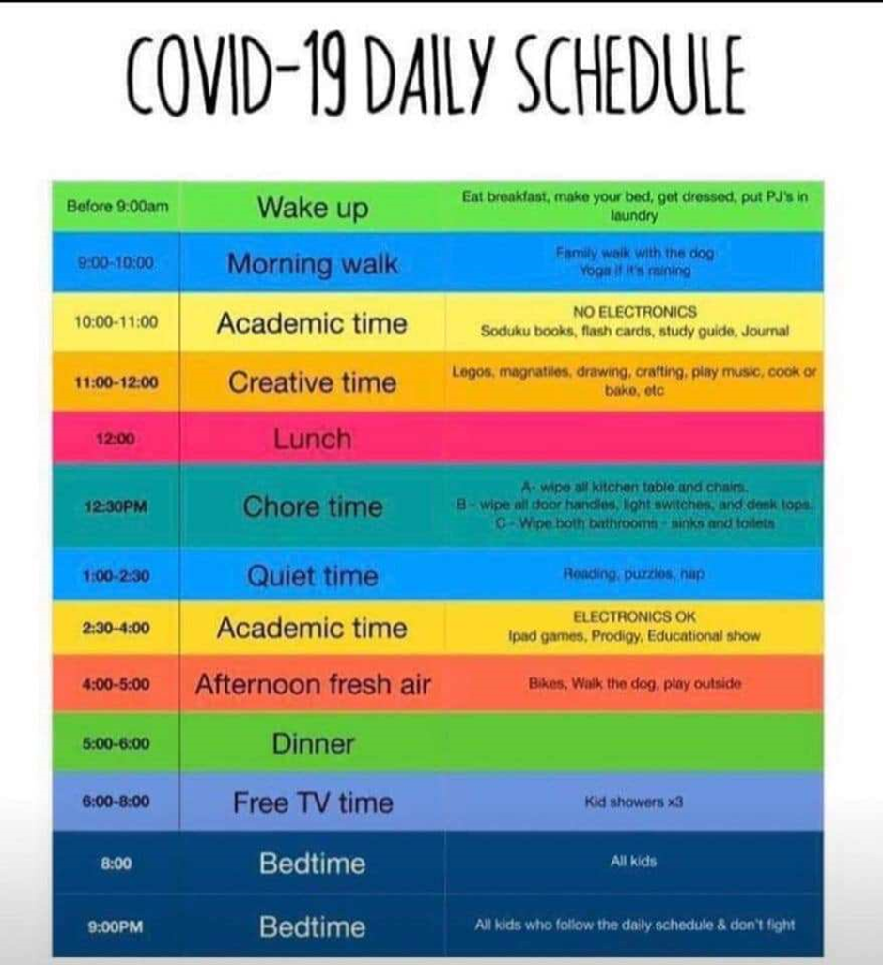
Get up, get dressed, get ready
Don’t treat every day like a Saturday. You’ll regret it soon! Have a time (e.g. 8:30am) to be out of best, dressed, breakfasted, and ready to go. And think about bed times too. Remember, it’s not the weekend every day.
Chores
Although not always fun, children like to contribute if they are motivated. Have set chores that need doing each day or each week. For example, tidying the lounge at 11am, or empty/stacking the dishwasher, or feeding the cats, or hoovering on Weds morning.
Keep a reward chart
Children love rewards charts. They can be for anything. Stick to them, be reasonable, and keep positive.
They work best when children are involved in creating them, too. Don’t force it.
Earn screen time and limit it
Resist the temptation to allow children on devices all the time. It’s not good for them. Perhaps make them earn the time when they complete their learning activities, jobs on their timetable, or for doing chores. This can really be a motivator for the boring things they have to do.
Make “Tech Free Tuesday” (or Thursday) a thing in your home. There are plenty of others things to do. Adults must join in!
Have to attend a virtual meeting. Plan ahead
Parents who are working at home find this very stressful. Children shouting in the background doesn’t make for a good meeting. So plan ahead. Tell the children what you are going to do, when it is, and for how long. Have a system so they can ask you a question if needed.
Keeping Fit and active – can be done inside
A popular option is Joe Wicks on Youtube. 9am weekdays, for 30 minutes. Aimed at children! Please check if you feel this is appropriate first.
Time out
Everyone needs down time. Why not set aside an hour a day where it’s quiet time. Perhaps reading on a bed, or taking a rest. See some of ideas in our Well-being section of our website. How about listening to audio books whilst colouring. There are free books available here (again, please check for suitability first!). Others are available, too.

I need my own space
We can feel very cramped in our homes. Think carefully about what is going to help children have their own space. Everyone gets cranky when they haven’t had time on their own, or peace and quiet. Again, talk about this with the children.
Special Time
If you have multiple children at home, make time (in your timetable!) to be with them on a 1-1 basis as well as doing things altogether. Make it clear that they will each have their special time with you. They will love you for it. It recharges them!
Set a daily challenge
Children love challenges. A daily challenge brings excitement and motivation. All it needs is creativity. For example: build the tallest Lego structure you can in 30 minutes, or write a story with exactly 42 words, or learn the song Happy Birthday in French.
Why not try one of the Great Indoor challenges: Click here to see for yourself!
Keeping in touch
Make it a daily requirement to phone or email a relative or friend. It makes them smile! Chose a different person each day. Remember to check for full stops and capital letters!
Make movies a treat, not a daily item
There is so much to watch, but it becomes too much day after day. Set a ‘Monday Movie’ time slot in your schedule. It makes it sound fun. Put those phones away and watch it together.
Give your brain a break
As an adult, it’s tempting to just keep going. Build in a routine that gives your brain a break several times a day. Go for a walk, have a cuppa, put the phone/laptop away. You’ll feel much better.
Look after your mental health
It’s easy to worry all the time. But don’t. Talk about what’s going on with adults and children. Be honest but positive. Recognise that all of this is going to affect your emotionally wellbeing. It’s important.

