



Achieving more together

St. Mary’s News
Autumn Edition 2 2022


A message from the editor…

Hi everyone,


Welcome to the Autumn 2 Edition of The St Mary’s News, where you will find: a delicious recipe to try at home, a Christmas themed quiz, an article from a teacher and news from around the world. We are also celebrating your brilliant writing from this half term and recommending some exciting books to you all. There are even some fun activities to keep you busy over the Christmas break. Enjoy reading this edition and have a Very Merry Christmas!
Mrs Gill
Mrs Lillywhite’s
Christmas Polar Bear Peppermint Creams
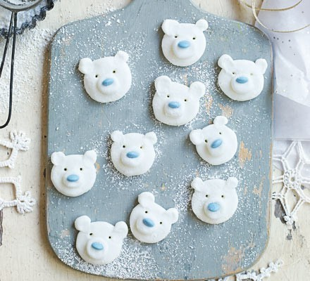

Preparation and cooking time
- Prep: 30 mins
- Makes 15-20
Ingredients
250g icing sugar
1 egg white, beaten
A few drops of peppermint essence
15 chocolate sweets
Method
1. Sieve the icing sugar into a large bowl. Mix in the egg white, a little at a time – stop adding it when you have a soft dough that feels like Plasticine.

2. Add 3 drops of the peppermint essence, mix well and taste. Add another drop if it isn’t minty enough.

3. Roll half the mixture into 15 balls, about the size of cherry tomatoes, then flatten them with your hand to make the bear heads.

4. Place on sheets of baking parchment on a large board or tray. Using half the remaining mixture, make blueberry-sized balls and flatten them out onto the heads to make snouts. Add chocolate sweets for the noses.

5. Use the rest of the mixture to make the ears. Shape them into tiny balls and press them gently into the top of the heads with your fingertips. Use a cocktail stick to shape the eyes.

6. Leave the polar bears to dry for 3-4 hrs, or overnight. Eat within 1 month.
Christmas Book Recommendations by Mrs Stephens
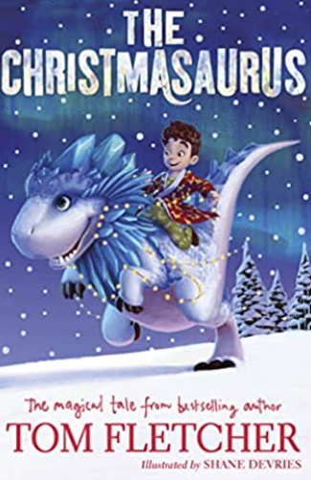

Year 3 – The Christmasaurus by Tom Fletcher
This is a story about a boy named William Trundle and a dinosaur named the Christmasaurus.
It's about how they meet one Christmas Eve and have a magical adventure. It's about friendship and families, sleigh bells and Santa, singing elves and flying reindeer.
It's about discovering your heart's true desire, and learning that the impossible might just be possible . . .
If you haven’t read this book yet – you really should! It is full of brilliant illustrations and hilarious moments. One of my all time favourite Christmas books…and book 2 (The Winter Witch) and book 3 (The Naughty List) are also fantastic.
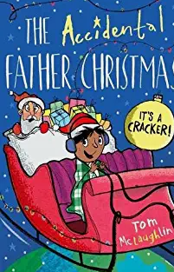

Year 4 – The Accidental Father Christmas by Tom McLaughlin
Ben has one important thing on his Christmas list, and it's the same thing every year. He wants his dad to be at home for Christmas. But his wish never comes true. And Ben's starting to get a bit sceptical about Father Christmas's existence, he needs proof. So, on Christmas Eve, he sets up an elaborate booby trap to capture the jolly bearded fella as he comes sliding down the chimney. Kicking off a sequence of hilarious events that makes this Christmas the most bonkers ever!
This book really made me laugh out loud, and I wanted Ben to succeed in his plan, really funny. It reminded me of when I was little and I would try to stay awake to see Father Christmas on Christmas Eve.

Year 5 – Virtually Christmas by David Baddiel
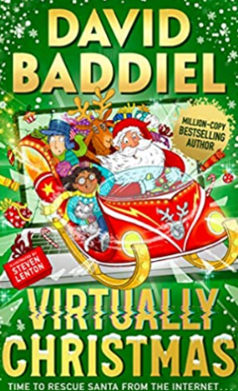

It used to be the most WONDERFUL time of the year, but for years Christmas has been taken over by Winterzone.
All the things that made Christmas special are gone: the human connection, the baubles passed down through generations, even the rubbish cracker jokes.
Instead, Christmas is run by robots, while 3D holograms of Santa Claus called Santavatars check if you’ve been naughty or nice – and on Christmas Eve, all of the presents are delivered by ZoneDrones instead of Santa’s reindeer!
But when they stumble on a curious clue, eleven-year-old Etta and her friend Monty find themselves thrown into a fight to bring back Christmas. Racing against time and against the might of Winterzone, they must find the real Santa – before the true meaning of the festive season is lost forever . . .
Lots of you are fans of David Baddiel already, but if you haven’t tried one of his books, then this is the one for you! It is brand new this year and you can almost imagine this being Christmas in the future!

Year 6 – Miracle on Ebenezer Street
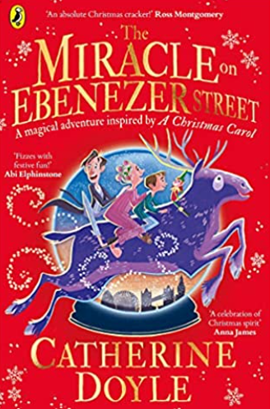
When George stumbles across Marley's Curiosity Shop, he finds a mysterious and magical snow globe.
George and his Scrooge of a dad are soon swept on an incredible adventure to Christmases past, present and future. With help from an enthusiastic elf, a rather grumpy purple reindeer and a very mischievous Nan, can George find a way to bring the joy of Christmas home once again?

This book starts off with me feeling sorry for George and his family and then being taken on such an adventure that by the end I had forgotten to feel sad and instead felt excited to see if they could find a way for George’s dad to be happy again!
TEACHER TALK – by Miss Shore

My name is Miss Shore and I would love to talk to you about my hobby which is field hockey! Since I was very young, I have always been a fan of team sports. Every other weekend, I used to watch my favourite football team Aston Villa with my dad, who also played football. Wanting to be like my father, I also played for my local football team and I really enjoyed it. Then one day, when I was in year 6, my teacher told us we would be learning how to play hockey. From that very moment, I was hooked (pardon the pun!) and that’s when I swapped my football boots for a hockey stick.
Over the years, I have played for many teams, including my university team, Winchester Hockey Club, Aldershot and Farnham HC, and now Basingstoke Hockey Club. I am also a qualified coach and have coached all age groups, from under 6’s to under 16’s. I have played both ladies and mixed hockey and even though hockey is a winter sport, like football, I still continue to play throughout the summer in various summer leagues. I never want to take a break from it!
This season, I have been playing in academy side, which means I have been helping develop youth players who are just starting to play adult hockey and I have really enjoyed this as it has allowed me to use my coaching expertise to develop players on the pitch. I am also currently playing with two ex St Mary’s pupils, which has been incredibly rewarding as I used to coach them as part of an after school club as St Mary’s!
There are many aspects of my hobby that I love. I keep fit by doing something that I love as I play at least twice a week. I also get to be part of a team and I have developed life- long friendships with those people I have played hockey with in the past. If you think you would be interested in taking up hockey, do come and see me as I would love to introduce more people into the hockey family!



Wonderful Work Gallery
A celebration of your writing this half term…
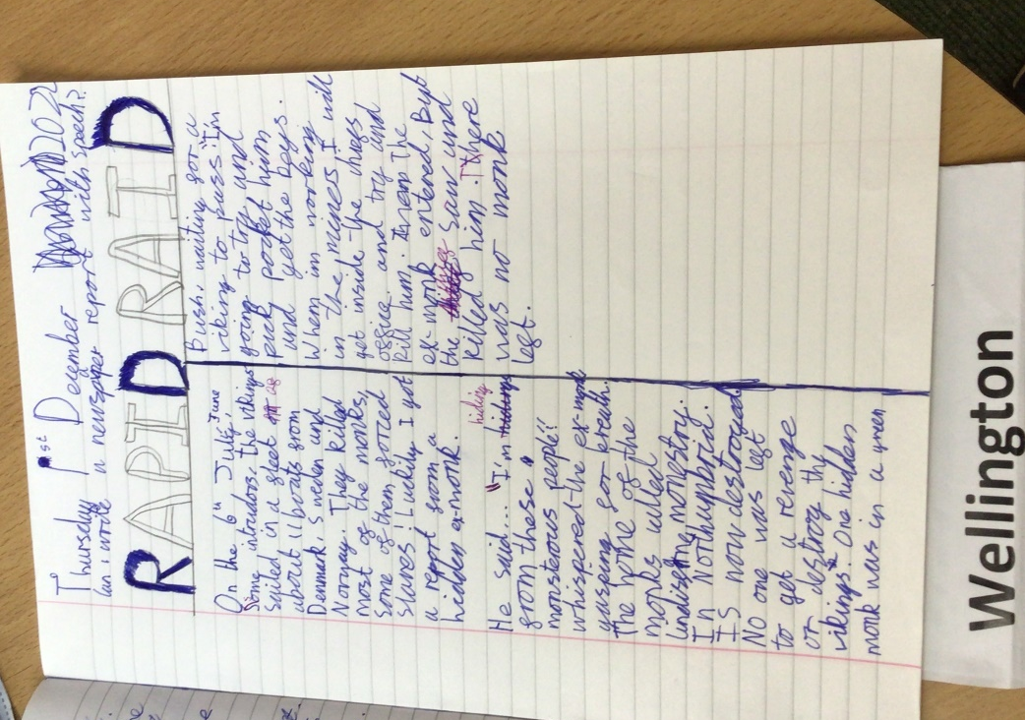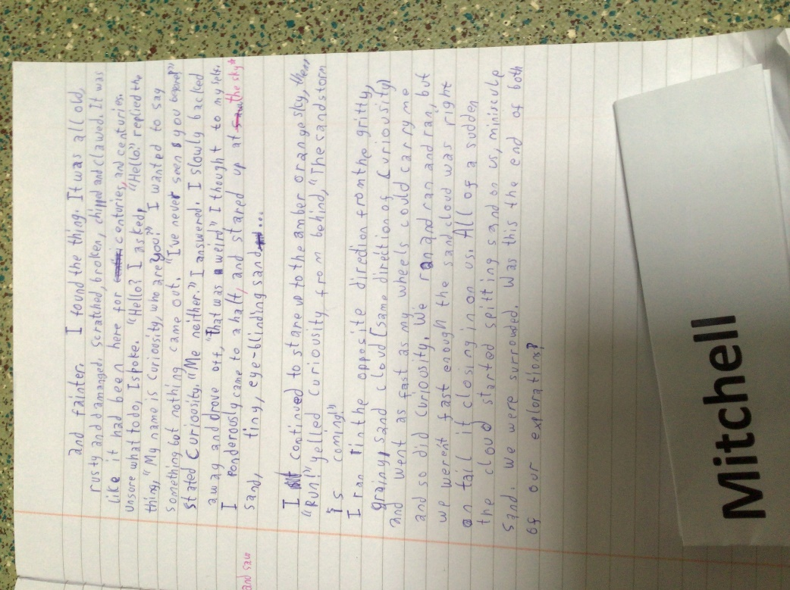
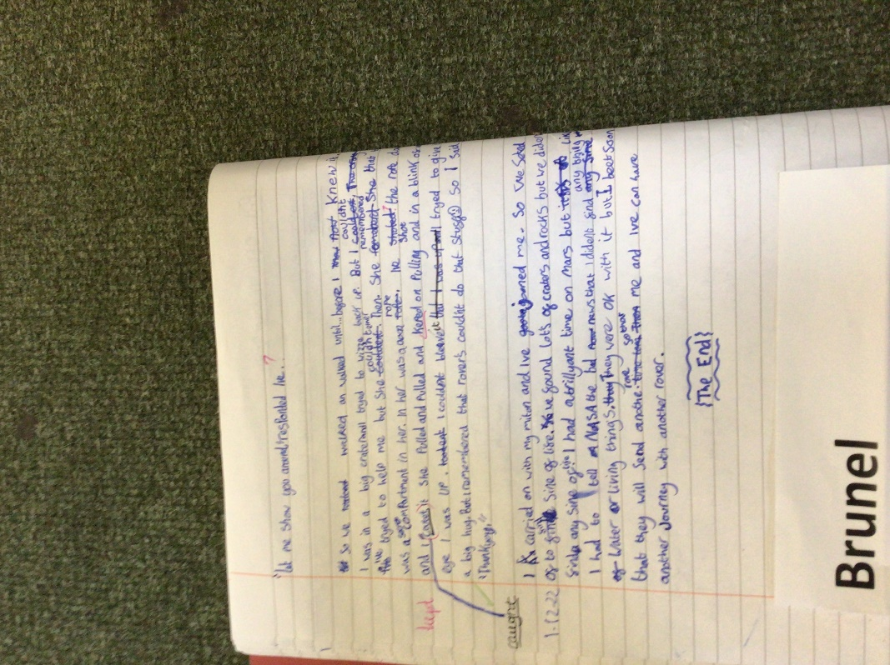
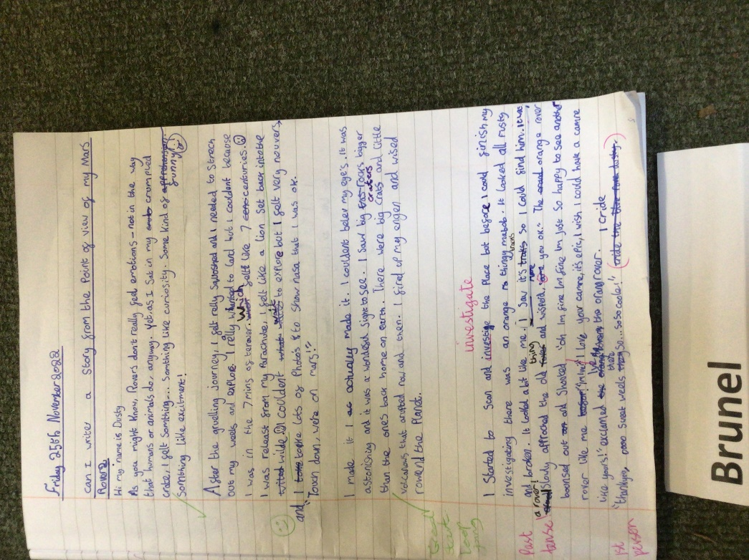
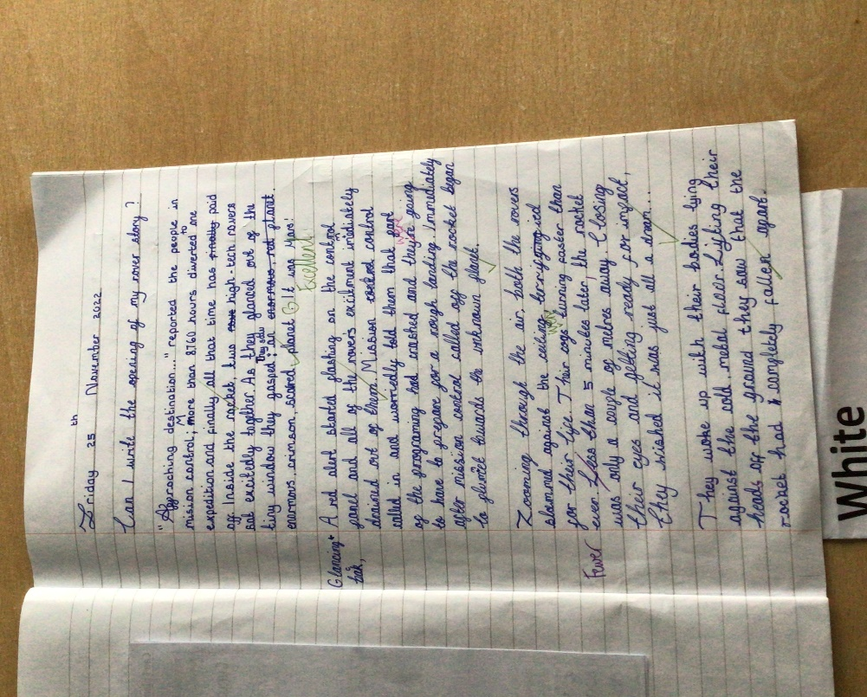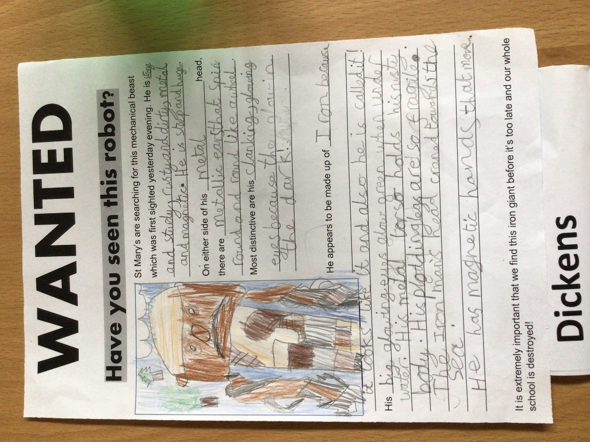
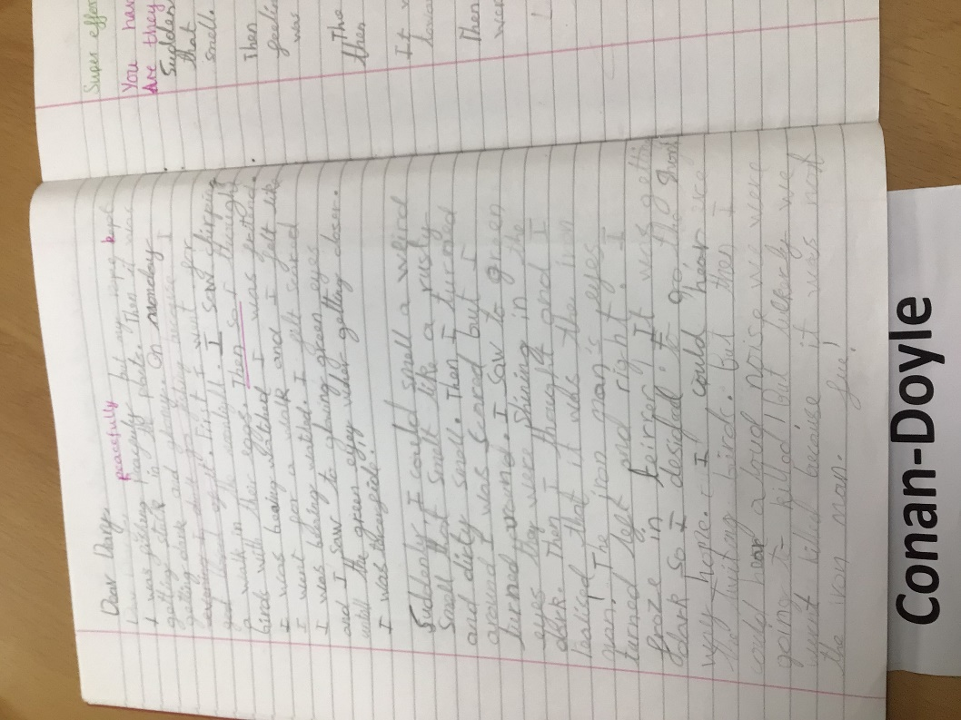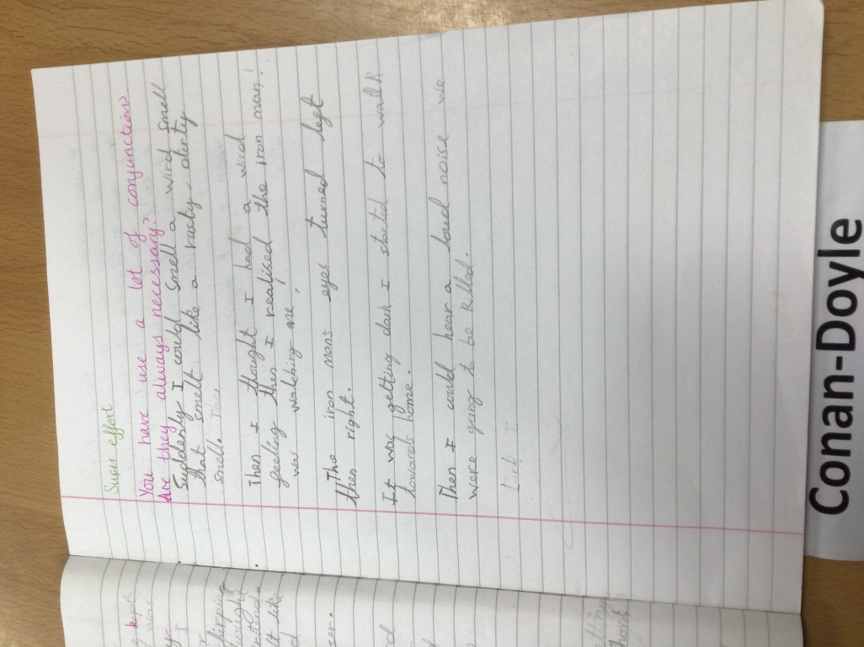

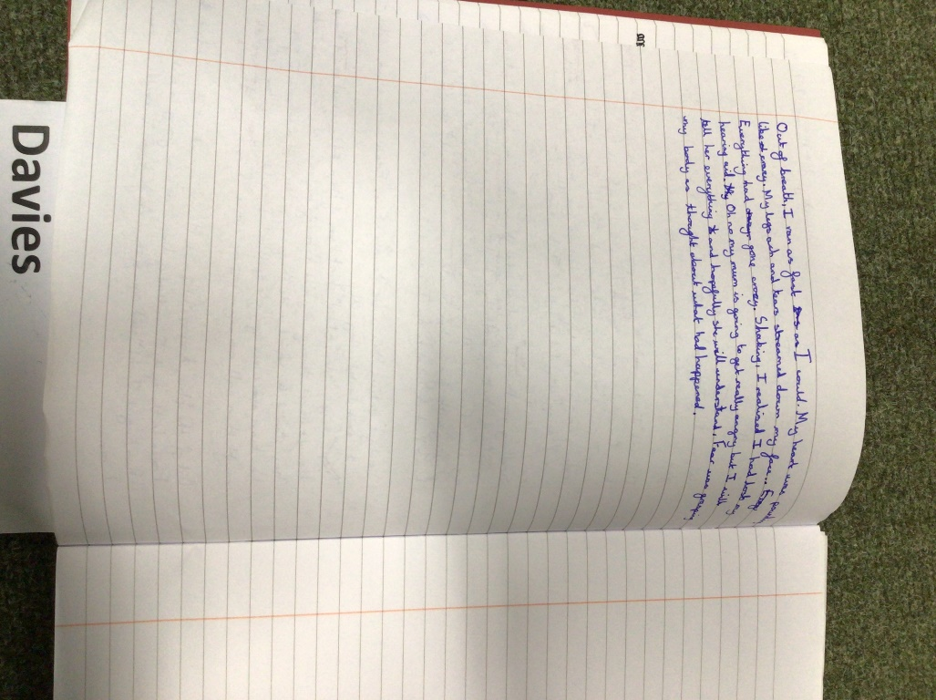
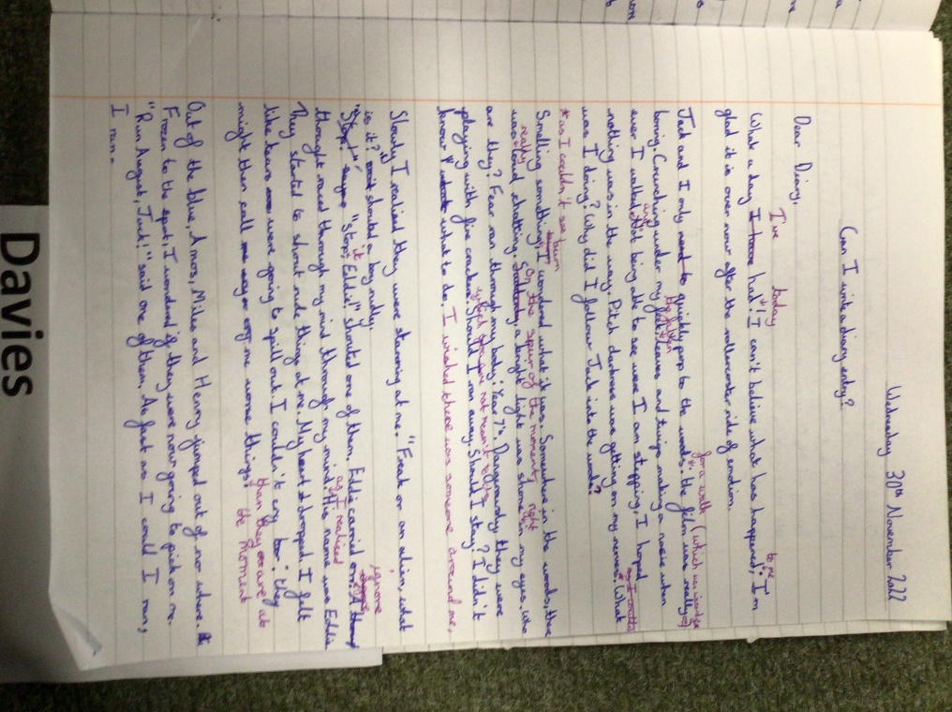
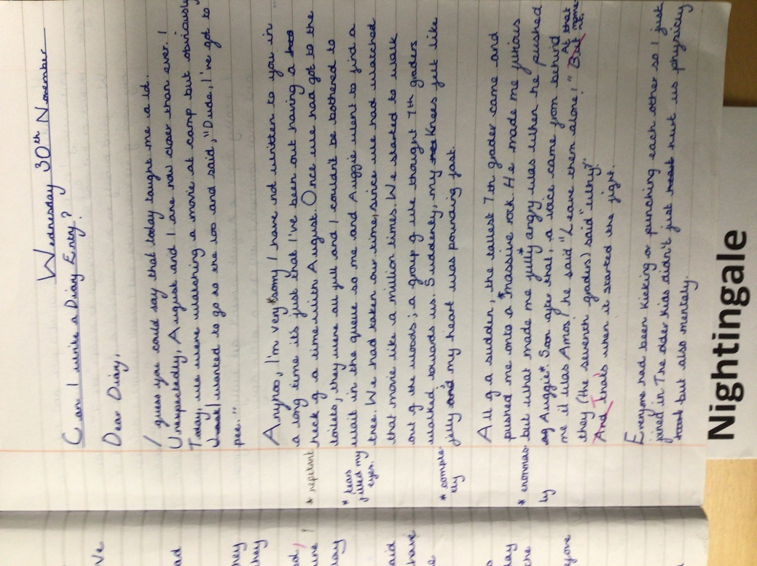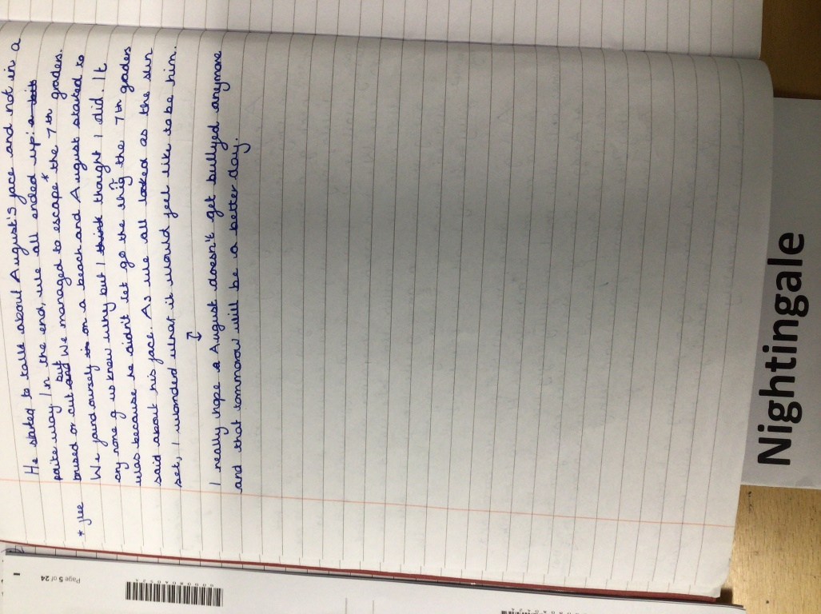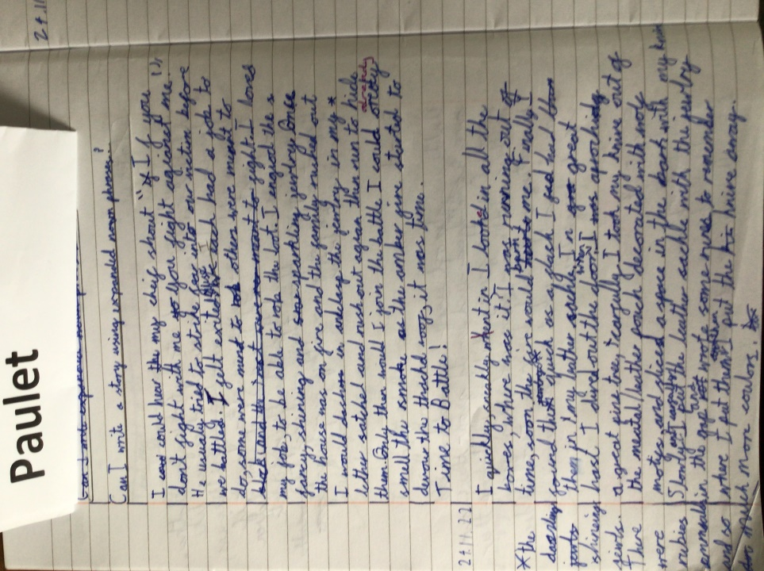

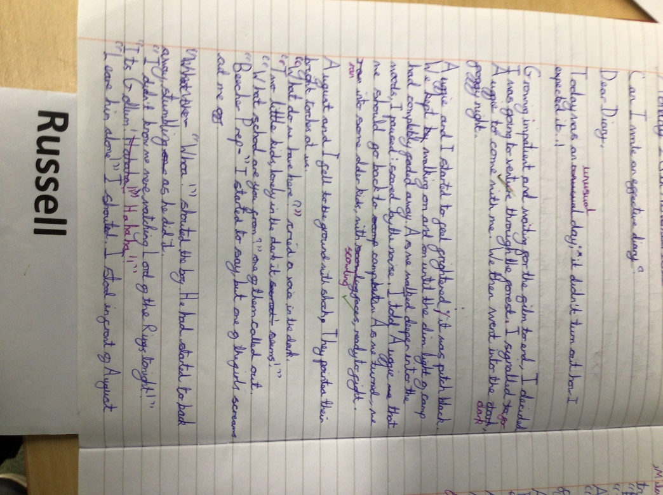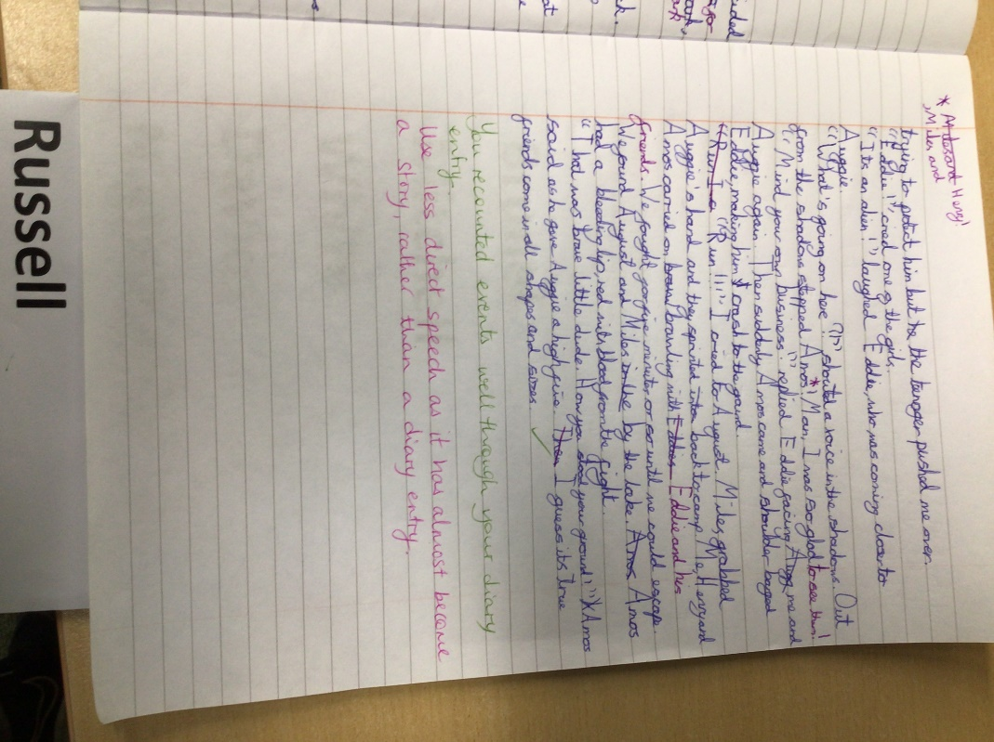

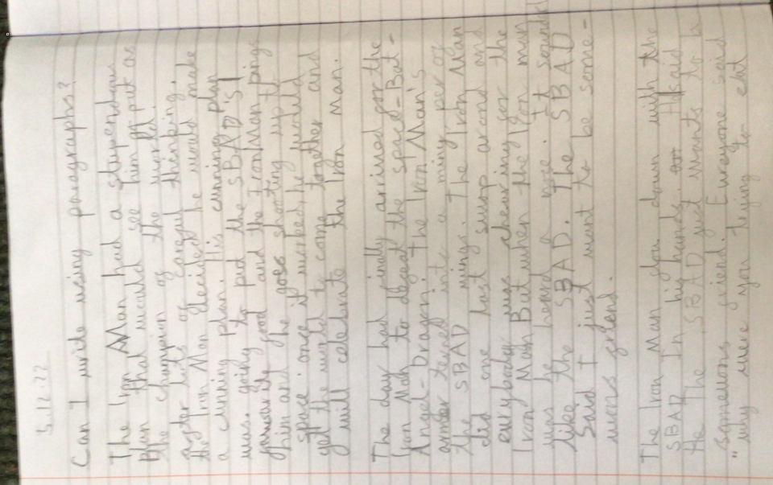
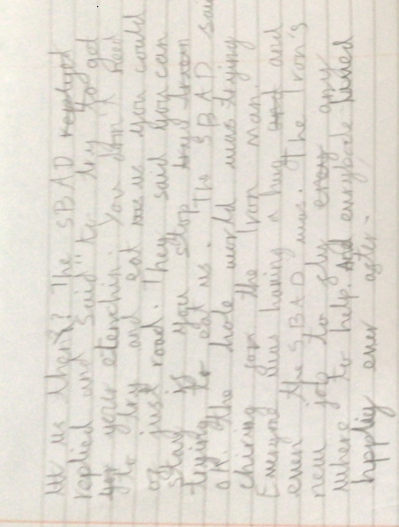
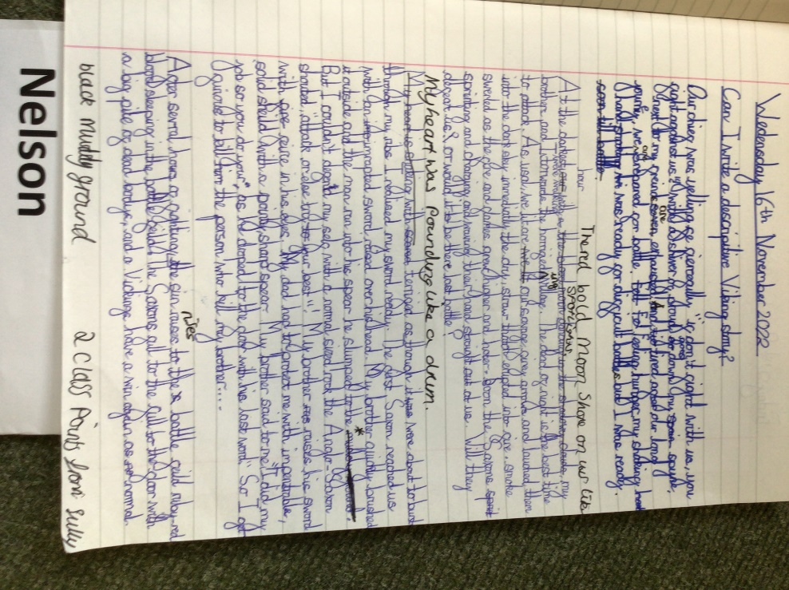

Austen
Christmas around the world.
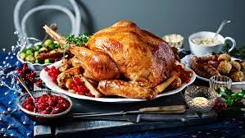
As we approach the Christmas holidays, our thoughts will be turning to how we will celebrate. Perhaps you will be having a big Turkey dinner with your family and enjoying a family walk on Boxing Day. Presents will be opened and some of us might be hoping for a White Christmas! But, have you ever wondered how Christmas is celebrated around the world? Read on to find out!

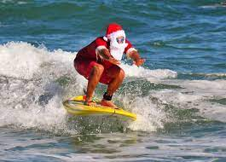
In Australia, Christmas actually falls in the Summer so many Aussies will heading to the a beach for a BBQ rather than a Turkey dinner like many of us have. The beach will be full of people dressed as Santa and children may made sandmen rather than snowmen! When Santa gets to Australia, he changes into a t-shirt, shorts and thongs (flip-flops). He then gives his reindeers a rest, calling on the help of his kangaroo friends!
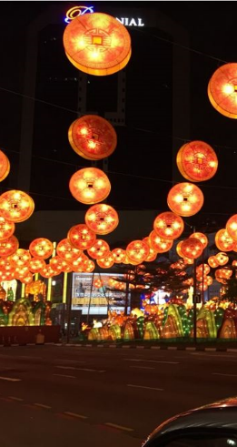
In Vietnam, Christmas Eve is often more important than Christmas Day. In Ho Chi Minh City, many people like to go into the city on Christmas Eve to visit a Catholic Cathedral.
Many people will celebrate Christmas by enjoying Christmas decorations and lights in big department stores and hotels across the city. They may also throw confetti and take pictures. At Christmas, some Vietnamese people will share a special Christmas Eve meal called ‘reveillon’ followed by a chocolate log for desert.

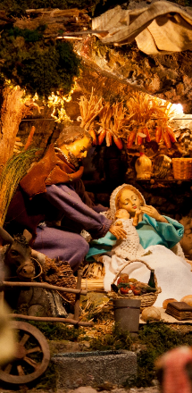
During the Christmas period, in some areas of Italy, shepherds come into the towns and play bagpipes and sing carols. The Christmas season is celebrated from early December until 6th January in Italy. Instead of getting presents on the 25th December, most children actually receive gifts on the 6th January. This day is called ‘Epiphany’. Most churches, town squares and houses will have a model of the nativity scene called a ‘presepe’. This is seen as the most important decoration at Christmas time. The traditional Christmas cake eaten is called a 'panettone’. It is a sweet cake filled with candied fruit.

No matter what you and your family do and how you celebrate, have a wonderful Christmas
By Mrs Candy

Something to keep you busy…

Mrs Lillywhite’s Christmas puzzles


