Religious Education Policy

Introduction
The following policy has been put together based upon the vision and aims of St Mary’s Junior school with the aims and key vision of the school which identify that:
- At St Mary's we are One Family providing for life in all its fullness – achieving more together. Living this out takes love, courage and creativity.
- We believe in fulfilment and excellence in all aspects of school life. We encourage individuals to be the best version of themselves academically, spiritually, socially and emotionally. Life in all its fulfilment is the gift God wants for all of us.
- John 10:10, "I have come that they may have life, and have it to the full."
In addition this policy document follows guidance from the Hampshire County advisor/inspector for religious education and the guidance provided by the locally agreed syllabus, Living Difference IV. In addition, the planning and delivery of Christianity within RE lessons is complemented with resources from the Church Of England’s Understanding Christianity publication, allowing for children to understand the big story of the Christian Bible and to explore life’s big questions, considering the part the children can make to our world.

The legal requirements of RE
In line with the schools trust deeds, the terms of Union with the National Society state with regard to religious education that: The Head teacher and the governing body will ensure that religious education is given at least five per cent of curriculum time and that such religious education is consistent with the faith and practice of the Church.

The Education Act 1996 requires that; religious education should be taught to all pupils other than those in nursery classes and except for those withdrawn at the wish of their parents. Teachers’ rights are safeguarded, should they wish to withdraw from the teaching of religious education.
We follow, under the advice provided by Winchester Diocese, the syllabus “Living Difference Revised” which (quoting from the syllabus and Education Act), reflect the fact that the religious traditions in Great Britain are in the main Christian, while taking account of the teachings and practices of the other principal religions in Great Britain. With regard to the law Religious Education must not be designed to convert pupils, or to urge a particular religion or religious belief on pupils, whether that of a secular agenda or of a particular religion.

The Department for Children, Schools and Families (DCSF) (now DfE) guidance, Religious education in English schools: Non-statutory guidance 2010, states that:
Every maintained school in England must provide a basic curriculum (RE, sex education and the National Curriculum). This includes provision for RE for all registered pupils at the school, except for those withdrawn by their parents in accordance with Schedule 19 to the Schools Standards and Framework Act 1998. The key document in determining the teaching of RE is the locally agreed syllabus within the LA concerned. ... Schools designated as having a religious character are free to make their own decisions in preparing their syllabuses.
As already stated, under the guidance of Winchester Diocese, we follow the locally agreed syllabus.

The School’s aims for RE & the contribution of RE to spiritual, moral, social and cultural education and developing understanding of the school’s Christian values.
“The overarching ambition of Living Difference IV is to play an educative part in the lives of children and young people as they come to speak, think and act in the world. Therefore, teaching must support children and young people discern from what has been studied, what this many mean in their own lives and for the world.” p. 43 LDIV.
Our aim of Religious Education is enable children to live life to the full according to our school vision. The curriculum is designed for children to feel a connection with their learning, either personally, spiritually or emotionally. This is through ensuring the faiths within our community are reflected within the curriculum and that pupils’ beliefs and ideas can be explored and broadened throughout their time here. This entails encouragement of each pupil to interpret and respond to a variety of concepts, beliefs and practices within religions and to their own and others’ cultural and life experiences. It is important that students progressively develop the capacities to interpret, evaluate and respond to differing values and beliefs. This can be achieved through extending their thinking and analytical skills and their creative, imaginative and emotional development. Opportunities through visiting speakers, a wide range of artefacts, resources from a broad spectrum of backgrounds and traditions, visits and enriching activities enable children to live life to the full.
A further aim of RE is to foster mutual understanding between pupils of differing religious and cultural backgrounds.

Parental right of withdrawal from Religious Education lessons
Parents are informed in the school prospectus that they have the right to withdraw their pupils from parts of or all religious education. Parents who choose to withdraw their children from Religious education lessons are requested to discuss the issue with the Head teacher. Those children who are withdrawn from RE lessons will be provided with alternative activities and fully supervised.

Implementing the RE curriculum
It is recommended that 45 hours minimum per school year should be devoted to religious education, and the programmes of study in Living Difference IV Revised have been designed with these time recommendations in mind. Timetables allow for RE to be taught for an hour, each week.

Class teacher’s responsibilities
- To teach RE for 1 hour each week
- To adapt medium term planning so that it is suitable for each class
- To provide oral or written feedback to the pupils, on their progress against RE skills
- To record pupils’ progress each half-term through Insight against RE skills and knowledge provided by the RE leader

Subject Leader’s Responsibilities
- Oversee & organise the long term RE planning
- Provide basic medium term planning each half-term to each year group’s team leader for dissemination and for adapting for their individual year groups and classes
- To monitor RE teaching and learning
- Provide sufficient provision of suitable resources
- Organise and support team leaders with enrichment opportunities, including visiting speakers, additional artefacts and resources and visits
- To facilitate any training as necessary
- To update and disseminate latest developments in RE to all staff
- To organise assessment opportunities and track progression of all children across the school
- To moderate the judgements made about pupils’ attainment and provide an overview of attainment in RE throughout the school

Assessment, Recording & reporting arrangements for RE
The RE leader is responsible for organising what will be assessed and how this assessment will be recorded. This is facilitated through using the school’s INSIGHT assessment system. Class teachers are responsible for recording the progress in RE at each stage of the cycle once each year (i.e. 5 stages to the cycle and 6 half-terms means that the contextualise part of the cycle is recorded twice in the course of the year). The RE leader will facilitate training on how to assess and record progress in RE. Each term the RE leader will monitor the recording of assessment in RE and annually will consider the implications following this assessment to monitor pupil progress in all areas of the cycle.

Approaches to teaching and learning
In addition to the teaching and learning policy it should be noted that unlike many other subjects, RE is a philosophical enquiry based upon the learners own perceptions and understandings of each concept which should remain fluid and develop as the learners’ progress through the cycle of learning (see diagram below for the learning cycle). The Living Difference IV syllabus is used to guide concept driven learning, encouraging children to begin from their own personal points of view and having opportunities to then hear about other people’s points’ view and how other religions would view these ideas.
We also lead RE teaching through a balanced approach of RE, including sociology, theology and philosophy, that we think of as living, believing and thinking. Ensuring that all parts of the cycle are used in planning and implementing the RE curriculum, ensures that the RE teaching and learning is balanced.
In addition, as a Church School, we teach Christianity as our main religion, however, also reflect the beliefs of the children at our school and the understanding of how religions are related to each other, teaching Judaism in Years 3 and 4 and Islam in Years 5 and 6. Alongside this and to ensure that there is a balance of different religions, we teach around Sikhi traditions in Years 3 and 4 and Humanist beliefs in Years 5 and 6. (see overview below)
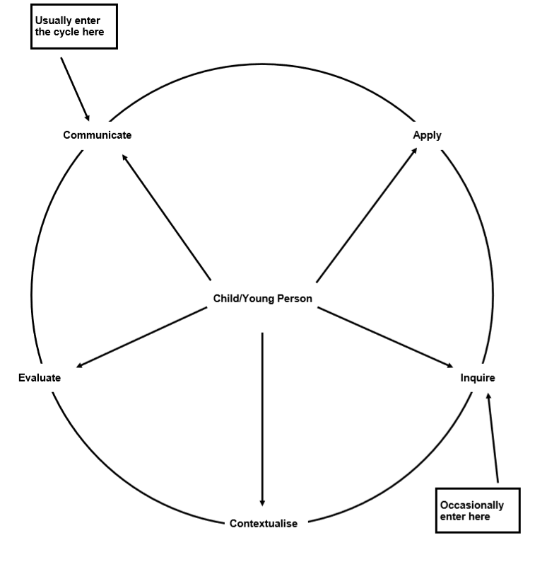
Date: June 2025 Review date: June 2027

Summary of the content of RE within the scheme of work
Golden Threads (LDIV) Understanding Christianity resources
Term | Autumn 1 | Autumn 2 | Spring 1 | Spring 2 | Summer 1 | Summer 2
Year 3 | Community  Parables  GOSPEL – KS1  (English link and intro to School Values and Church school)  Christian / Jewish | ANGELS  INCARNATION KS1 – digging deeper – focus on the message of the angels telling the Christmas story  Christian | REMEMBERING  Shabbat  Jewish  NB: Resource box needed | FORGIVENESS  The Easter Story  SALVATION – KS1 digger deeper  Christian | TEMPTATION  CREATION / FALL – who made the world?  Christian | Special as  SACRED PLACES  Places of worship  Synagogue / Gurdwara  Jewish / Sikhi
Year 4 | Belonging as IDENTITY  Bar / Bat Mitzvar  Jewish / Humanism | LIGHT AS A SYMBOL  How is Jesus seen as the Light of World?  INCARNATION – ks2 digging deeper  Christian | FREEDOM  The Passover  PEOPLE OF GOD – Upper KEY STAGE 2  Christian / Jewish | Love  The Easter Story  Salvation - Lower Key Stage 2 (digging deeper)  Christian | WISDOM  Torah / Guru Nanak and the Gurus  Jewish / Sikhi | PRAYER  KINGDOM OF GOD – Key Stage 2  Christian
Year 5 | GOOD LIFE  The Golden Rules  Humanism / Christianity | HOPE  Christianity  INCARNATION – Was Jesus the Messiah? – Upper Key Stage 2 (core learning) | COMMUNITY  The five pillars of Islam  Islam  Community | SACRIFICE  The Easter Story  SALVATION – Upper Key Stage 2 2b.6  Christian | Belonging  Muhammad (PBUH) and the Qur’an  Islam | STEWARDSHIP  CREATION / FALL – What do Christians learn from the Creation Story?  Christianity / Humanism
Year 6 | SERVICE  KINGDOM OF GOD – What kind of king is Jesus? Upper Key Stage 2  Christian / Humanism | INTERPRETATION  INCARNATION – Was Jesus the Messiah? – Upper Key Stage 2 (digging deeper)  Christian | SPECIALas RITUAL  What does it mean to be a Muslim today?  Islam | Resurrection asLove  Resurrection - The symbol of the empty cross  SALVATION – Upper Key Stage 2 2b.7  Christian / Humanism | JUSTICE  PEOPLE OF GOD - How can following God bring Freedom and Justice?  Christian/Islam/Judaism | Belonging  River of Life  Humanism

