Year 6 Spring Term Newsletter
January is now well under way and the children of Year 6 fully settled and back into the swing of learning. We have been so impressed with everyone’s positive attitude and commitment to working hard and making the most of the last year at St. Mary’s. The spring term is primarily history-led and will cover plenty of opportunities to learn more about our wider community and give children more experiences and memories, beyond the classroom.

‘Let Me Entertain You’ topic
During this term, we will be exploring many aspects of entertainment through a wide range of subjects. This will be a history-led topic, looking at a variety of different concepts like continuity and change, significance and chronology. The works of Shakespeare will feature prominently and we will be focusing on this during our English learning. In Maths, we will be continuing our work on Fractions, Decimals and Percentages, as well as more that is highlighted below. We have a range of exciting topics in computing, art and science that we will be completing. In our reading learning, we are studying the book ‘Wonder’ by R.J. Palacio; a wonderful book that encourages us all to consider our actions and words when meeting new people.
Notices
Please could your child make sure they are in their full P.E kits on Tuesdays and Fridays. This must include black joggers and a white t-shirt. They will need to wear a school jumper/cardigan as well as bringing in a coat because it is cold at the moment and children should be prepared with warm clothing for outdoor PE. We also ask that all children come to school with a warm, waterproof coat; some children are going outside at break time and lunch time without coats! Furthermore, please ensure your children are bringing in appropriate footwear for school.
Reading Reminder
We would like to ask all of you to keep up the great reading at home! Listening to, reading with and reading to your child all helps in developing comprehension skills and, above all, an enthusiasm for reading itself. The expectation is for your child to read at home at least 5 times a week (for 15 minutes or more at a time) and to record it in his/her pupil organiser. Please ensure that the reading records are brought to school each day.
Homework
As you are already aware, we normally set Year 6 their homework on Thursdays to be submitted by the following Wednesday evening. To get into the routines of home learning, ready for secondary school, it is vital that children stick to these deadlines. There will normally be a combination of Maths and English, alongside a foundation subject. Please ensure your child has completed their homework and handed in their learning on Google Classroom. If your child is finding areas of the homework difficult to complete, please encourage them to speak with their class teacher so they can act and support them during the week.

Too Much Selfie Isn’t Healthy!
Now it is the Spring term, we will soon be looking at the topic of ‘Too Much Selfie Isn’t Healthy!’ in Heart Smart and PSHE lessons. Primarily, this is thinking about others, but is also thinking beyond our school environment and out into our wider community and the contribution we can make, to make a difference. We will be considering some of the lessons that can be learnt from historical events too, such as the Holocaust, and the rights and responsibilities that were taken away from people at this time.

Should you have any questions or concerns over the coming term, please do not hesitate to contact your child’s teacher or another member of the Year 6 team.

Mrs Parsons Miss Hill Miss Dee

 | 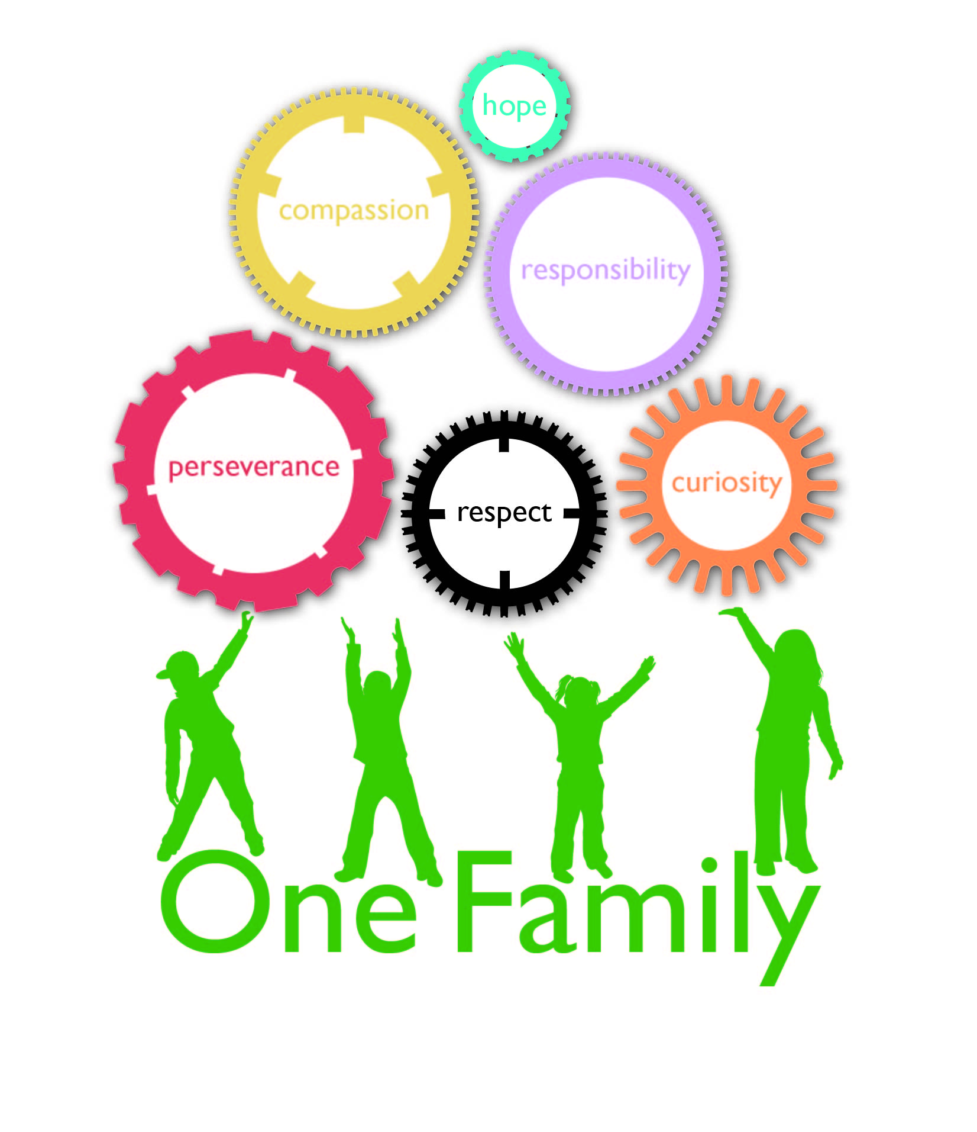
  Church of England Junior School
  Achieving more together
We are following the National Curriculum which provides a balanced and broad curriculum – promoting spiritual, moral, cultural, mental and physical development & preparing pupils for the opportunities, responsibilities and experiences of later life. Click here to see the full document.
Year 6 |  | Term – Spring 2024
Let Me Entertain You
Subject | Areas covered
Learning Enrichment | - World Book Day celebration  - Woking Mosque visit  - Young Shakespeare Company Visiting Theatre
English | - Poetry  - Biography writing  - Narrative writing, based around The Piano  - Balanced arguments about issues related to migration  - Use of formal/informal language  - Revision of key grammar skills: revision of word classes, wide range of punctuation, direct and reported speech, sentence structure  - Spelling rules and learning Year 5/6 spellings (national curriculum)
Mathematics | Decimals  - Identifying the place value of decimals up to three decimal places  - Add, subtract, multiply and divide by decimals  - Divide and multiply by 10, 100 and 1000  - Order and compare decimals  Percentages  - Decimal, fractions and percentages equivalence  - Percentages of amounts  - Ordering and comparing  - Shape  - Measure with a protractor to be able to draw lines and angles accurately  - Angles on a straight line and around a point  - Calculating the angles in an equilateral, scalene and isosceles triangle  - Identifying angles in special quadrilaterals and regular polygons  - Draw shapes accurately and drawing nets of 3-D shapes  - Position and direction using quadrants  Algebra  - Find a missing variable and a pattern  - Solve two-step equations  Measurement  - Converting, comparing and ordering units of measure  - Solving word problems
Science | - Human body – circulatory system and explaining the functions of the heart, lungs, blood vessels and blood.  - Evolution and inheritance – Applying the theory of evolution to habitats of different species, including humans.
Art and design | - Pop art  - Human figure sketching
Computing | - Internet safety  - Computer Systems and Networks  - Stop frame animations
History | - Understanding when the Elizabethan era occurred in history  - Recognising and discussing the links between society and the theatre in the Elizabethan period?  - Explaining the causes and consequences of events and how this created changes in entertainment in mid 20th century Britain?  - Assessing why some primary or secondary sources may be more reliable than others?
Languages (French) | - Revising word classes, including verbs and tenses.  - Revising how to use a negative and some adjectival agreements- creating some amusing cartoons to do so!
Music | - We will be looking at issues from the news and composing songs that have a message behind them.
Physical Education | - Dance  - Badminton  - Tag rugby  - Ultimate Frisbee
RSHE/HeartSmart | - Sex and relationship Education (SRE)  - Money  - Physical illness and medication  - HeartSmart – ‘Fake is a Mistake’ and ‘Too much selfie isn’t healthy’
Religious Education | We follow the “Living Difference” syllabus devised by Hampshire Inspection and Advisory service (more details)  - Special – Through Islam  - Love – Easter Story

