Church of England Junior School
April 2026
Year 6 Summer Term Newsletter
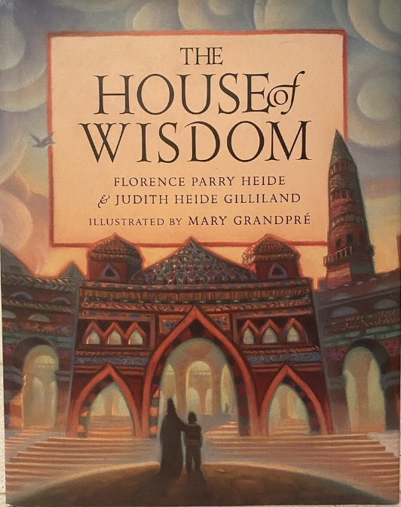
We hope you all had an enjoyable Easter holiday and we welcome you back to another busy term! The children are working extremely hard in preparing for their SATs tests in a couple of weeks. We know that they will do their best and we are already very proud of them.
‘Was Early Islamic Civilisation a beacon of light in the Dark Ages?’
During this term, our topic will be history led, we will be exploring life during the Middle Ages in Britain, and in the Islamic World during the period 500 – 1000 CE (sometimes referred to as ‘The Dark Ages’.) Study will involve looking at chronology, identifying and making comparisons about the characteristic features of the era, and describing the historical significance of these features. This topic will also include using our art skills for exploring Islamix patterns and using these for printing. A more detailed breakdown of the work to be covered can be found in Curriculum on the website:
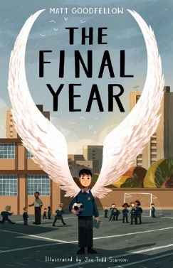
https://www.st-marys-jun.hants.sch.uk/page/?title=Curriculum+Overviews&pid=337
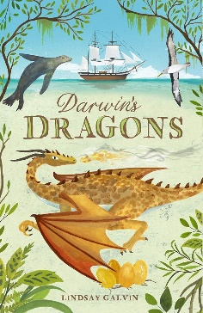
Whole Class Reading
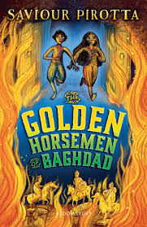
As part of our English curriculum, and with links to our science and history learning, we will be studying Darwin’s Dragons by Lindsay Galvin, The Golden Horsemen of Baghdad by Saviour Pirotta and The Final Year by Matt Goodfellow. All of these books give us opportunities to further analyse language features of different styles of texts and to enjoy a wider variety of authors and contexts.
Bags of Hope
As part of the end of year activities, Year 6 will be attending Winchester Cathedral, alongside other church schools, as they take their next steps onto their new secondary schools. Each school are asked to consider a concept as part of their preparation for this visit and this year the Winchester Diocese are focussing on Hope particularly focussing on the plight of refugees. We will be preparing a joint project, alongside the other schools, that will be on display in the Cathedral.
Reading reminder
We would like to ask all of you to keep up the great reading at home! Listening to, reading with and reading to your child all helps in developing comprehension skills and, above all, an enthusiasm for reading itself. The expectation is for your child to read at home at least five times a week (for 15 minutes or more at a time) and to record it in his/her reading record. Please ensure that reading records are brought to school each day as well.
Secondary school transition
The children are already thinking ahead to life at secondary school and you have all received information regarding your child’s secondary school. During RSHE sessions and Circle Time, they will be given opportunities to discuss their feelings and to share their thoughts about this transition. We are in communication with the secondary schools about how we can support the children with transition to ease any worries they may have. We know that discussing the transition helps to reassure the pupils and we see it as an important part of the entire process. Each of the Year 6 teachers will also talk to the link secondary teachers from a variety of schools in order to hand over assessment information about individuals and to explain about their strengths and areas of specific need. If you or your child have any concerns about secondary school transition, please contact your child’s class teacher and they’ll do their best to support you. Individual queries about the secondary schools themselves are best directed to the school your child will be attending.
Year 6 production
We are very excited about our choice of musical production for the Year 6 end-of-term performances. So as not to break with tradition, we will be announcing which musical it is on the Friday afternoon of SATs week (once they are all over!). We will then begin the process of auditioning for parts and planning the various things that will need to be organised. This is always a very enjoyable and exciting time for the children and staff and we are really looking forward to it. Nearer the time, more details will be released regarding costumes, performances and tickets.
Parent Helpers
If you think you may be able to spare some time to help and create costumes/props/staging for the production or for our DT unit, which will be sewing gadget cases, please let Mrs Parsons, Miss Hill or Miss Dee know. We would be very grateful for any time that anyone could offer. Thank you.
SATs (11th - 14th May)
Here are the dates for the tests:
Monday 11th May – English grammar, punctuation and spelling papers 1 and 2.

Tuesday 12th May - English reading

Wednesday 13th May –. Mathematics papers 1 and 2.

Thursday 14th May – Mathematics paper 3

How can you help during SATs Week?
- Reassure your child - they can only do their best.
- Allow time to talk through any concerns or worries.
- Ensure that your child goes to bed early.
- He/she should have a good breakfast and arrive at school on time with a snack and a drink.
- Continue going to Scouts, football, swimming club, etc.
- They must be in on time! Doors will be open for Year 6 slightly earlier as we must be ready to start the test at 9:00am.
- If there is a problem, please contact school immediately as there are procedures in place to help.
- All children are expected to be in school each day during SATs week.

IMPORTANT DATES FOR YOUR DIARY
27th and 28th April | SRE lessons (puberty and sex education lessons – further information has already been shared about this and a further reminder will be sent out on Parentmail nearer the date)
4th May | Bank Holiday
11th – 14th May | SATs days
15th May | Hoodies will be brought home and Year 6 Production announced
16th May | Children can bring their hoodies to school, as a coat. They will not be worn in lessons.
Week beginning 18th May | Walk to School Week
22nd May | INSET day (school closed)
26th May – 30th May | Half term
4th June | Sports Day (more details to follow)
12th June | Reserve Sports Day
16th June | School class photos
18th June | Whole Year 6 photo
19th June | BPSM Orchestra rehearsals
23rd June | BPSM Orchestra rehearsals during the day and evening performance
23rd and 24th June | RMS Induction Day (for those students attending Robert Mary’s in September)
24th June | BPSM evening performance
24th June | Leavers’ Service at Winchester Cathedral (more details to follow)
25th and 26th June | Costello Transition Days (for those students attended Costello in Setpember)
29th June | Year 6 Enterprise Week raising money for their Year 6 Party at school at the end of term.
10th July | Reports sent home including SATs results
6th July | F.O.O.B.S Summer Fair
13th – 17th July | Year 6 Show week (more details to follow)
17th July | Family picnic on the school field. Everyone Welcome.
20th July | Year 6 Leavers’ service at St. Mary’s Church (more details to follow)
21st July | Year 6 party (more details to follow)
22nd July | Last day of school

There will also be other induction days for the other secondary schools, only Robert May’s and Costello have been included here. These are dotted through June and July and you will be notified of these dates directly from the secondary schools themselves. Do keep an eye on these dates as the children will spend a whole day, sometimes two, at their secondary school.
As ever, thank you for all your ongoing support and we look forward to a very exciting (although busy!) last term with your children,
Regards,
Mrs Parsons Miss Hill Miss Dee

