11th September 2026
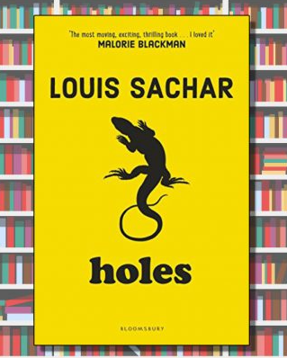

Year 6 Autumn Term Newsletter
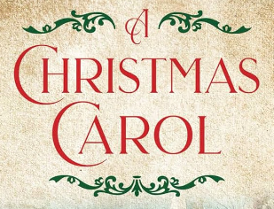

Introduction
Welcome to Year 6 and to the start of an exciting and important year in your child’s education! As we begin the autumn term of Year 6, we are looking forward to a term full of growth, learning, and preparation for the next big step in their school journeys. This is a crucial time as the children embrace their roles as the oldest members of our St. Mary’s One Family and work towards achieving their very best in their final year with us. Already, this year’s Year 6 have shown themselves to be hard-working, responsible and showing our school values of Love, Courage and Creativity. We are thrilled to be able to work alongside you in supporting your child’s success and well-being and are really looking forward to all that this year will bring.
Year 6 Curriculum
Alongside this newsletter, there is a curriculum overview for the Autumn term on our website. There will also be the slides and notes from the Briefing Meeting about Year 6 and our residential trip to Calshot. This meeting is scheduled for Wednesday 16th September but we realise that not everyone will be able to attend and so these notes will help you to see what is in store for this year. As with anything, we are always happy to hear from you, so if there are any questions or concerns, please do get in touch.
To find our curriculum overview, please go to our website and click on the curriculum tab and find Year 6. To find the briefing meeting notes, please go to our website and click on Parents, Year groups, Year 6.
This terms topic - ‘Extreme Earth’ topic
During this term, we will be exploring a variety of extreme weathers and the impacts of natural disasters, such as earthquakes and volcanoes. We are excited that RAF Odiham will be joining us on Wednesday 23rd October to help us launch our ‘disasters day’ when we learn more about our extreme world of volcanoes and earthquakes and how the RAF respond to emergency areas around the world. We will be building spaghetti towers and creating parachute egg drop to consider how emergency aid can reach isolated areas in the world. As a geography-led topic, we will be looking at the construction of the Earth and how natural disasters form, but also the economic impact that these disasters have in different places around the world. Then, after our Calshot visit, we will then be comparing our local area, with the Calshot area finding out about socio-economic differences and land-use differences. Our art topics include using photography to photograph our local area and at Calshot and paint to depict volcanoes, inspired by the work by Stephanie Peters. Our science studies include learning about the circulatory and respiratory systems of the human body in science, including a visit to the Primary Science Centre at Queen Mary’s College. Later in the term, we will be studying light in science along with a food project in DT creating our own vegetable soup. Our reading focus will be around the wonderful book ‘Holes’ by Louis Sachar and, as we head to Christmas, we finish with an exciting opportunity to look at some classic fiction including ‘A Christmas Carol’ by Charles Dickens. This will include a drama workshop given by a visiting theatre group to school and a chance to attend the theatre production of this story at the Haymarket in Basingstoke. More information about this will be sent out to you, nearer to the time.
Reading and Maths
In Year 6, reading continues to be a main priority for our children’s learning. We would like to ask you to keep up the great reading at home. Listening to, reading with and reading to your child all helps in developing comprehension skills and, above all, an enthusiasm for reading itself. The expectation is for your child to read at home at least five times a week (for 10-15 minutes or more at a time) and to record it in their reading record. Please ensure that your child brings in their record into school each day. Our behaviour reward system is also placed in the back of the reading record: another great reason for children to bring this into school everyday!
Homework
We will be giving Year 6 their homework on Fridays and this will need to be submitted on Google Classroom by the following Thursday. The children are well acquainted with the online platform now but if there are any questions then please contact your class teacher. Your child will also have four CGP books for maths and grammar. Tasks are set from these books too and will need to marked at home and then photographed and submitted online. Further notes about this are given at the briefing meeting.
Your child may also, on occasion, come home with a skills card, identifying specific areas in learning which they found challenging in class that day or that we would like to further progress their skills in. On such occasions, the teacher will give an example of the learning point and set a few tasks to work on and to return a few days later. Please could you acknowledge receipt of this by signing the card and making any comments you deem necessary?
We are really looking forward to all that this year brings. Should you have any questions or concerns over the coming term, please do not hesitate to contact your child’s teacher or another member of the Year 6 team.
Mrs Parsons, Miss Hill and Miss Dee

IMPORTANT DATES FOR YOUR DIARY
21st and 22nd Sept | Year 6 visit to Primary Science Centre at QMC – see recent email for details
23rd Sept | RAF Odiham visit to Year 6
28th Sept– 2nd Oct | Bikeability – it would be good for children to get practicing and to feel confident on their bikes ahead of this time.
6th Oct | 1.45pm Year 6 Year Group Act of Worship at St. Mary’s Church – all welcome
8th Oct | Davies Sharing Assembly – 2.45pm (all families / friends of Davies class welcome)
14th and 15th Oct | Parents’ Evenings
19th Oct – 23rd Oct | Calshot residential trip
26th– 30th Oct | Half term
2nd Nov | INSET
3rd Nov | Back to school
16th – 20th Nov | Friendship Week including Odd Sock Day on the Monday
3rd Dec | Russell Sharing Assembly – 2.45pm (all families / friends of Russell class welcome)
11th Dec | Big Foot Arts Drama Workshop based on A Christmas Carol in school  6.30pm – Optional ‘A Christmas Carol’ Theatre trip at Haymarket Theatre – details to follow
15th Dec | 6pm Carol Concert at St. Mary’s Church – all welcome
16th Dec | Class parties
17th Dec | End of term church visits  Last day of term
18th Dec | INSET day

