  High Five!
  There are five simple truths that we use to unpack what it means to be HEARTSMART. These five principles help us be smart with our heart, help us love ourselves and others, help us guard our heart and process how we feel. They help us build resilience and active empathy.
  Don’t Forget To Let Love In!
  Learning how important, valued and loved we are.
  Too Much Selfie Isn’t Healthy!
  Exploring the importance of others and how to love them well.
  Don’t Rub It In, Rub It Out!
  Understanding how to process negative emotion and choose and choose forgiveness to restore relationships.
  Fake Is A Mistake!
  Unpacking how to bravely communicate truth and be proud of who we are.
  ‘No Way Through,’ Isn’t True!
  Knowing there is a way through every situation, no matter how impossible it may seem.
  
  
  
  
  
  HeartSmart
  
  St Mary’s C of E Junior School
  [Company Name]
    - [Subtitle]

Why HeartSmart at St Mary’s?  Our core Christian Value is Love. In our school this is described in terms of being One Family, where each member is encouraged to love and respect themselves, others, God and his world. The value of ‘love’ underpins everything we do at our school.  Love is what holds everything together in perfect unity.  Colossians 3:14  Love your neighbour as yourself.  Matthew 22:38  Heartsmart is an exciting programme which connects all of our school values, RE, PSHE and wellbeing.  For a person to develop character two main ingredients are required; love and challenge.  Challenge – If a person is not challenged, they will not be willing to step out of their comfort zone and their mind-set will be fixed.  Love - You’re important, you matter, you’re one in a million and above all you’re loved. These are messages that the children have been learning to embed in their minds and others as we all need to hear, believe and remember – because sometimes we forget.  Heartsmart believes that creating a healthy culture involves having these two in balance and it provides the optimum environment for hearts to grow well.  Make It Picture Perfect  To replace any photo with your own, just right-click it and then click Change Picture.  If your photo is not a flawless fit for the space, you can crop it to fit in almost no time. Just select the picture and then, on the Picture Tools Format tab, click Crop. |  |  | What is HeartSmart?  HeartSmart is a new approach that primary schools use to build character, emotional health and resilience in children.  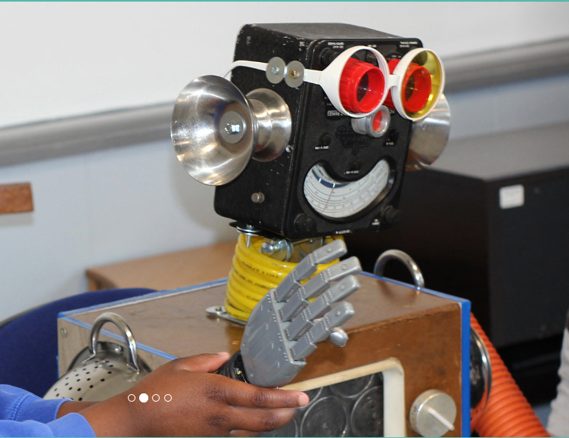  It is a creative way of enabling children to adopt a growth mindset whilst maintaining a healthy emotional epicentre. At its core, HeartSmart is about loving and accepting ourselves as well as loving and responding well to others.  Boris, HeartSmart’s very own purpose-built Robot, provides a fun, interactive and dynamic way for children to explore their hearts, the very thing that makes them unique.

