Dear Year 6,

Week Beginning 15th June

Hope you are all well. The year 6 teachers have enjoyed receiving emails from some of you over the last two weeks showing the work you have done; do remember to send photographs of anything to them that you wish to share.

In your pack for this week you will find English activities linked to a video clip called ‘The Ridge’, Maths activities, some more Science linked to the human body and some PSHE. If you need to complete any of your work from last week do that and also carry on with any art, craft, baking and PE you enjoy doing at home with your family.

These activities are similar, but not all the same, to those that year 6 will be doing in school this week.

Any worksheets or resources mentioned will be saved on the website on the year 6 pages.
https://www.st-marys-jun.hants.sch.uk/page/?title=Year+6&pid=343

Don’t forget you should still be regularly logging onto Mathletics for some additional Maths practice and do keep reading!

You may also like to look on the school website at some of the activities other year groups are doing as you may like to try some of them yourself.

Maths
This week the focus for our maths learning is time and timetables -important things you will need to know when moving to secondary school so you can get to your lessons on time!
- Have a look at the Time Questions Set 1 saved on the website – you don’t need to print them out you can read them on screen and make notes on paper. The answers are on the last card but make sure you do not cheat!
- Try the Minecraft Time problems on the website. There are 3 different levels of questions – do not do them all! A is the easier level and AAA are the hardest, maybe chat with your parents to see which you want to have a go at, the answers are at the end – no cheating!
- These activities are all to do with the 24hour clock. If you have a printer you can print off the 24 hour clock jigsaw and try to complete that, cut out the pieces then match them up. There are also some 24 hour clock word problems you can try – you can just make notes on paper for these, you do not need to print them out.
- Have a look at the sheet called reading timetables and have a go at answering the questions, then if you want to have a go at the extension task – planning a TV schedule. You could always do this tomorrow if you want to!

English
For the next two weeks your English work is based around a video clip called ‘The Ridge’. The video clip can be found here https://www.literacyshed.com/the-sports-shed.html
Work through these activities in order, perhaps doing one or two a day. Some are very short.

- Watch the clip up to 2min25sec and stop there! Can you come up with words to describe the setting, create a mind map or list of interesting words. Then use a thesaurus if you have one, or an on line one, to see if you can find better words (synonyms) for these words, can you make your vocabulary even better?
- Using the words that you collected in activity 1, write a description of the setting. You can use this as a starting point if you wish to. “Calm, icy water
surrounds the rocky mountain, and sea birds glide overhead, singing softly.” We would love you to send us your descriptive paragraph.
- Now watch the rest of the video – how amazing would it be to ride there!
- Freeze the vide at 0:25 where you can see the seals surrounding Danny’s boat. How long have they lived on the island? If they could speak what tales might they tell? Today you are going to write as one of the seals, telling Danny about what he is going to find on the mountain. Would they be pleased that he is there? Would they warn him about anything? Would they suggest a particular spot he should visit? What would the seal predict that Danny might encounter? Write at least 2 paragraphs of narrative (story) from the perspective of the seals on the island, remember to use descriptive and high quality vocabulary.
- Music often provokes emotions and feelings. Listen to this piece of music on You Tube -https://www.youtube.com/watch?v=jSRHpA2giUk
Do you recognise the music from ‘The Ridge?’ Why do they think that this piece was chosen to accompany the film? How does listening to it make you feel? How does it relate to Danny’s feelings through the film ‘The Ridge’. How do his emotions change during the video. Listen to the music again and as you do complete an emotions graph (there is a template on the website you can use for this) jot down ideas of how Danny feels at each part of the soundtrack. How does the music convey his feelings? If you want to, you can write a paragraph about how the music reflects the mood and actions of Danny – but the emotions graph is enough! You can do this while watching the original video as well if you want to.
- How do you feel when you are angry/ excited/ upset/ surprised? What happens to your appearance and body? Choose an emotion and write it on a piece of paper. Around it write all the characteristics that you can think of that would suggest somebody is feeling that way. Repeat this for another emotion. How do authors show that characters are feeling in these ways? How do they ‘show, but not tell’ the reader? Have a look at the ‘Character Feelings’ worksheet on the website – read each paragraph and decide how the character is feeling. How do you know? Highlight or underline any words or actions the author has used to show the reader how the character feels.

Next week we will carry on with work around ‘The Ridge’ video and you will be writing a great poem and story based on this extract.

PSHE
Can I identify how powerful feeling grateful is?

This is a scary and confusing time and for some people, it can be hard to feel positive, especially when missing friends and family.

Have a think about things which you feel have been positive about this time. This could be a tiny thing and may be very personal to you!
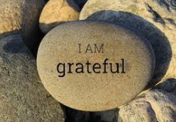
Examples could be:
- Roads being quieter so it is easier to cycle!
- Finding new parts of the local area.
- Learning to bake a cake.
- Spending more time with family.

What have you felt good about or been grateful for over the last 10 weeks since our world changed so much?
Scientists at universities in the UK and US have found that that a great way to protect your mental health and feel happier, is to think about the little things which you are grateful for. The research seems to show that practising being grateful for small things in life means you feel more positively and are better able to cope when things go wrong.

Main Activity- Create a 'gratefulness' board.
People in lots of different walks of life use 'mood' boards to collect things they love, to design new buildings or rooms and to come up with new ideas!

Use an A4 or A3 sheet of paper and start to add colour, sketch out pictures, add words...anything which represents your list of things to be grateful for.

The bolder and more colourful the better!

You could add pictures from magazines, leaves, recipes, photos or anything else which represents things you are grateful for. Remember to send us photographs of your finished gratefulness boards. You can see photographs of some that some children produced in school last week here https://www.st-marys-jun.hants.sch.uk/gallery/?pid=7&gcatid=51&albumid=335

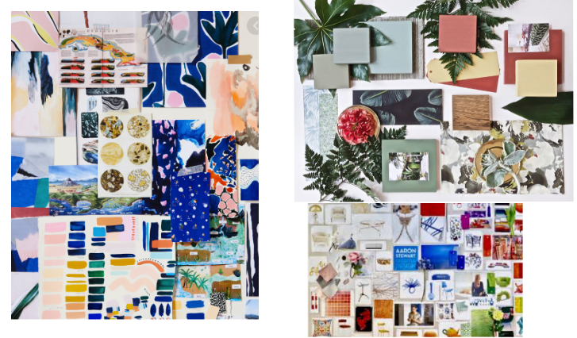

Science
Circulation
There several science activities to work through this week for science, choose just one to do each day.

- Read through the Circulation PowerPoint. Use the interactive parts to find out more about the parts of the heart. Make any notes as you read to help you remember the facts – use bullet points or a mind map/spider diagram and highlight on your notes key scientific vocabulary. Isn’t the heart an amazing organ!
- Read the sheet called circulation system and answer the questions at the end. What have you learnt now that you didn’t know before?
- If you would like find out more this link takes you to an animation on you tube about the Circulatory System! https://www.youtube.com/watch?v=-s5iCoCaofc
- Present what you have learnt about the circulation system – you could create a poster, a leaflet or write a short report to demonstrate your learning.

History
Carry on with the history you started last week if you need to finish your poster or leaflet you can do that this week. What have you found out about the Golden age of Islam and life in Baghdad during the Dark Ages. Remember to send us any work you have done, we would love to see how you presented your ideas about their inventions etc.

Have a good week Year 6!

