Dear Year 6,

Week Beginning 29th June

We have seen some lovely work over the last few weeks from some of you at home, do keep sharing it with us!

This week your English is all based around a poem called High Flight by John Gillespie Magee and your Maths work is all around Fractions.

These activities are similar, but not all the same, to those that year 6 will be doing in school this week.

Any worksheets or resources mentioned will be saved on the website on the year 6 pages.
https://www.st-marys-jun.hants.sch.uk/page/?title=Year+6&pid=343

Still regularly log onto Mathletics for some additional Maths practice and keep reading, let us know if you have discovered any new books lately!

You may also like to look on the school website at some of the activities other year groups are doing as you may like to try some of them yourself.

Keep up with the daily exercise, baking, arts and crafts and all the other thing’s that you have been enjoying doing with your family.

PE

Tuesday 30th June is the St Mary’s Virtual Sports Day!
- On Monday can you create a plan for your family sport day? What events will you undertake? Create a timetable for your day and who will take part in which events. There are a few ideas on the website and a certificate you can down load. Your parents have been sent all the details in a parent mail.
- Have fun on your sports day! Remember to send us lots of photographs of your events!

Maths
The fractions work is all things you have covered in Year 5and 6 and it is a chance to revise some of these concepts ready for Year 7. If you get stuck have a look on line for further activities for help, there is a lot out there or you can email your teachers for help.

On the website you will find a pack called ‘Fractions – Learning from home workbook’. This week we would like you to work through this pack. Perhaps on Monday look through it with an adult and decide how many pages you want to try and get done each day. You can carry on with it next week too if you need to.

The answer booklet is also saved on the website so you can check your work and if you find anything you need to practice look on Mathletics for some activities related to that area of fractions.

English
This week our English work is all based around a poem called High Flight by John Gillespie Magee.

During the dark days of the Blitz, John Gillespie Magee was one of the many Americans who enlisted in the Royal Canadian Air Force. Within a year, he was sent to England and assigned to Fighter Squadron where he flew the Spitfire. On September 3, 1941, he flew a high-altitude test flight in a new model of the Spitfire V. As he climbed upward through 33,000 feet, he experienced great exhilaration which inspired his immortal line, “to touch the face of God.” He later expanded it into a poem.
Three months later, he was killed in a mid-air collision. He was only 19 years old. He had sent a copy of his poem to his father, who was then rector of a church. His father printed it in church publications.
High Flight has since become the most famous aviation poem ever written. It has inspired countless aviators and astronauts.

- Read through the Poem High Flight

- Now watch a video clip of the poem being read to help you further imagine the scene and feelings https://www.youtube.com/watch?v=j-790e4YVHo

- Answer the three reading comprehension questions on the poem. Make sure you give detailed explanations and use examples from the poem for question 3 to expand on your thoughts.

- We are now going to write our own poems to describe a flight. To make your poem really effective remember you could include: description, alliteration, rhythm, metaphor, simile etc. If you need some inspiration watch the video called ‘Aviatrice’ from this link. You could jot down emotions during different stages of the test flight and describe what the pilot might be feeling. This could help you come up with ideas for your own poem. https://www.literacyshed.com/aviatrice.html

- Present your poem into neat once you are happy with your draft – do send your teacher a photograph of your final published poem, we would love to see it.

- We would then love you perform your poem to someone at home, maybe they could record you performing it and you could send the video to your teacher? Remember the techniques you used when we had our poetry slam in school!

PSHE

Can I make fixed mindset attitudes into growth mindset?

Having a grotwth mindlset is really imporatice to enable us to keep posirtive iin challenging ties It is isalso really imporatn for henyou start secondary school and are faced with new challenges and experiences.

Look at these two people, each with a different mindset.
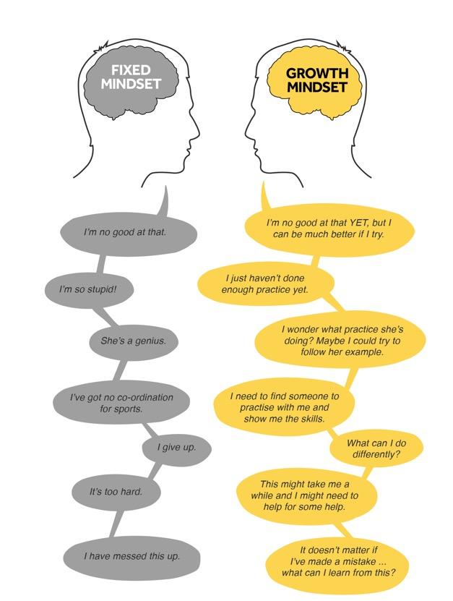

- Which mindset are you and why?

- Does it change depending on different situations in your life?

- Are you someone who thinks that you are just born intelligent?

TASK:

- Identify three things that you say you ‘can’t do’. Write them down.
- Now write each thing down using a growth mindset approach. For example, ‘I can’t do maths’ turns into, ‘I am going to practise the things in maths that I can’t do yet’.
- Think of something you’ve always wanted to get better at. Write it down. How could you practise that thing now?

Have a good week Year 6!

