Dear Year 6,

Every year Winchester Cathedral hold a Year 6 Leavers’ Service for Church Schools in our local area. In these services we celebrate our time together at school and look forward to the future as you transition to your new schools. The services are themed, with each school bringing an artistic creation to contribute. You may have seen the colourful sheep in the courtyard; our ‘Chair for a Hero’ in the reception area or our ‘Bee Kind’ canvas from last years’ service. Sadly, due to the current situation, this year’s service is unable to go ahead at the Cathedral. However, the dioceses would still like us to commemorate our time at school and wish you well for the future, albeit at a distance.

The theme for this year’s service is ‘Peace’ in recognition of the 75th anniversary of the liberation of the concentration camps in WWII in partnership with The Holocaust Memorial Trust. You will all remember the work we did on ‘The Harmonica’ back in January and how we all agreed that this is something to learn from to ensure no one suffers in this way again. With this in mind, we have been tasked with creating 4 ‘Peace Poles’. A peace pole is a world- famous symbol of hopes and dreams, a sort of silent prayer for unity and love on Earth. They are all different, but every peace pole has the same message on it - May Peace Prevail On Earth.

One will be displayed outside the school entrance (this will be made up of designs from everyone in the year group) and the remaining three (one for each class) will be installed around the school grounds as a lasting legacy of the year group, sharing empowering words and encouraging the future children of St. Mary’s school to share the message of peace, unity and love.

In order for us to create these peace poles we are going to need some designs from you all. Our poles are 10cm in width and 6ft tall, so we have a lot of space to fill. The only requirement in your designs is that they must have the message ‘May Peace Prevail On Earth’ clearly visible on the pole. The rest is up to you. How do you think you could share the message of unity in peace? Are there any well-known symbols of peace you could include? Will your peace pole be bright and colourful or simple and modest?

Once we have your designs, we will collate them together to produce our 4 peace poles. We look forward to seeing what you come up with.

We have included some examples for inspiration and have also given you a design template.

Good luck!

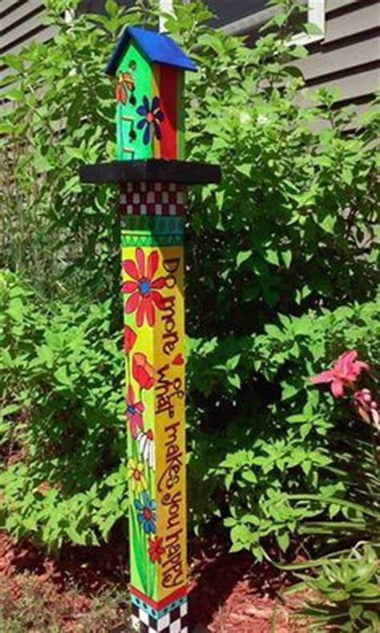

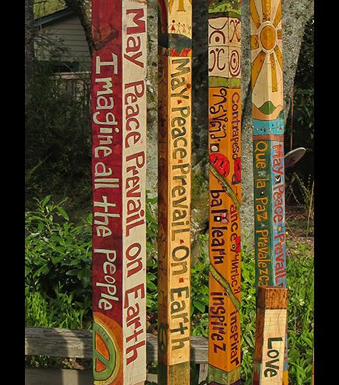

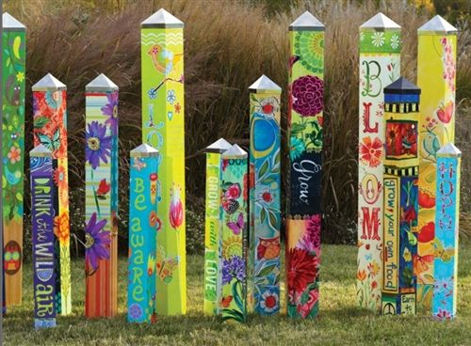

Front Rear

Left Side Right Side

