Indus Valley - Did you know?
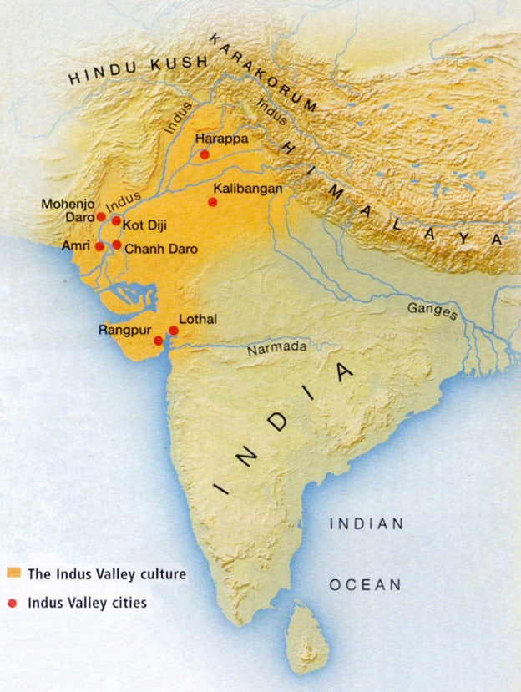
- The Indus Valley civilization was one of the world's first four great civilizations. It came into existence about 4500 years ago in what is now Pakistan and western India.
- It was the largest of the early Bronze Age civilizations, covering half a million square miles from the Indian Ocean to the foothills of the Himalayas. Despite it covering a much larger area than any of the other early civilizations, much less is known about it than the others.
- The fertile plains of the Indus Valley provided an ideal site for early settlers. Irrigation and the use of the plough enabled many crops to be grown throughout the year. Excavations have revealed the world’s oldest ploughed field. Surplus grain was stored in communal granaries, possibly for less productive years. Animals such as goats, cows, sheep and buffalo were domesticated and other animals were probably hunted. Dogs, cats, monkeys and peacocks may have been kept as pets.
- Although most people lived by farming there were skilled craftsmen who worked with metals and clay, hunters, fishermen, builders and scribes. Beautiful pots and figurines, polished stones and jewellery, and strong buildings provide evidence of their abilities. Decorative seals were used to identify the goods produced by each tradesman.
- The people who lived in the Indus Valley were the first to grow cotton and weave cotton cloth.
- Only a limited number of weapons have been recovered and there is little evidence of conflict, although the cities had strong walls and gates so could perhaps be defended if necessary. It seems that for much of the period of its existence the people of this civilization led peaceful, prosperous lives.
- The cities show clear evidence of town planning with broad streets and access to water, drainage and sewers in even the smallest houses. For example, almost every house in Mohenjo-Daro had a bathroom with toilets that were flushed by pouring water into them. Waste emptied through drains in the main walls into covered, brick-lined sewers running beneath the street with regular inspection holes.
- Cities were divided into different zones with a fortified area containing communal baths, granaries and other communal buildings separate from the part of the city where people lived and worked. Many buildings were built on top of earlier buildings.
- Although no evidence has been found of kings or priests it is clear that the city states must have had strong leadership.
- Models of carts pulled by oxen or bullocks have been found in the archaeological record. It is likely these were modelled on full sized carts used for transport and inland trade. A harbour and the world’s oldest dock excavated at Lothal suggests they traded via the Indian ocean too probably using boats made of wooden planks, with a single sail made of reeds or cotton cloth.
- Children in the Indus Valley played with toys made of terracotta pottery. These toys included animals and carts with moving parts.
- The oldest dice in the world were found at Harappa. Archaeologists have also found grids which were used for board games and counters made of ivory.
- We do not know why this civilization came to an end, but a number of possibilities have been suggested. One of the main candidates is climate change. The people were dependent on the heavy rains or monsoons to water their crops. Over time the monsoons seem to have gradually moved East and patterns of settlement seem to show that people followed them. Another suggestion is that an earthquake caused one of the major rivers in the area to divert its course and eventually to dry up, again depriving the people of a vital water source. It is also possible that barbarian invaders forced the people to move on.

Ancient Sumer - Did you know?
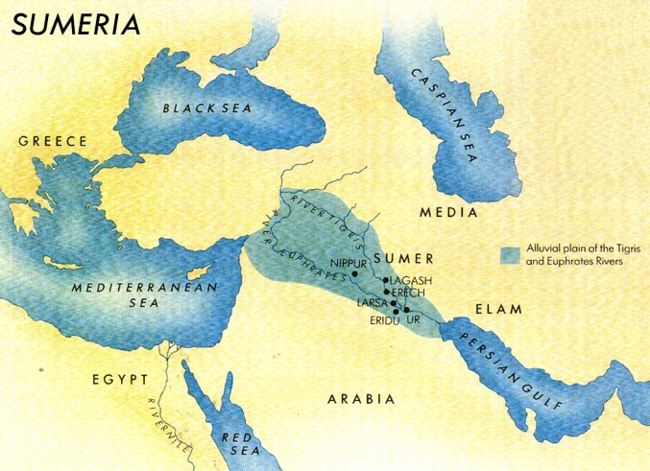
- Ancient Sumer was sited in the east of an area often referred to as ‘the fertile crescent’. The Fertile Crescent is where farming began, around 9000 BCE. Sumer was centred where the rivers Tigris and Euphrates meet, which falls mainly in modern Iraq. This area is part of a larger area which is often referred to as Mesopotamia, which means between the rivers. Small settlements had been in existence along the banks of the rivers for many centuries before the Sumerian civilization developed and other civilizations developed in this area after the Sumerian civilization had declined.
- Sumer was a conglomeration (linked group) of city states. Each city state had its own patron god or goddess, served by priests and a king who may also have had priestly duties. The king was assisted by advisors who included both men and women.
- Prosperity and agricultural surplus led to an increase in population. At its height the population of Sumer was between 800,000 and 1,500,000, the majority of whom lived in cities.
- Sumerian civilization was very long lived, lasting from c5300 BC to c1940 BC – from the late Neolithic to early Bronze Age periods.
- The Sumerians believed that their gods had given them Eridu as their first city.
- The Sumerians called themselves ‘the black headed people’ and their country either ‘the land’ or ‘the land of the black headed people.’
- The development of irrigation and of techniques such as ploughing and domestication of animals for food enabled surpluses of food to be produced and traded (more than people needed to feed themselves).
- The Sumerians were probably the first to invent the wheel which they used on carts and chariots. A number of different types of boats were also used for transport and trade.
- The Sumerians were the first to develop writing, first in the form of pictographs and later as a wedge-like script we call cuneiform. Some words of Sumerian origin are still in use today – the word alcohol for example. It is possible trade and the need to keep accounts may have led to the development of writing. Not everyone could read and write, those that did, like important people and scribes, had to attend school for many years to master the art.
- Mathematics also flourished. The Sumerians were the first to work out the formulas for the area of a triangle and the volume of a cube. Calculations such as these were useful in developing sophisticated architecture such as their stepped pyramids, ziggurats, and arches and domes, both of which have been found in Sumer.
- Astronomical observations led to the development of the calendar and the plotting of constellations. The constellations mapped by Sumerian astronomers form the basis of the Zodiac.
- The need for public works such as building projects, irrigation schemes and the upkeep of the priests, rulers and armies meant that it was necessary to collect taxes, develop legal codes and enforce justice.
- Skilled craftsmen produced a range of fine goods in gold, silver, copper and bronze. Slaves, captured from surrounding states, were used as labourers. Many goods had to be imported, including metal ores and wood as there were few trees due to the hot dry climate. Especially prized was the cedar wood of Lebanon and cedar oil was used to make paints for pot decoration.
- The Sumerians told stories about their gods and their early kings, who they thought had supernatural powers. The Epic of Gilgamesh is the first known work of literature. It is about an early Sumerian king who may or may not have been a real person. It includes an episode where the world is flooded and survivors used an ark – just like the story of Noah’s Ark!
- The Sumerians loved music and played lyres and a type of oboe. We know this because such instruments have been found in burial sites.
- Sumerians believed monsters guarded the gates to the world of the dead. They believed that the dead became ghosts (gidim).
- Although the Tigris and Euphrates rivers helped the Sumerian civilization start and grow, they might also have caused its decline. Flooding could destroy crops and wash goodness from the soil. The water from the rivers was rich with mineral salts. After many generations of flooding and using the water for irrigation, evaporation of the water from the fields led to the soil having too much salt in it. This meant that some crops would no longer grow well. Although the Sumerians tried to grow crops that were not affected by this such as barley, the earth could no longer grow enough to feed the population. People moved away to more fertile lands and the cities grew weak. Eventually Sumer was invaded by the Elamites and the civilization came to an end.

Shang Dynasty – Did you know?
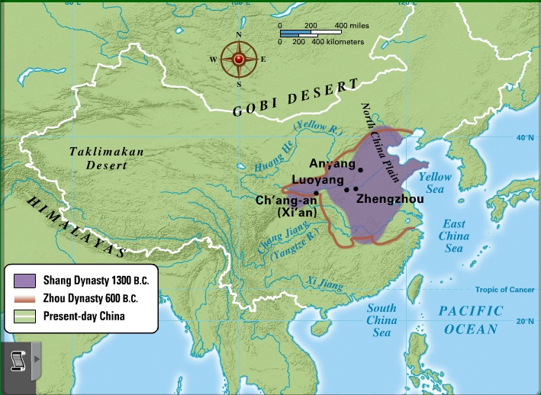
- The Shang Dynasty is the first historic dynasty of China. The river valley of the Yellow River provided a fertile area for this civilization to develop.
- That area of China had large forests so the Shang built homes and important buildings with wood. This means that very little evidence of their buildings has survived because most wood rots away completely over time.
- Shang cities were surrounded by defensive mud walls. The remains of these reveal the struggle to keep back the waters of the Yellow River during times of flooding.
- Most clues about the Shang come from royal and other tombs. Often these contain artefacts from which archaeologists and historians can interpret what life was like for Shang people. Items such as beautifully carved jade and stone, bronze ritual vessels and weapons and domestic items such as the earliest glazed porcelain and woven silk testify to the levels of craftsmanship and artistry they achieved.
- The Dynasty lasted for six hundred years and encompassed the reign of thirty emperors.
- The Shang dynasty is said to have come to power when Tang Shang defeated the evil King Jie of the Xia Dynasty, but historians believe that the Xia dynasty may be legendary rather than real.
- Tai Wu, the ninth Shang Emperor, reportedly ruled for 75 years.
- Lady Fu Hao was a Shang dynasty queen and military leader who died c1200 BC. She led an army of 10,000 men. Her intact tomb contained many artefacts and the remains of 16 slaves and six dogs who were sacrificed when she died.
- Emperor Zhou, the last Shang Emperor, was said to have been very cruel. He was overthrown by Wu who became founder of the Zhou dynasty.
- A Shang week lasted ten days.
- The Shang enjoyed music and played ocarinas, pipes, drums, chimes, cymbals and bells.
- Most of the written evidence we have about the Shang comes from oracle bones, although some bronze and pottery goods also have inscriptions.
- The Shang used wheeled carts for transport in times of peace and chariots for hunting and as a means of overseeing warfare. They also used canoes for local trade. Cowrie shells show they traded with coastal dwellers but they did not trade further afield. Roads enabled communication to be maintained between the city states.
- The Shang are important because they left a legacy of Chinese culture that proved durable and long lasting. The hereditary dynastic succession that they set in place endured for millennia. The role of the family and importance of ancestors remain central to Chinese culture today. Their artistry, with bronze in particular, continues to be admired for its beauty and grace.

