Create a story using the picture below as an inspiration.
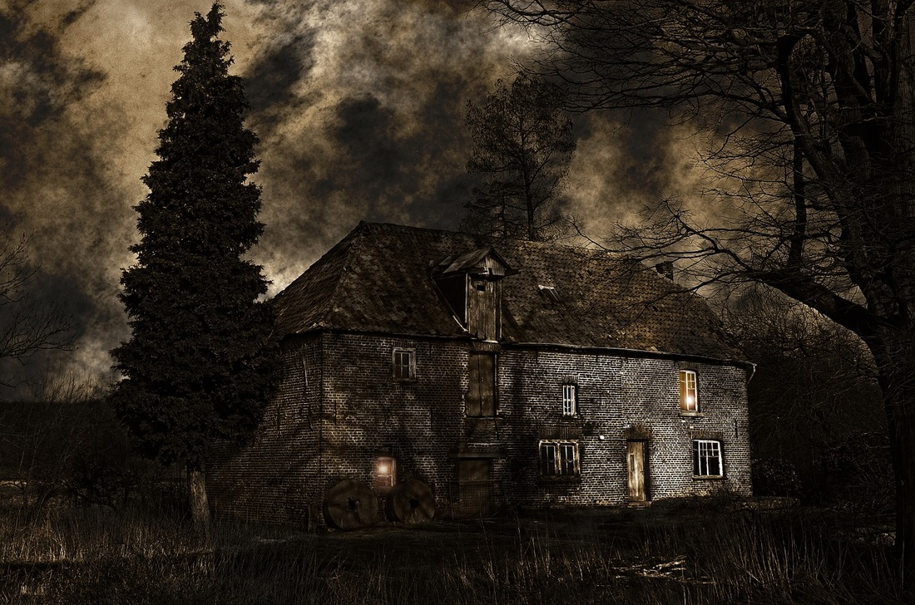
Remember to use paragraphs, capital letters and full stops.
Use five senses to describe what is around you. (Sights, sounds, smells, touch and taste.)
Include strange and wonderful creatures and characters to bring your story to life (dragons, aliens, mythical beasts.)
Try some ISPACED starters for interest and variety (below.)
Use FANBOYS conjunctions to create a variety of sentences (below.)
Use speech, if you like. Remember to punctuate it correctly.
“I can’t see,” whispered Lily.
“I’m frightened!” screamed Will.
Mum reminded them, “Be home by tea time.”



