5 a day! | Date:
- What is 5 ÷ 10?  0.5 | 2. What is 16 x 8?  128
3.  What double 89?  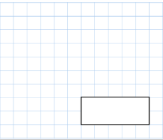  178 | 4. 3742+ 2397  6139
5. Write 4 numbers between 10 and 11

Write any decimal numbers E.G. 10.1, 10.5, 10.65, 10.8, 10.99 etc
5 a day! | Date:
- What is 7 ÷ 100?  0.07 | 2. What is 72 x 3?  216
3.  What is ¾ of 32?  32 ÷ 4 = 8 (this is ¼)  8x3=24 (this is ¾)  24 | 4. 4756+3245  8001
5. What is an obtuse angle?

An angle bigger than a right angle/bigger than 90 degrees but smaller than 180 degrees.

What is half of £11?  £5.50 | Write 4 fractions that are the same as 1/3.  2/6, 3/9, 4/12, 5/15, 6/18. There are many more if you follow this pattern.
A pack of oranges has 6 in it and a pack of apples has 8 in it. Mr Gibbs buys 7 packs of each. What is the total of oranges and apples?  7x6=42 oranges  7x8=56 apples  42+56=98 oranges and apples | What is 676-386=  290
Circle all of the acute angles

Mr Gibbs ate 4 packets of crisps every day in the month of April. How many packets did he eat?  4x30=120 packets of crisps | If Mr Gibbs grows 40cm, how many millimetres and meters is this?  400mm  0.4m
Arsenal beat Liverpool  3-0. They scored in the 12th, 45th and 79th minute. What is the total of these three numbers?  136 minutes in total | A sofa weighs 3kg. What is this in grams?  3000g
There are 48 smarties in a pack. Mr Gibbs eats ½ and then gives ¼ of the remaining smarties to Mrs Gill. How many are still left in the pack?

Mr Gibbs eats 24 (meaning there is 24 left)
¼ of 24= 6 (these go to Mrs Gill)
24-6=18 smarties left in the pack

5 a day! | Date:
- 75 ÷ 5  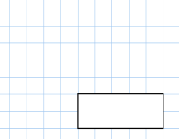  15 | 2. 60 × 8  480
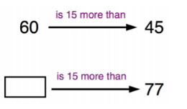  3.  65  50 | 4.  Mr Gibbs had 95 Christmas cards to post. He has posted 34 so far. How many Christmas cards does he have left to post?  61 cards
5. What is 8x6x5

240

5 a day! | Date:
- 45 X 5  225 | 2.Write your 9 times tables down  9, 18, 27, 36, 45, 54, 63, 72, 81, 90, 99, 108
3.  Describe what a right angle is.  An angle that is 90 degrees, a perfect L shape. | 4. Mr Gibbs eats 17 cakes on Monday, 19 on Tuesday and 4 on a Wednesday for 3 weeks. How many cakes did he eat all together?  120 cakes
5. Write the time down when you are on this question. Think about pm/am, past and to and also 24-hour time.

Self-mark- use clocks to help

5 a day! | Date:
- 52 + 89  141 | - 18 x 3  54
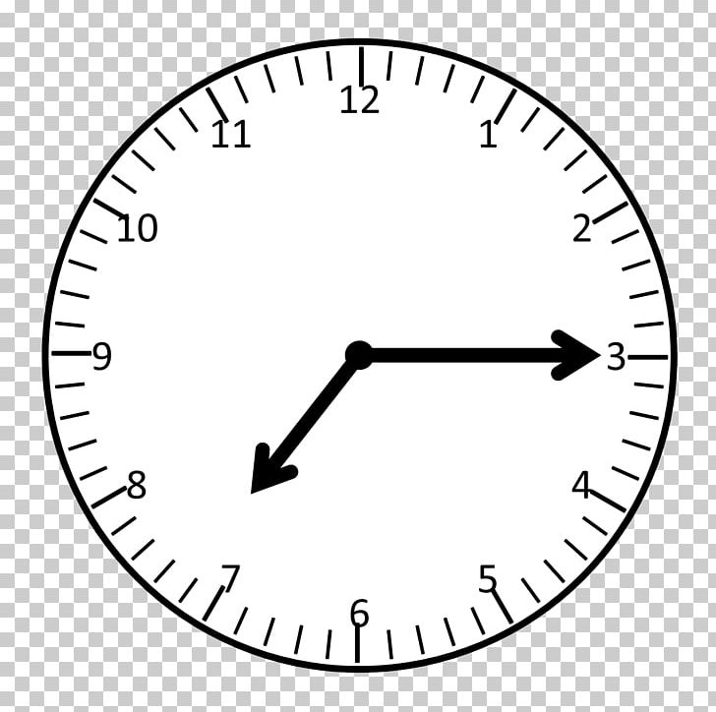 | - What time does this clock show?  7:15, quarter past 7, 19:15  What is the time 90 minutes before this time?  7:15-90mins= 5:45
- Round 832 to the nearest 10.

The nearest 10 is 30. Meaning the answer is 830.
- What number is after the arrow?  After the arrow is 9. | 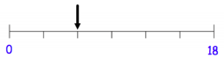

5 a day! | Date:
- If it is 9:10am now, what time will it be in 150 minutes?  11:40am | 2. What is half of 484?  242
3.  What is 43 x 8  344 | 4. 3381 –648  2733
5. Double 732
1464
5 a day! | Date:
1.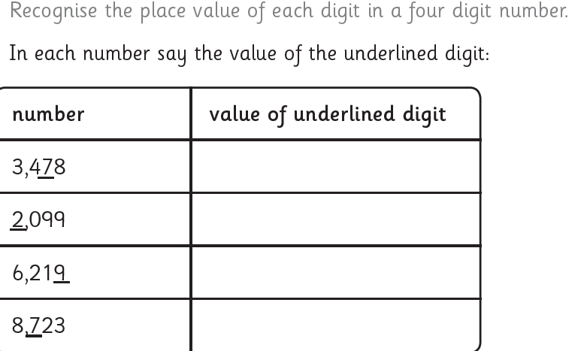  70  2000  9  700 | 2. What 65x10  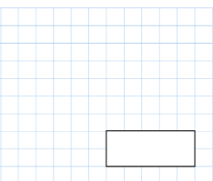  650
3. What time is it?  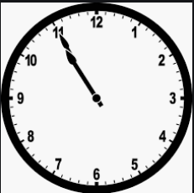  10:55, 5 to 11, 22:55 | 4. Double 95  190  _________
5. Half 7

3.5
5 a day! | Date:
- 134 x 9  1206 | - 2467 – 753  1714
3) Write down 4 quadrilaterals.  A quadrilateral is a 4 sided shape:  - Square  - Rectangle  - Kite  - Diamond/rhombus  - Trapezium  - Parallelagram | 4) Pens are ½ price.  They were £8.42. How much are they now?  £4.21
5) What is ½ as a decimal? 0.5

