5 a day! | Date:
- What is 5 ÷ 10? | 2. What is 16 x 8?
3.  What double 89?  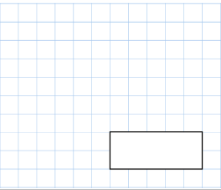 | 4. 3742+ 2397
 | 5. Write 4 numbers between 10 and 11
5 a day! | Date:
- What is 7 ÷ 100? | 2. What is 72 x 3?
3.  What is ¾ of 32? | 4. 4756+3245
 | 5. What is an obtuse angle?

What is half of £11? | Write 4 fractions that are the same as 1/3.
A pack of oranges has 6 in it and a pack of apples has 8 in it. Mr Gibbs buys 7 packs of each. What is the total of oranges and apples? | What is 676-386=
Circle all of the acute angles

Mr Gibbs ate 4 packets of crisps every day in the month of April. How many packets did he eat? | If Mr Gibbs grows 40cm, how many millimetres and meters is this?
Arsenal beat Liverpool  3-0. They scored in the 12th, 45th and 79th minute. What is the total of these three numbers? | A sofa weighs 3kg. What is this in grams?
There are 48 smarties in a pack. Mr Gibbs eats ½ and then gives ¼ of the remaining smarties to Mrs Gill. How many are still left in the pack?

5 a day! | Date:
- 75 ÷ 5  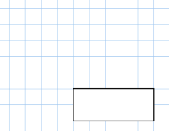 | 2. 60 × 8
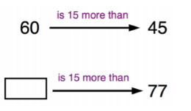  3.  50 | 4.  Mr Gibbs had 95 Christmas cards to post. He has posted 34 so far. How many Christmas cards does he have left to post?
5. What is 8x6x5

5 a day! | Date:
- 45 X 5 | 2.Write your 9 times tables down
3.  Describe what a right angle is. | 4. Mr Gibbs eats 17 cakes on Monday, 19 on Tuesday and 4 on a Wednesday for 3 weeks. How many cakes did he eat all together?
5. Write the time down when you are on this question. Think about pm/am, past and to and also 24-hour time.

5 a day! | Date:
- 52 + 89 | - 18 x 3
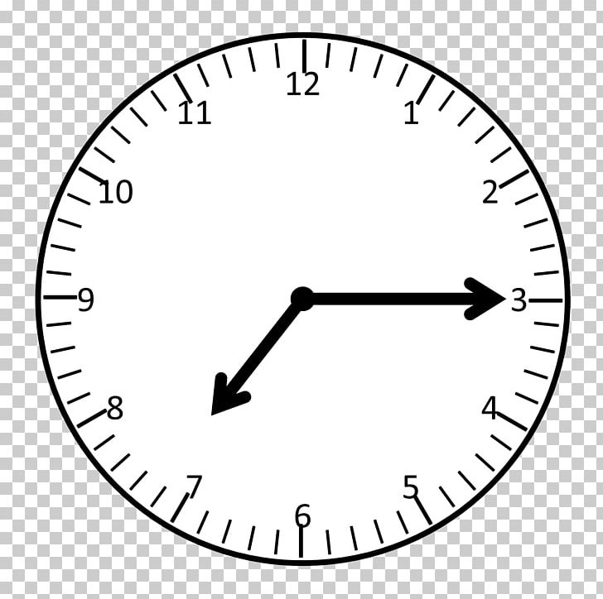 | - What time does this clock show?  What is the time 90 minutes before this time?
- Round 832 to the nearest 10.
- What number is after the arrow? | 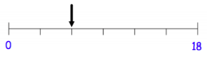

5 a day! | Date:
- If it is 9:10am now, what time will it be in 150 minutes? | 2. What is half of 484?
3.  What is 43 x 8 | 4. 3381 –648
 | 5. Double 732
5 a day! | Date:
1.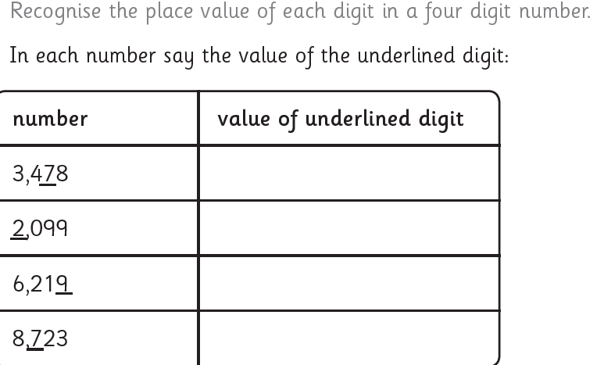 | 2. What 65x10  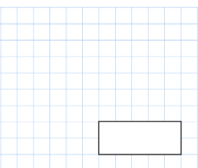
3. What time is it?  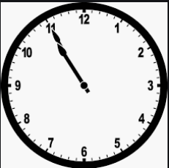  ______ | 4. Double 95  _________
5. Half 7

________
5 a day! | Date:
- 134 x 9 | - 2467 – 753
3) Write down 4 quadrilaterals. | 4) Pens are ½ price.  They were £8.42. How much are they now?
5) What is ½ as a decimal? __________

