5 a day! | Date:
- What is 40 ÷ 100?  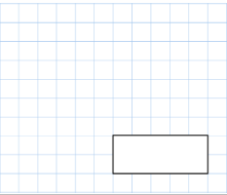  0.4 | 2. What is 28 x 9 ?  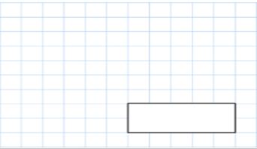  252
3.  What double 52?  104 | 4. 6384 + 3975  10359
5. Write 4 numbers between 0.1 and 0.5
0.2, 0.3, 0.4, 0.42
0.11 etc.
Accept any answers that are between these numbers

5 a day! | Date:
- What is 7 ÷ 100?  0.07 | 2. What is 742 x 4?  1568
3.  What is ¼ of 120?  30 | 4. 752 + 3842  4594
5. Write down 4 3D shapes
Cube, cuboid, sphere, triangular prism, square based pyramid, cylinder, cone etc.,

What is half of £66.94  £33.47 | What is 2/7 + 3/7?  5/7






Write down one piece of information about each shape.
Accept any facts about sides, corners, angles, parallel lines, names of shapes.
Red pencils come in packs of 4. Blue pens come in packs of 9.
If Jen buys 5 packs of red pencils and 6 packs of blue pens, how many pens and pencils does she have in total?
74 total pens.
What is 506 – 64?
442

How many days are in June, July and August?  92 days | - 4 bottles of water weigh 750g. How many KG is this?  3KG
If 7 busses come every hour for 10 hours a day, how many busses come in one day?  70 busses | Jimmy had 4.5kg or pasta in a week. How many grams is this?  4500g
A jet ski travels 50MPH for 150 minutes. How far does it travel? If you are feeling brave, try and work this out in KM remembering that 1mile is the same as 1.6km.
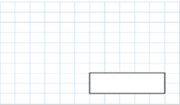
2 ½ hours = 125M
125M=200KPH

5 a day! | Date:
- 629 x 10  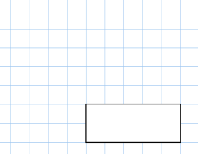  6290 | 2. 86 x 9  774
3.  78 is 11 less than 89  99 is 34 more than 65 | 4.  Lottie is making a beaded neckless. She will need 705 beads. She has 693 beads. How many more will she need?  12 more beads
5. What is 8 x 3 x 9?

216

Put these numbers in order from smallest to largest (ascending.)  2738 2784 2956 2740  - 2738  - 2740  - 2784  - 2956 | Round these numbers to the nearest 10.  43 93 6 56 39 73  43----40  93----90  6-----10  56----60  39-----40  73-----70
Write these words in numbers.  Fifty-eight  Nine hundred and four  one thousand seven hundred and ninety-two.  58  904  1792 | Write the time thant you are completing this question. Can you write it 2 different ways.  Self-mark the time.
Create and answer 4 number sentences using these numbers. E.G. 5+7+3=15
5 7 3 2
Accept any number sentences using any of the numbers E.G.
7x5=35, 7X2X5=70 etc

5 a day! | Date:
1. 579x4  2316 | 2. 92 divided by 2  46
3.  Complete the table: | 4.  Jess has 34 stickers. Jack has 323 more. How many stickers does Jack have?  Jack has 357 stickers
  Hour | Minute
  1 | 60
  2 | 120
  3 | 180
  4 | 240
  5 | 300
  6 | 360
  7 | 420
  8 | 480
  9 | 540
  10 | 600
  11 | 660
5. What is the
The difference means subtract…

405
Difference between
479 and 74?

