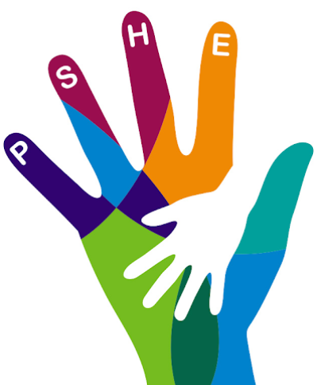
PSHE Activity 3
LT: To reflect on events and how you feel.

Look back at the things you were grateful for in the last session.

Task 1 – Make notes:
Now, imagine we could time travel back to the summer term of 2019, before we knew what Coronavirus was.

What might you say to your younger self?

Main task:

Imagine we could send a letter to our younger selves. Today’s task is to write that letter thinking about:

- What would we say to explain what is happening at the moment?

- What would you tell yourself to enjoy?

- Would you tell yourself not to worry?

Once you have written your letter, photograph or send it on Seesaw to your teacher.

If you are stuck with how to start, look at this example structure:

Dear me....
I hope you are well and enjoying ________.

Life here has taken an unexpected turn.......(explain coronavirus, what lockdown was like and what school is like now).

If I could go back to where you are I would want to....(which bits of your life do you miss?)

So, please appreciate ___________ while you can. (which things do you wish you had spent more time doing?)

