The Girl Who Went to Space
Tammy, though only a girl of seven
Filled her days dreaming of life in the heavens
She always wanted her own space rocket
She carried a planet map in her pocket
One day at school she was inspired to listen
As her teacher explained the solar system
Thinking intently her mind started to wander
She was off in her rocket and into the yonder
While travelling the stars in a curious way
She wanted to see what each planet would say
Sun
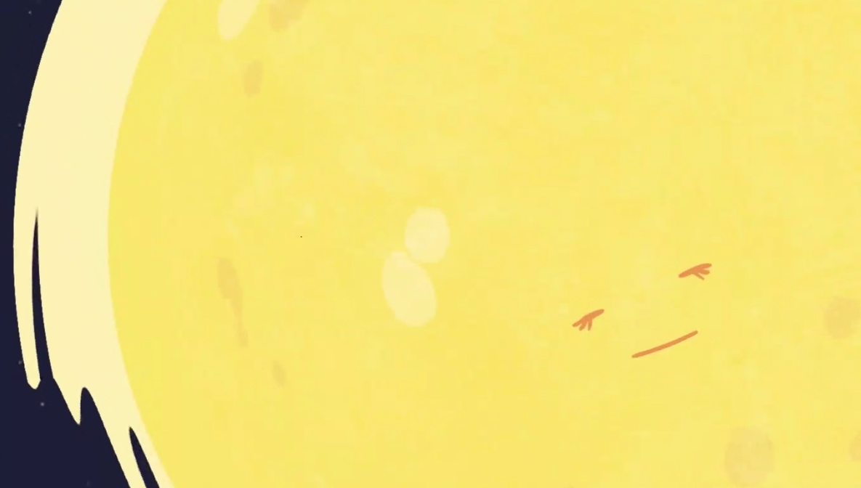
I give life, I give warmth and days by the sea
The planets you love they all orbit me
I am hotter than anything you have ever known
Nothing comes near me, I am all alone
One day I’ll explode: no ifs, buts or maybes
In the meantime, however, come meet my babies
Mercury
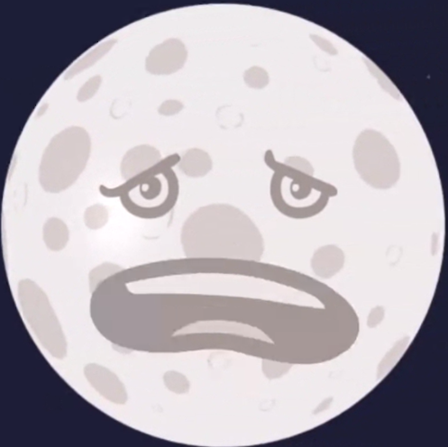
Well below freezing and blistering heat
I’m named after the Greek god with wings on his feet.
I’m smaller than Earth and coloured dark grey
One thousand hours in just one day
I have no protection and no atmosphere
You’d find it impossible to make a home here
Venus 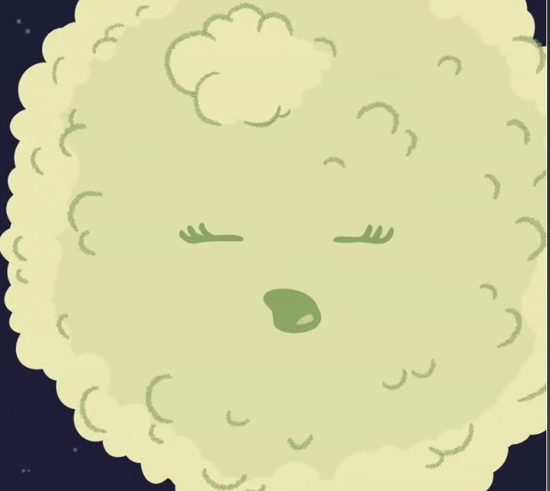
Don’t be fooled by my lovely name
If you’re after heat, you’ll be glad you came
I hide myself under a thick layer of gas
I slowly rotate due to my mass
My volcanoes may give you a nasty surprise
You can see me from Earth with just your eyes
Earth
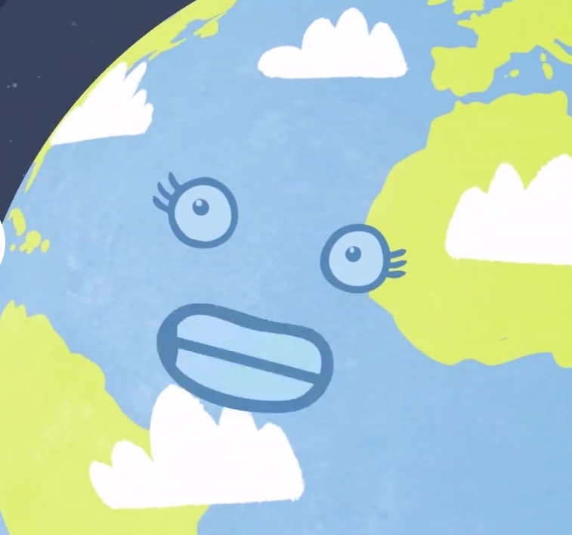
This beautiful planet of green, yellow and blue
I am home to me and home to you
My water and life are the only ones known
Protected from sun by a layer of ozone
You may wish for better but take my advice
No other planet would support your life

Mars
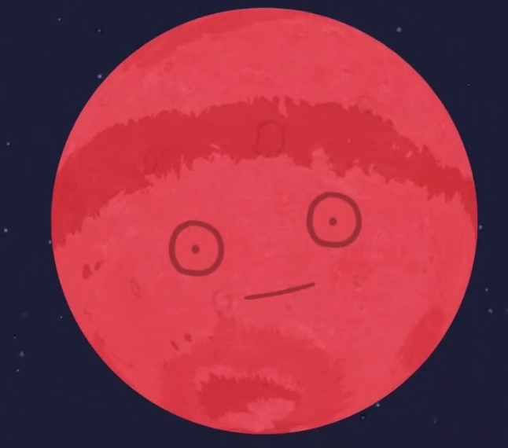
Most like your own planet with mountains and ice
During dust storms it isn’t so nice
My air is thin, my oxygen low
I may have had life, you just don’t know
In future in might want to call me your home
But you would only survive in a great big dome
Jupiter
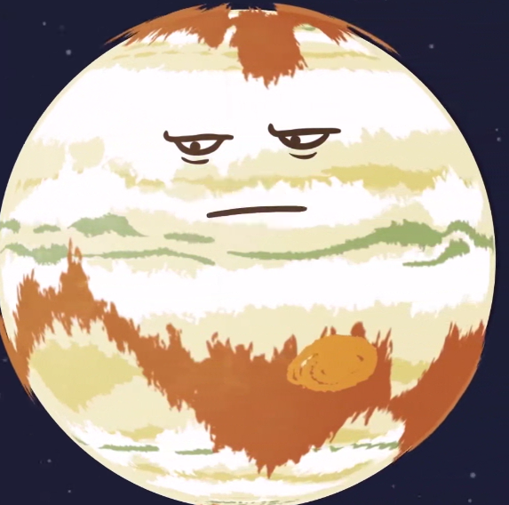
A huge mass of gases: yellow, brown, red and white
If you sniffed the air here, you would get a fright!
Passing through gas clouds while on your course
My centre has a strong magnetic force
My atmosphere would instantly crush you flat
No place to make a home, you can’t argue with that!
Saturn 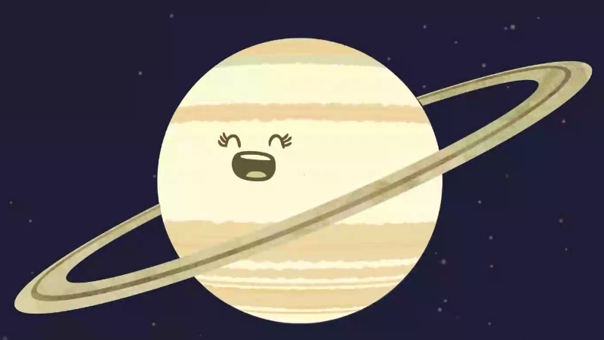
I’m a gas based planet, no surface area
With high speed winds I couldn’t be scarier
I give off a strange, crackling sound
My beautiful rings they dance around
The second largest planet but no home for you here
One of my moons might be a better idea
Uranus
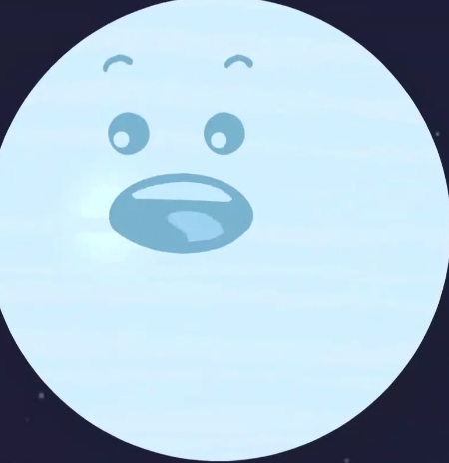
I’m a frozen gas ball of light blue-green
I have more moons than you’ve ever seen
I’m terribly cold, too cold for you
With no surface to speak of. what would you do?
My deadly gases make a terrible pong
You won’t want to hang around me for too long
Neptune
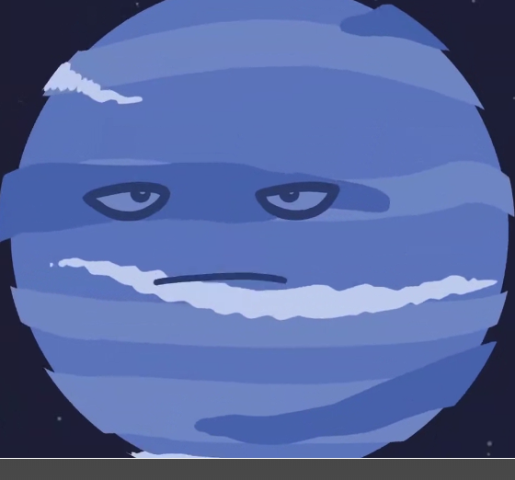
I’m a sphere of gases, coloured bright blue
Don’t try to land on me or you’ll fall right through
Dark and cold, a long way from the sun
Wild, swirling winds don’t make me much fun.
Freezing temperatures can’t sustain life here
I’ll drag you down with my crushing atmosphere
"Wake up, Tammy!" the girl gave a jump
And came back to her classroom with an almighty bump!
Sometimes things don’t appear as they seem
Perhaps it was just an intergalactic dream...?

