Earth, our wonderful world! But how much do you know about the planet we call home? Let’s find out with our fascinating facts about the Earth…
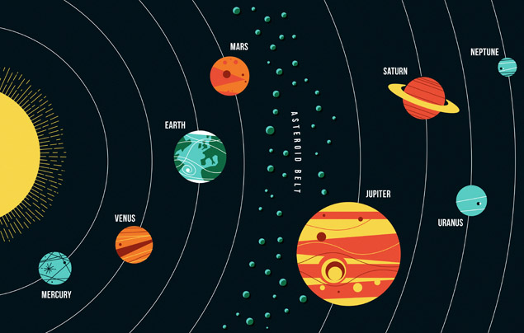
- 1) Earth is the third planet from the sun in our solar system. Its name comes from the old English and Germanic words meaning ‘the ground’.
- 2) Our amazing planet has been around for quite some time. By researching our planet’s rocks, scientists have calculated the Earth to be around 4.5 billion years old!
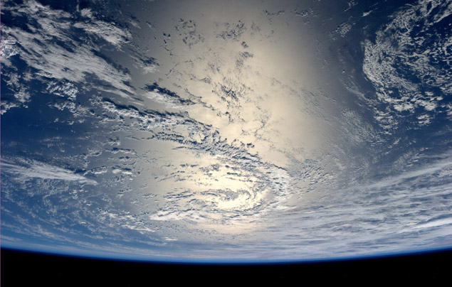
- 3) Like all the planets, Earth orbits (travels around) around the sun. And it does so at some serious speed –– around 30 kilometres per second, in fact! It takes 365 days (one year) for the Earth to complete one full orbit.
- 4) Have you ever wondered why we have different seasons? We’ll tell you –– it’s because the Earth is tilted 23.4 degrees on its ‘axis’, an imaginary line straight through the middle of the planet form the North Pole to the South Pole. This means that different parts of the globe are tilted towards the sun at different times of the year (or at different times during its orbit).
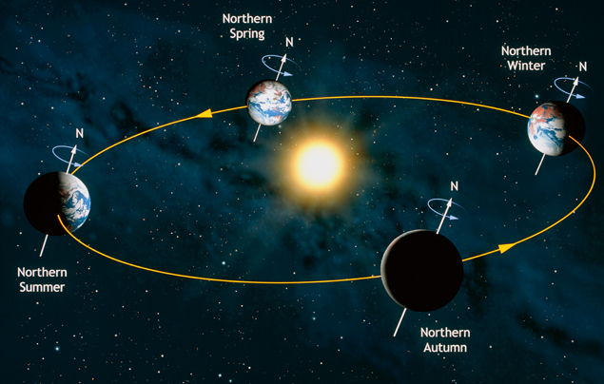
- 5) Not only does Earth zoom through space, it also spins on its axis. The result? We have daytime and night-time! As the planet rotates, the side facing the sun receives daylight and the other is in darkness.
- 6) People often think of Earth as a gigantic sphere. But, in fact, its shape is more like a squished ball that bulges out at the equator –– an imaginary line around the middle of the planet, exactly between the North Pole and the South Pole.
- 7) This ‘bulge’ is caused by the Earth’s spin and the effect of ‘gravity ‘. Gravity is an invisible force that attracts objects towards each other. It’s this force that pulls things towards the Earth and stops us floating off into space!
- 8) The Earth’s diameter (distance straight through the middle) measures a huge 12,800 kilometres, making it the fifth largest planet in the solar system. Jupiter, Saturn, Uranus and Neptune are even bigger!
- 9) Earth is the only planet in our solar system known to support life. This is because it has two very important things that living creatures need to survive –– lots of oxygen and lots of water! Its distance from the sun means it’s not too hot and not too cold for creatures to live on, too.
- 10) Earth’s ‘atmosphere’ is also hugely important for sustaining life. The atmosphere is a huge blanket of gases – mostly oxygen and nitrogen – wrapped around Earth, protecting our planet from the sun’s strong rays. At the same time, the atmosphere helps keep the Earth’s temperature comfortable for living beings – and it protects us from meteors, too!

