5 a day! | Date:
- What is 2 ÷ 10?  0.2 | 2. What is 34 x 7 ?  238
3.  What double 85?  170 | 4. 8233 + 9564
3.  What double 85?  170 | 5. Write 4 numbers between 1 and 2  1.01 TO 1.99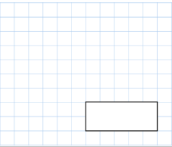
5 a day! | Date:
- What is 45 ÷ 100?  0.45 | 2. What is 72 x 6?  432
3.  What is 2/5 of 200?  80 | - 678 + 3392  4070
5. How many vertices
does a hexagon have?

6

What is half of £124.50?  £62.25 | Write 3 fractions that are the same as 2/3.  4/6 6/9 8/12 ETC




Tick all the quadrilaterals:
Red pencils come in packs of 6. Blue pens come in packs of 12.
If Jen buys 4 packs of red pencils and 7 packs of blue pens, how many pens and pencils does she have in total?

108
What is 507 – 89?

418

During July, 7 crows visited the garden each day. How many visits were there in total in July?  31 X 7 = 217 | There were 3 pieces of ribbon on the dress:  25cm  47cm  And 27 cm  - How many cm of ribbon were there altogether?  - Can you convert the total to m?  99 CM OR 9.99M
The carpark was half full.  It’s capacity, when full was 268 spaces. How many spaces were empty?  268 HALVED IS  134 | Rose bought 3.7 kg of potatoes. How many grams is this?  3.7 X 1000 = 3700G
180 people came to the tournament. 1/6 supported Rovers. 2/6 supported Liverwood and the remainder supported Tottasham. How many supporters did each team have?
Rovers | Liverwood | Tottersham
30 | 60 | 90
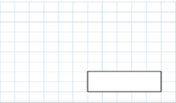
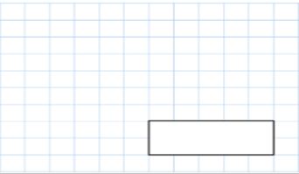

5 a day! | Date:
- 496.7 x 10  4967 | 2. 99 x 9  891
3.  123 is _34_ more than 89  99 is _291_ less than 390  835 is 450 more than 1285  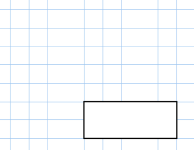 | 4.  Lottie is making a beaded neckless. She will need 1094 beads. She has 783 beads. How many more will she need?  311
5. What is 6 x 4 x 9?

216

Put these numbers in order from smallest to largest (ascending.)  2845 2864 2819 2809  2809 2819 2845 2864 | Round these numbers to the nearest 10.  12 45 1 0 67 91  10 50 0 0 70 90
Write these words in numerals (numbers.)  Seventy five  eighteen  One hundred and one  Seven thousand three hundred and nine  75 18 101 7309 | Write these numerals (numbers) in words:  23 287 5609  TWENTY THREE  TWO HUNDRED AND EIGHTY SEVEN  FIVE THOUSAND SIX HUNDRED AND NINE.
Multiply these numbers together:
10 3 10

300

5 a day! | Date:
- 235.5 x 10=  2355 | 2. 34 x 7=238
3.  Complete the table:  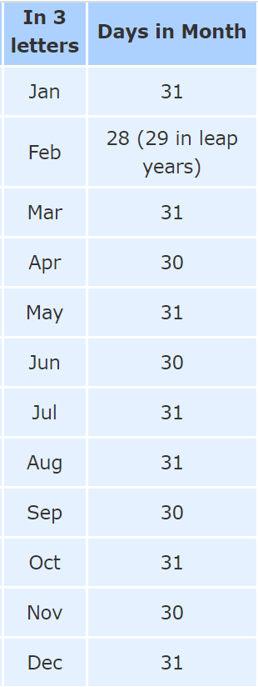 | 4.  Jess has 117 stickers. Jack has 123 more. How many stickers does Jack have?  240
5. What is the
Difference between
3479 and 709? 2770

