'National Flags'
During an Olympic Games many national flags are on display.
a)
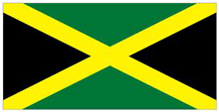
b)
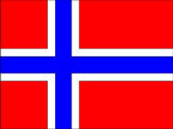
c)
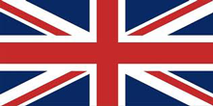
d)
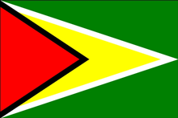

e)
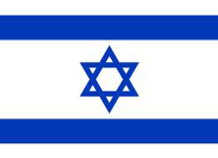
f)
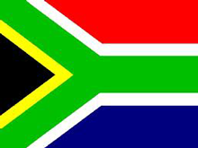

Pick a flag and investigate some of the following:-
What shapes can you see in it?
Does the flag have any horizontal lines in it, if so how many lines?
Can you find any vertical lines? How many?
How many right angles does your flag have?
Now try with another flag.

