- 8065 + 801 = 8866  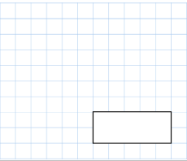 | - 8959 – 6001 = 2958  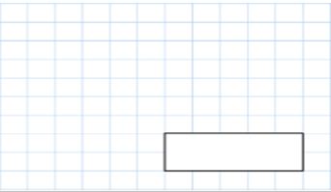
3.  6 x 9 x 3 = 162 | 4. 39 x 8 = 312
5. 88 divided by 11

= 8
- What is double 77?  154 | - 3/7 + 2/7 =  5/7
- In a shop, 3 apples cost the same as 2 bananas One banana costs 57p How much does one apple cost?  57+57 = 114  114 DIVIDED BY 3 = 38P  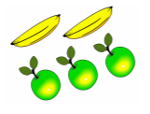 | - 1/ 4 + 1 /4 + 1/ 4 =  3/4
 | 5. 123 x 4= 492
- A sweet costs 7p. How many sweets can be bought for £1.12?  16 SWEETS | 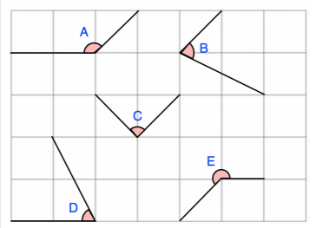  - Tick the angles that are obtuse? A IS OBTUSE.
3.  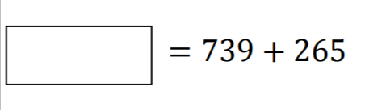  1004 | 4.  The perimeter of the rectangle is 30cm. Work out the length of the rectangle.  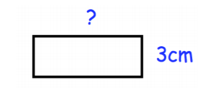  30-3-3 = 24  24 DIVIDED BY 2 = 12CM
5. 12 x12 = 144

Circle the number that is 10 times greater than eight hundred and forty.  8,040 84 8,004 8,400 840 | - A group of friends earn £60 by selling lemonade. They share the money equally They get £12 each. How many friends are in the group? 5
3.

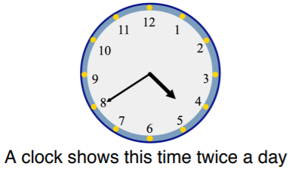

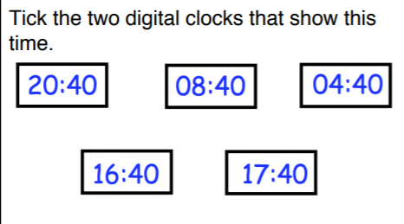

04:40
16:40
 | 4.3/5 - 1/5 = 2/5
- 5 × 6 × 9 × 2 =
540

- Write two thousand, two hundred and six in numerals:  2206 | - What is 95 x 7?  665
3. How much money in total?
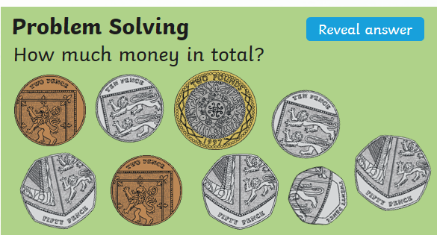
£3.94

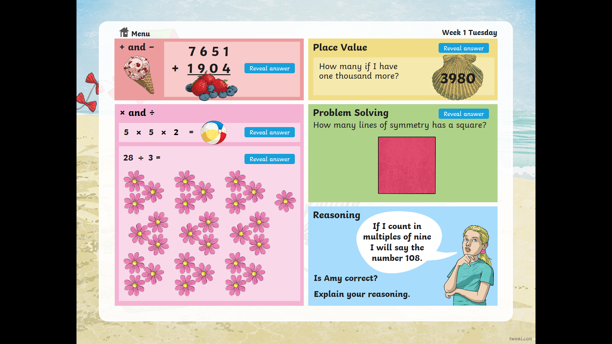
6
- 501.4 x 10 =
5014

