- 8065 + 801  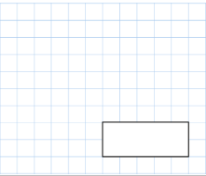 | - 8959 - 6001  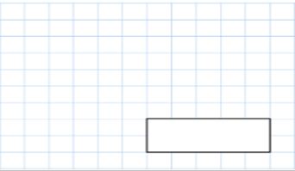
3.  6 x 9 x 3 | 4. 39 x 8
 | 5. 88 divided by 11
- What is double 77? | - 3/7 + 2/7 =
3. In a shop, 3 apples cost the same as 2 bananas One banana costs 57p How much does one apple cost?  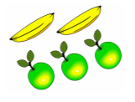 | 4. 1/ 4 + 1 /4 + 1/ 4
 | 5. 123 x 4
- A sweet costs 7p. How many sweets can be bought for £1.12? | 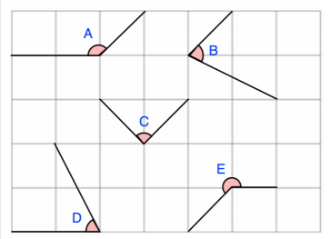  - Tick the angles that are obtuse?
3.  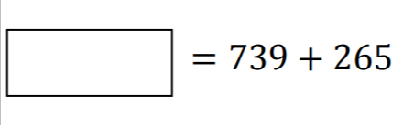 | 4.  The perimeter of the rectangle is 30cm. Work out the length of the rectangle.  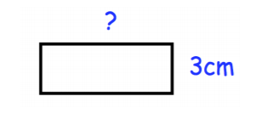
5. 12 x12 =

Circle the number that is 10 times greater than eight hundred and forty.  8,040 84 8,004 8,400 840 | - A group of friends earn £60 by selling lemonade. They share the money equally They get £12 each. How many friends are in the group?
3.

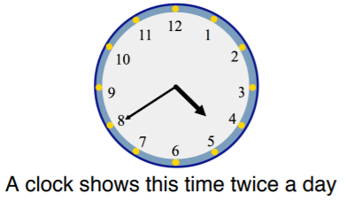

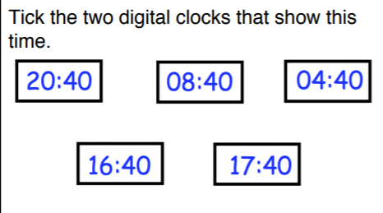
 | 4.3/5 - 1/5
 | 5. 5 × 6 × 9 × 2
- Write two thousand, two hundred and six in numerals:  ________________ | - What is 95 x 7?
3. How much money in total?
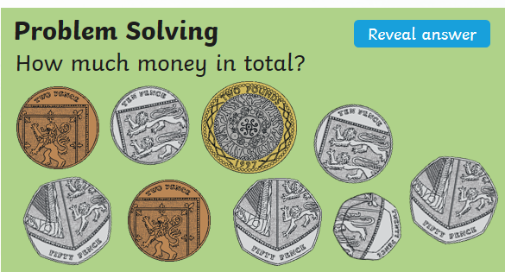
4.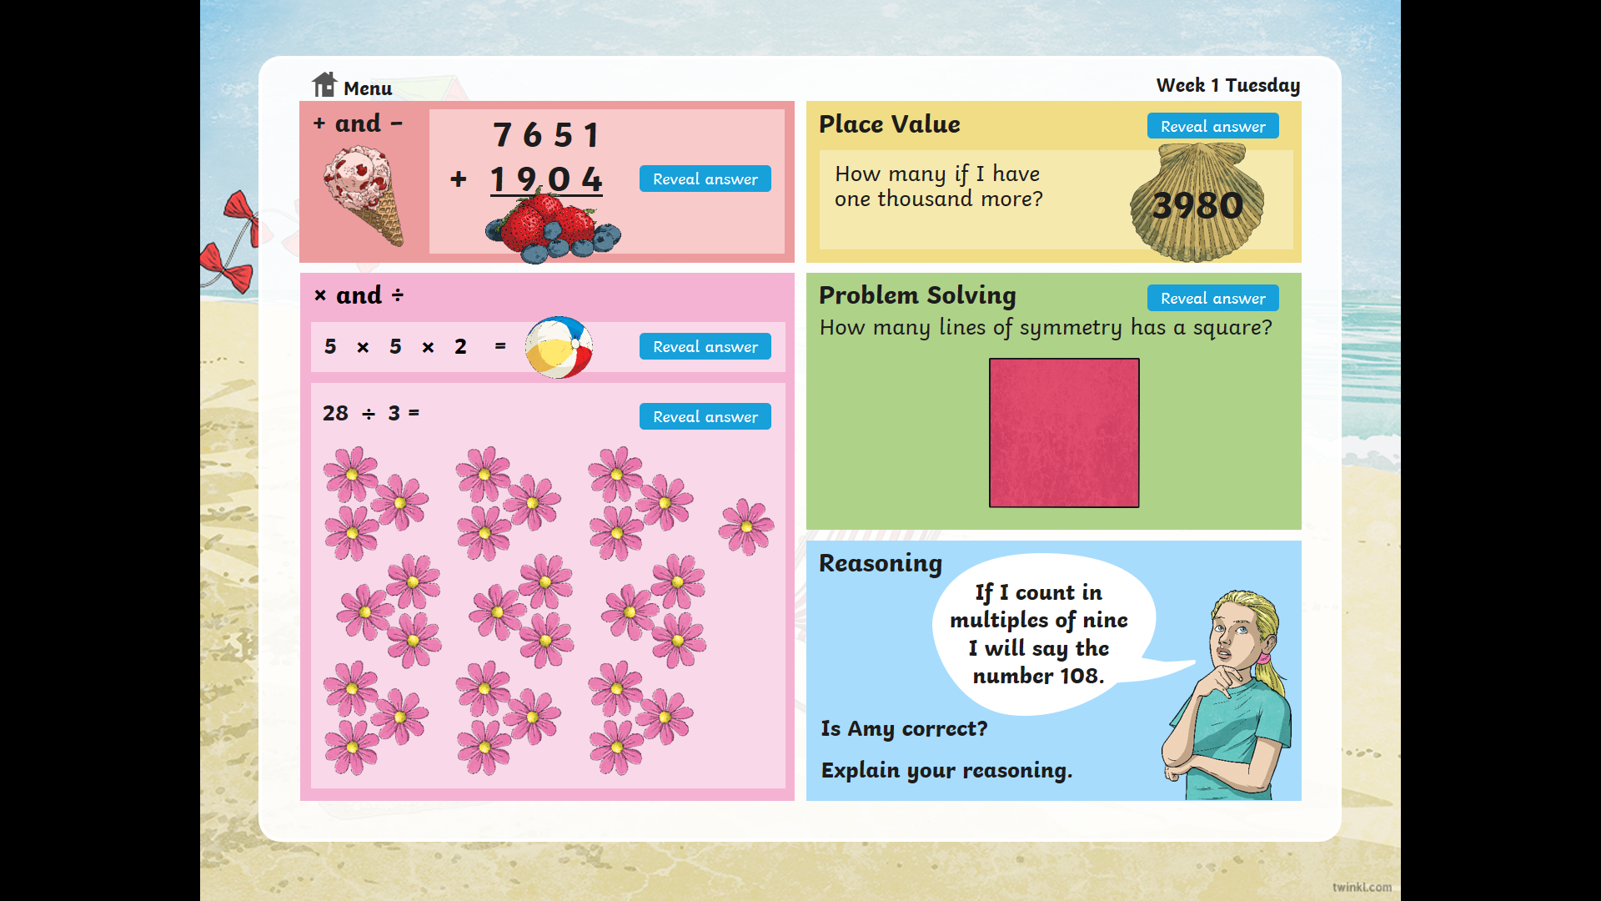
5. 501.4 x 10

