1. Five A Day English Date:____________________
1.
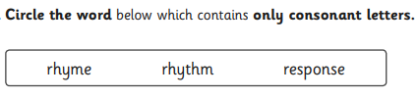

2. 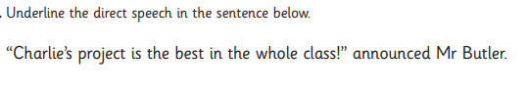
3.
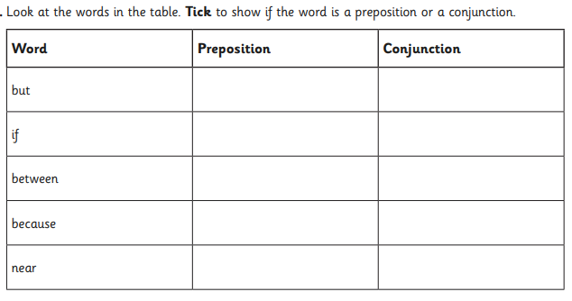
4.
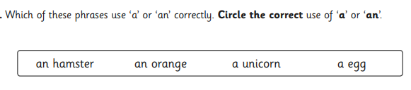

5.
A paragraph is Accept any answers that include a section of writing that normally discussed one theme.

________________________________________________________________
Five a day English Date:__________________
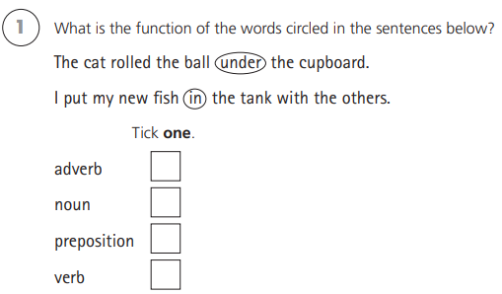
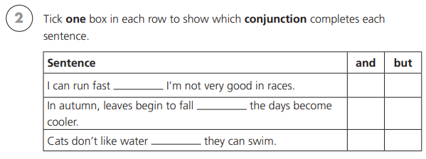
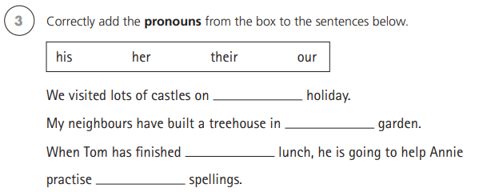
her
his
their
our
4)
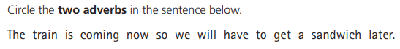
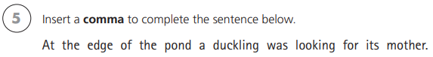

Five a day English Date:__________________
- Underline the fronted adverbial in the sentence below.
During the ferocious storm, the weathervane spun wildly.
(research what a weathervain is if you’re not sure.
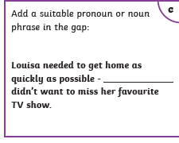
She, Louisa
- Mr Whoops has accidentally jumbled up a pair of homophone words. Can you unjumple them and then put them into a sentence. (hint, they begin with p.)

ceepi aecpe

piece- Sentence about a piece of something
peace- Anything about peaceful
4) Add the punctuation to the sentence below.

“Put that down now shouted,” Mr Gibbs

5. What is a noun?

A place, person or thing (object)

Five a day English Date:__________________
- Can you think of the sub – prefix words to match the definition?

An underwater vessel submarine
An organisational feature that is used in
non-fiction writing. Subheading
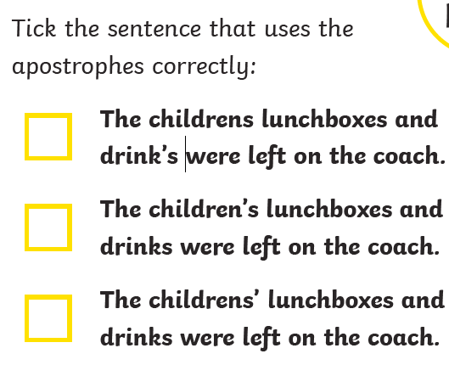
- Create 2 sentences that use the word ‘there’ and ‘their’.

There – sentence about something over there, where it is
Their- sentence about it belonging to them

- What is a verb?
Doing word or action

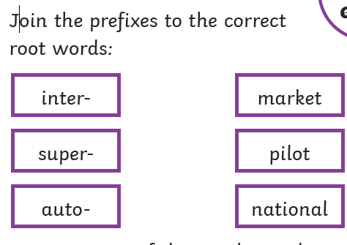

Five a day English Date:__________________
- Add a fronted adverbial to the sentence below.
Quickly, speedily, fastly etc , he turned on his heels and ran.
- Re-write the sentence below using the correct punctuation.

Mr Gibbs decided to go the park to practise his football skills

_____________________________________________________
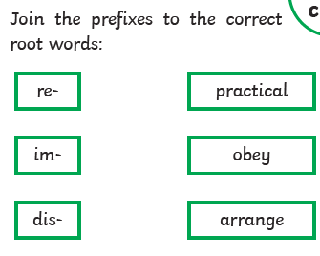
4) Add the determinor ‘a’ or ‘an’ before each word.

a banana a kite an elephant an hour

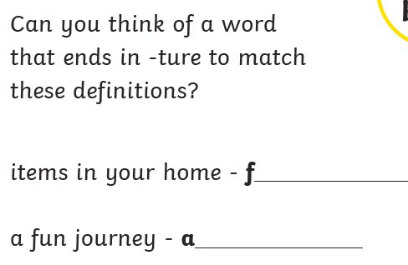
5.
adventure
furniture

