1. Five A Day English Date:____________________
1.
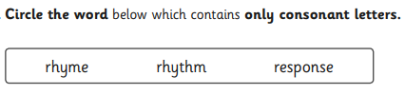

2. 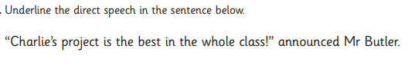
3.
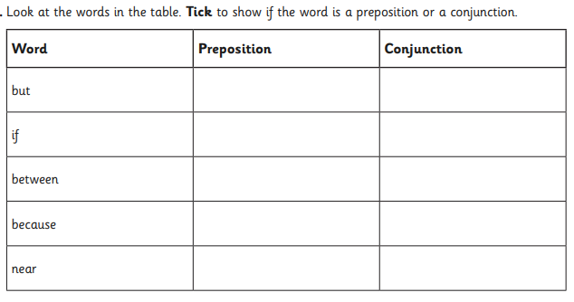
4.
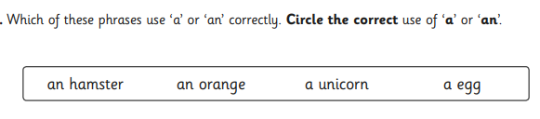

5.
A paragraph is ________________________________________________________________

________________________________________________________________
Five a day English Date:__________________
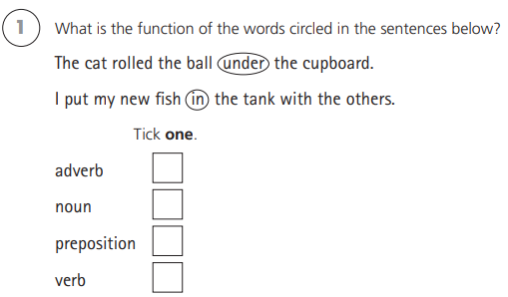
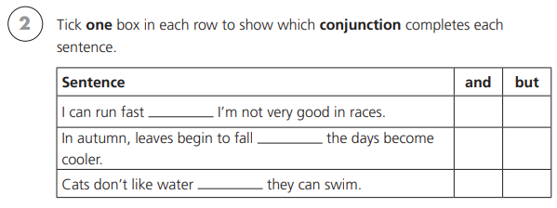
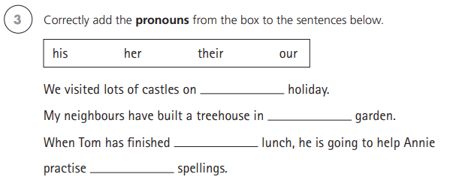
4)
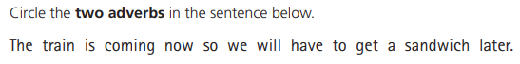
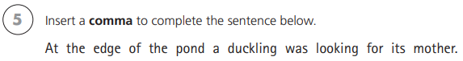

Five a day English Date:__________________
- Underline the fronted adverbial in the sentence below.
During the ferocious storm, the weathervane spun wildly.
(research what a weathervain is if you’re not sure.
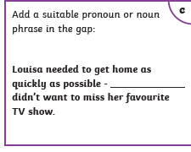
- Mr Whoops has accidentally jumbled up a pair of homophone words. Can you unjumple them and then put them into a sentence. (hint, they begin with p.)

ceepi aecpe

______________________________________________________

______________________________________________________

4) Add the punctuation to the sentence below.

Put that down now shouted Mr Gibbs

5. What is a noun?

Five a day English Date:__________________
- Can you think of the sub – prefix words to match the definition?

An underwater vessel sub________________
An organisational feature that is used in
non-fiction writing. Sub___________________
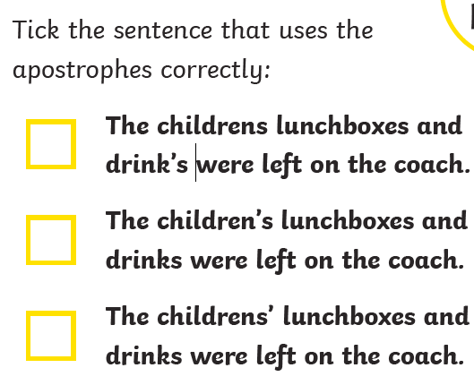
- Create 2 sentences that use the word ‘there’ and ‘their’.

_____________________________________________________

_____________________________________________________

- What is a verb?

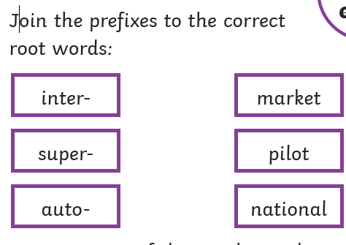

Five a day English Date:__________________
- Add a fronted adverbial to the sentence below.
_________________, he turned on his heels and ran.
- Re-write the sentence below using the correct punctuation.

mr gibbs desided to go the park to practice his fotball skills

_____________________________________________________
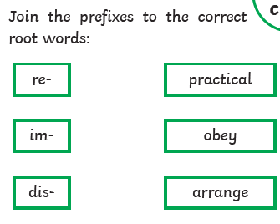
4) Add the determinor ‘a’ or ‘an’ before each word.

_____ banana ______ kite _____ elephant ----- hour

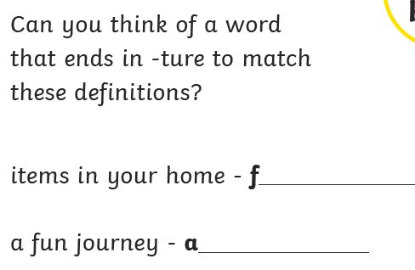
5.

