1.  What is the value of the underlined digit in each number?  6809 nine ones  23 two tens  479 seven tens  100 zero ones | 2. What is 3/5 of 75?  45
3. What time is it?  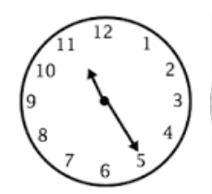  10:55 | 4. Double 69  138
5. Half 99?

49.5

1.What is half of £9?  £4.50 | 2.Write 4 fractions that are the same as a quarter.  2/8 4/16 3/12 5/20  6/24 7/28 etc
3.A box of cabbages has 16 cabbages in it. Each cabbage weighs 1.5 kg.  What is the total weight of all the cabbages in the box?  24kg | 4.What is 9005 – 877?  8128
5.Circle the right angle:
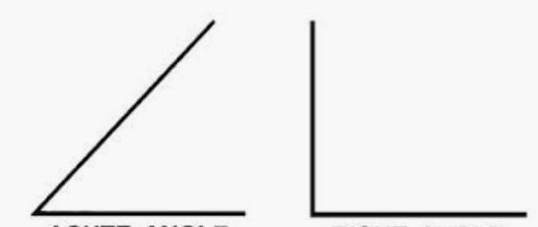

- 790 + 992  1782 | - 29 x 8  232
3. What is the time on this clock?
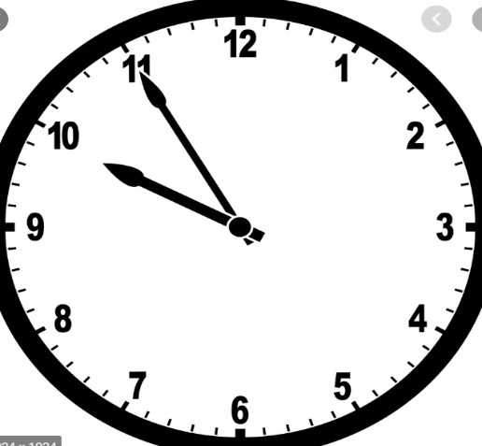
_ 9:55

- Round 3541 to the nearest 10.

3540
________
- What number is the arrow pointing to?
10.5

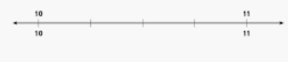
Trevor runs a half marathon. He started at 09:25 He ran for 135 minutes What time did he finish?  11:40 | 2. 190 + 10 = 230 − 30
3.  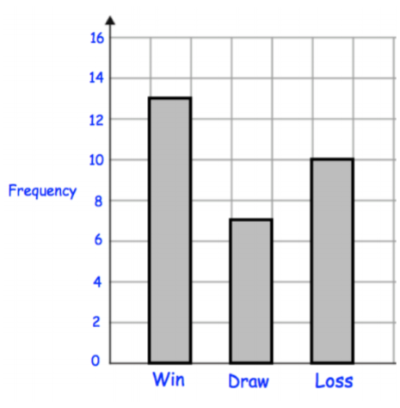  How many matches did the football team win?  13 | 4.  123 x 9  1107
- If three packs of cookies cost £6.30,
How much is the cost of one packet?

£2.10

1.  Write a number with:  3 ones  4 tens  No hundreds  and 5 thousands.  5043 | 2. 9455 + 1999  11454
3. What time is it?  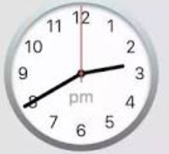  2:40  ______ | 4. Double 127  254  _________
5. Half 86.

43

