1.  What is the value of the underlined digit in each number?  6809  23  479  100 | 2. What is 3/5 of 75?  
3. What time is it?  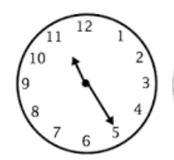  ______ | 4. Double 69  _________
5. Half 99?

________

1.What is half of £9? | 2.Write 4 fractions that are the same as a quarter.
3.A box of cabbages has 16 cabbages in it. Each cabbage weighs 1.5 kg.  What is the total weight of all the cabbages in the box? | 4.What is 9005 – 877?
5.Circle the right angle:
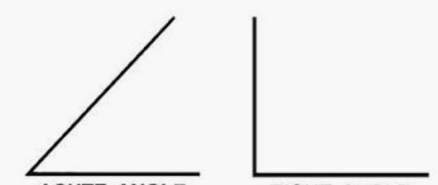

  - 790 + 992 | - 29 x 8
3. What is the time on this clock?
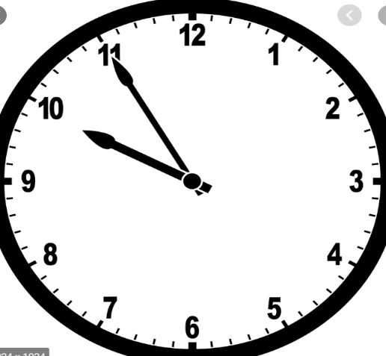
________________

- Round 3541 to the nearest 10.
________
- What number is the arrow pointing to?
__________

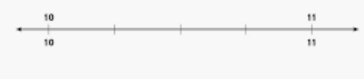
Trevor runs a half marathon. He started at 09:25 He ran for 135 minutes What time did he finish?  ___________________ | 2. + 10 = 230 − 30
3.  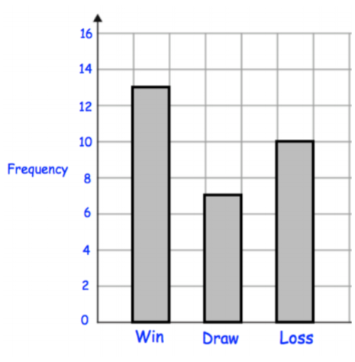  How many matches did the football team win?  A win is worth 3 points. A draw is worth 1 point. How many points did the team get in total? | 4.  123 x 9
- If three packs of cookies cost £6.30,
How much is the cost of one packet?

1.  Write a number with:  3 ones  4 tens  No hundreds  and 5 thousands.  ______________________ | 2. 9455 + 1999
3. What time is it?  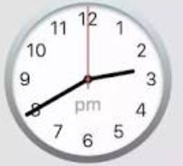  ______ | 4. Double 127  _________
5. Half 86.

________

