1.  What is the value of the underlined digit in each number?  6804 - 800  2375 - 2000  4790 - 700  10890 - 90 | 2. What is 2/3 of 42?  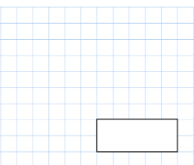  42 divided by 3 = 14  14 x 2 = 28  The answer is 28
3. What time is it right now? Try and write it in 2 different ways using analouge and digital.  Ask your parents to mark it or check a clock | 4. Double 89  178
5. Half 51?

25.5

1.What is the sum of all the coins added up together?  1p+2p+5p+10p+20p+  50p+£1+£2=£3.88 | 2.what is 3/8 + 2/8  5/8
3.If one bottle holds 750ml, how many ml are in 4 bottles?  3000ml or 3L | 4.What is 724 – 317?  407
5.Draw an octagon

Accept any shape with 8 straight sides.

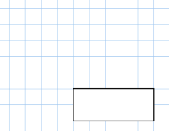  - 790 + 1276  2066  2066 | - 34 x 8  272
3. If I have 2 sets of parallel lines and 4 right angles what shapes could I be?

Square and rectangle

- Round 16863 to the nearest 1000.
17000

- Write down 5 numbers between 3.1 and 3.2.
3.11, 3.12, 3.13, 3.15, 3.16, 3.18 3.19, 3.1374, 3.186
Accept any answer between 3.1 and 3.2

If a train departs at 12:50 and is running 23 minutes late, what time does it arrive at the station?  1:13, 13 past 1, 13:13, 01:13 | - 7 x 6 = 2 x 23
3.  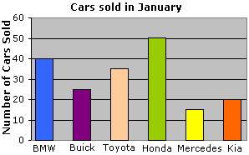  How many cars did Toyota sell? Accept 34, 35, 36  What is the total of Kia, Honda and BMW? 110  Create a question for your parents. | 4.  43 x 5=  215
What is the closest whole number to 4.78?
5

1.  What number has 4 ones, 7 tens and 18 hundreds?  1874 | 2. 7354 + 1748  9102
3. What time is it?  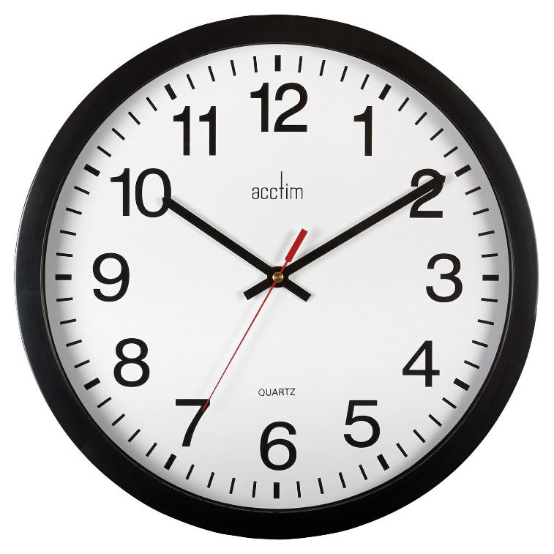  10:10, 10 past 10, 22:10, 10.10am | 4. 87 + 73 + 27=  187  _________
5. My number is even, between 70 and 80 and in the 9 times table. What is it? Create one for your teacher and email it to them!
72

