1.  What is the value of the underlined digit in each number?  6804  2375  4790  10890 | 2. What is 2/3 of 42?  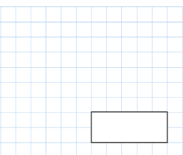
3. What time is it right now? Try and write it in 2 different ways using analouge and digital.  ______ | 4. Double 89  _________
5. Half 51?

________

1.What is the sum of all the coins added up together? | 2.what is 3/8 + 2/8
3.If one bottle holds 750ml, how many ml are in 4 bottles? | 4.What is 724 – 317?
5.Draw an octagon

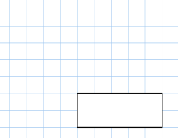  - 790 + 1276 | - 34 x 8
3. If I have 2 sets of parallel lines and 4 right angles what shapes could I be?

________________

- Round 16863 to the nearest 1000.
________

- Write down 5 numbers between 3.1 and 3.2.

If a train departs at 12:50 and is running 23 minutes late, what time does it arrive at the station?  ___________________ | - 7 x 6 = 2 x ____
3.  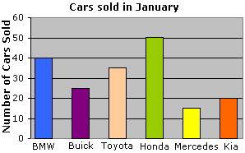  How many cars did Toyota sell?  What is the total of Kia, Honda and BMW?  Create a question for your parents. | 4.  43 x 5=
 | What is the closest whole number to 4.78?

1.  What number has 4 ones, 7 tens and 18 hundreds?  ______________________ | 2. 7354 + 1748
3. What time is it?  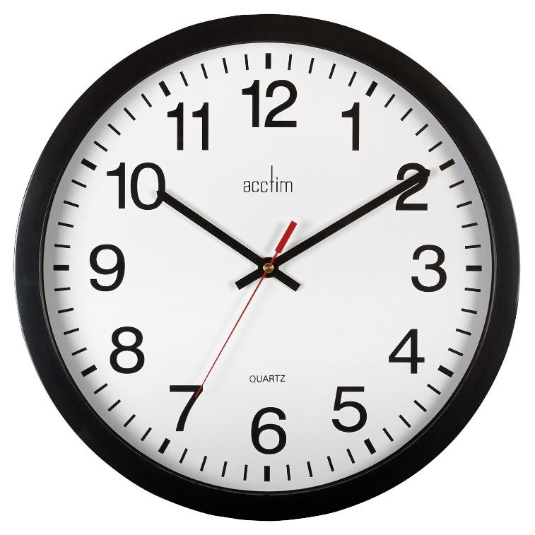  ______ | 4. 87 + 73 + 27=  _________
5. My number is even, between 70 and 80 and in the 9 times table. What is it? Create one for your teacher and email it to them!
________

