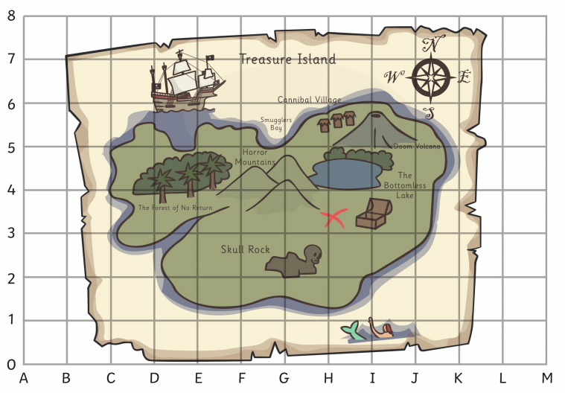
Treasure Map Questions
- What can you see on F2? ___________________
- Where can you see the mermaid? ____
- What will you find at D4?
- Where does X mark the spot?
- What is East of the Horror Mountains?
- What is north of Skull Rock?
- What is south of the Doom Volcano?
- Which direction is the treasure if you are in the Cannibal Village?

