5 a day! | Date:
- What is 550 ÷ 11?  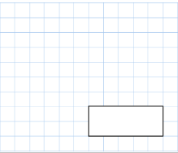  50 | 2. What is 72 x 7 ?  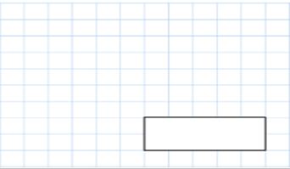  504
3.  What double 169?  338 | 4. 7658 + 7854  15512
5. Write 5 numbers between 99 and 100
99.1, 99.2, 99.3, 99.7, 99.8, 99.9, 99.67, 99.51 etc
5 a day! | Date:
- What is 99 ÷ 100?  0.99 | 2. What is 64 x 8?  512
3.  What is ¼ of 88?  22 | 4. 853 + 3632  4485
5. What is a quadrilateral? (hint-square)

A 4 sided shape

What is half of £118.50  59.25 | Write 3 fractions that are the same as 1/8.  2/16, 3/24, 4/32, 5/40 etc…

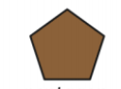
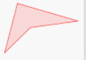



Tick all the acute angles:
Red pencils come in packs of 4. Blue pens come in packs of 11.
If Jen buys 4 packs of red pencils and 7 packs of blue pens, how many pens and pencils does she have in total?
93 pens
What is 608-59?
549

The year 4 teachers ate 3 packets of crisps between them ever day during October. How many packets of crisps did they eat?  93 | There were 3 pieces of ribbon on the dress:  49mm  70mm  4cm  - How many cm of ribbon were there altogether?  - How many mm would be left over from 200mm of ribbon?  - 15.9cm  - 41mm left over
The carpark was a quarter full.  It’s capacity, when full was 300 spaces. How many spaces were empty?  225 left | Rose bought 89 kg of potatoes. How many grams is this?  89000
Create a bar chart using this data:
17 people liked salt and vinegar crisps
29 people liked ready salted crisps
6 people liked cheese and onion crisps
38 people liked prawn cocktail crisps

Create a bar chart with a title, label the X and Y axis and bars. Send a picture of your bar chart to your teacher to check and write some questions for them!

5 a day! | Date:
- 497 x 10  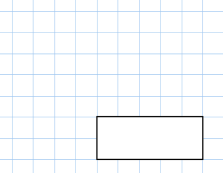  4970 | 2. 56 x 9  491
3.  123 is 48 more than 75  99 is 246 less than 345  835 is 86 more than 749 | 4.  Lottie is making a beaded neckless. She will need 753 beads. She has 456 beads. How many more will she need?  297 more beads
5. What is 9x3x6=

162

