

Developing resilience through a growth mindset.

‘Success is your ability to go from failure to failure, without losing your enthusiasm.’

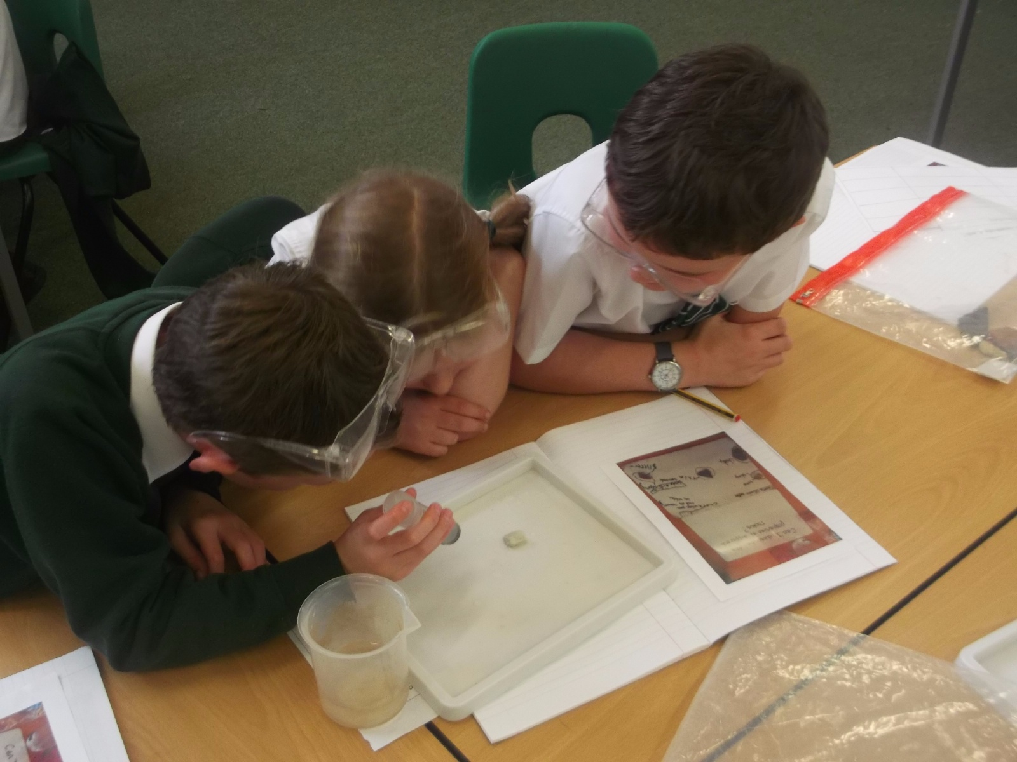

At St Mary’s we want our children to become happy, healthy and well-adjusted people who find success and happiness in whatever they do.

A fixed mindset leads children to see effort as a sign of inability and to feel badly about themselves when they need to expend effort. As a result, they avoid it. People with a growth mindset see effort as what makes them clever and capable so they seek it.

Part of a growth mindset is the ability to demonstrate resilience – the capacity to recover quickly from difficulties.

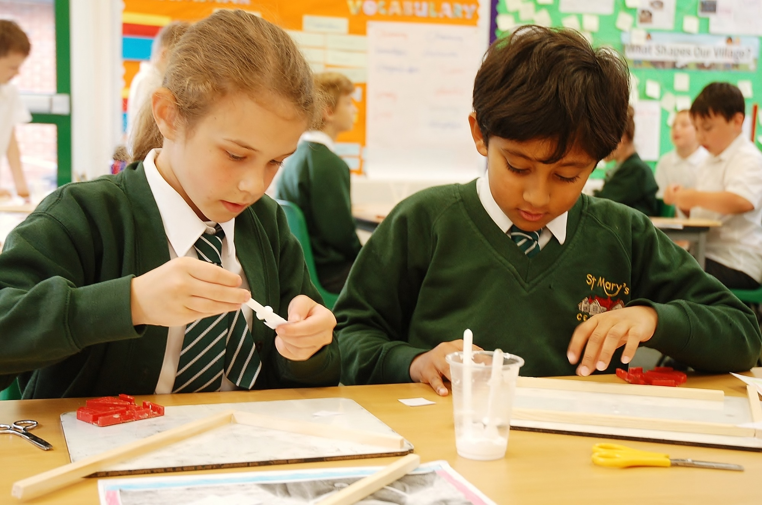
Resilience is made up of:
Absorption
Being able to lose yourself in your learning.
Managing distractions
Being able to recognise and reduce distractions.
Create your own best environment for learning.
Knowing when to walk away and refresh yourself.
Noticing
Looking for details, noticing everything. Really sensing what’s out there.
Perseverance (Stickability)
Keeping going even when the task is very demanding or when mistakes are made.
Knowing what a slow and uncertain process learning is.

How you can demonstrate resilience to your child:
- Demonstrate / model sticking at things even when it is difficult.
- Talk about how you feel when you take on challenges.
- Acknowledge when you have persevered and model when it is time to take a break!
- Talk to your child about what helps you to concentrate and manage distractions.

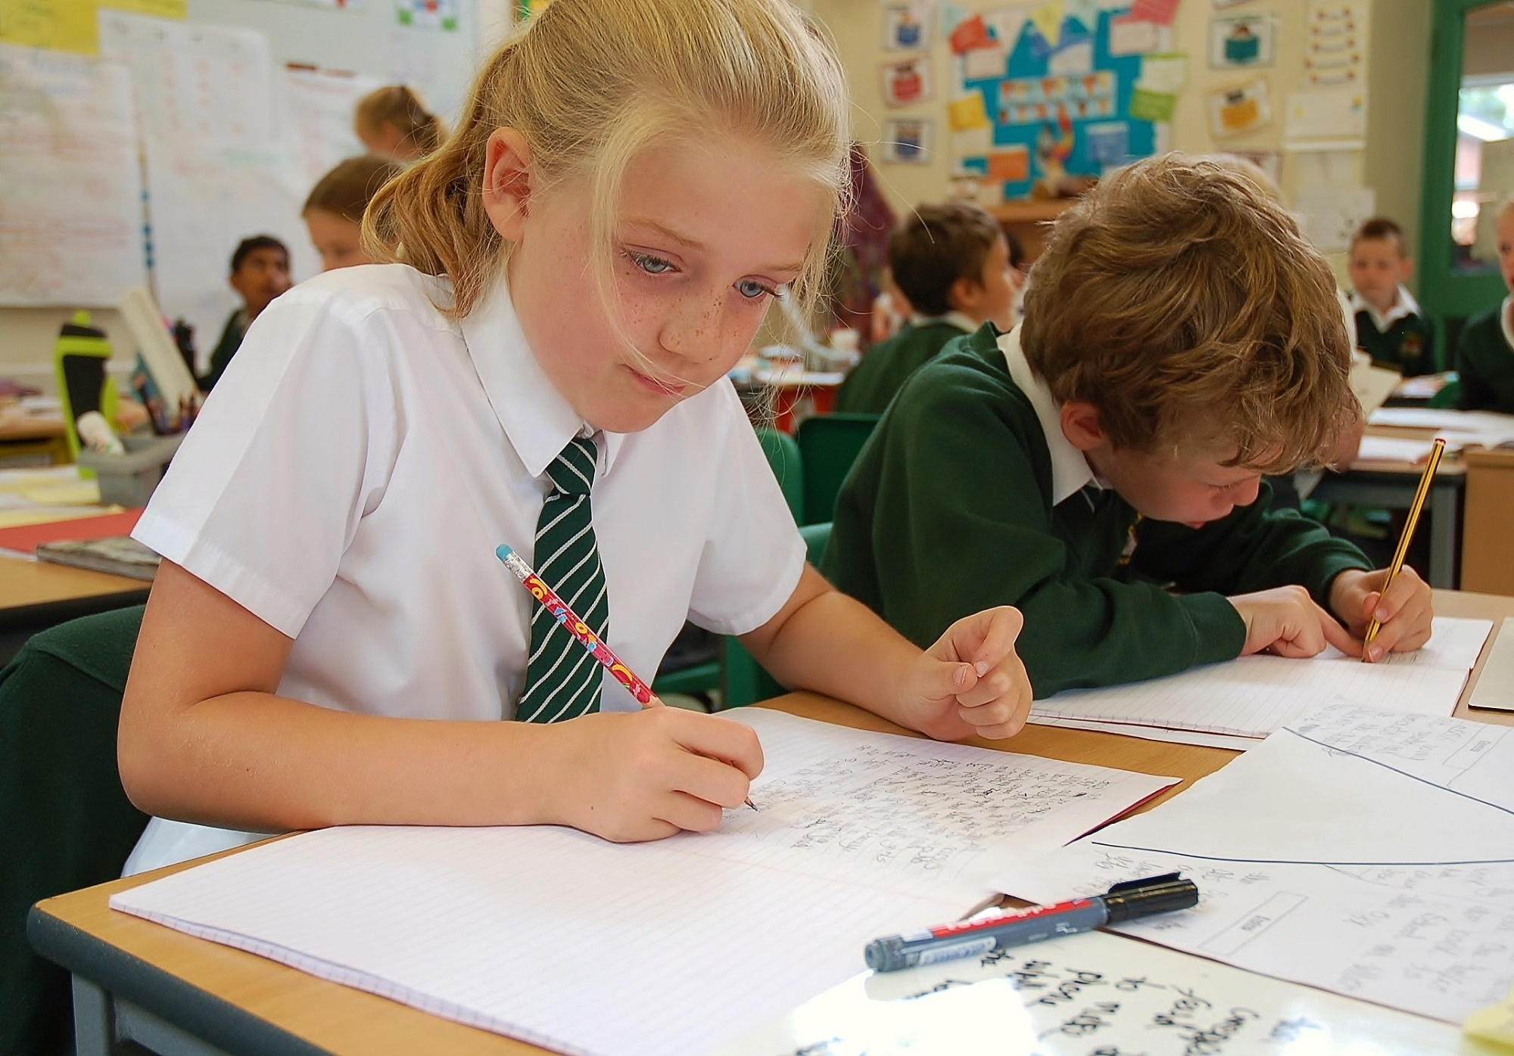
How to help your child develop resilience through a growth mindset when working with them at home.
Absorption
- Try and make any tasks you set your child as interesting and as fun as possible.
- Talk through their homework tasks with them before they start to get them interested. Tell me how this fits in with things you have been learning in school? Will this help you with something you are about to learn about? Tell me one thing you already know about this from work you have done at school?
Managing distractions
- Find a quiet place in the home to carry out their activity.
- Turn off the T.V!
- Try to avoid distraction from older or younger siblings or make it a family game or task for all to enjoy together.
- Think carefully about when you ask your child to compete some work – if their mind is on something exciting they are about to do, or somewhere fun they are about to go, they won’t fully engage in the task. Their mind will understandably be elsewhere!
- Encourage them to take regular breaks if they need it and to come back to the task later. Your child may not recognise themselves when to walk away and refresh! Give them praise for any time they have spent completing a task set by home or school.
Noticing
- Look for details when you are out and about. Ask questions about what you see? Encourage your child to accept they may not get an answer to these questions straight away!
- Ask your children questions around the tasks they are completing. How else could you have solved that problem? Have you found all the possible solutions? Could there be more than one answer? Can you notice any patterns in what you have discovered? Do you know where the word you have just read originated? Do you know what this really interesting word means?
- Encourage them to really think!
Perseverance (Stickability)
- Encourage your child to keep going even if the task is difficult, acknowledge their effort.
- Talk to your child about what specifically it is that are finding difficult and highlight the things they have understood and the things that the can do.
- Praise and talk about mistakes – never criticise. Nobody is perfect!
- When things are difficult ask what they already know that could help them.
- Explain that things can take a while to understand – learning can be a slow process – but it is OK to stop the homework if you think YOU are the one doing it!



