5 a day! | Date:
- What is 550 ÷ 11? | 2. What is 72 x 7 ?  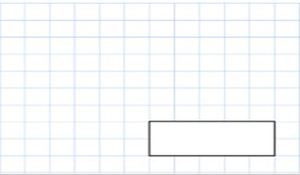
3.  What double 169? | 4. 7658 + 7854
 | 5. Write 5 numbers between 99 and 100
5 a day! | Date:
- What is 99 ÷ 100? | 2. What is 64 x 8?
3.  What is ¼ of 88? | 4. 853 + 3632
 | 5. What is a quadrilateral? (hint-square)

What is half of £118.50 | Write 3 fractions that are the same as 1/8.
Tick all the acute angles:
Red pencils come in packs of 4. Blue pens come in packs of 11.
If Jen buys 4 packs of red pencils and 7 packs of blue pens, how many pens and pencils does she have in total?
What is 608-59?

The year 4 teachers ate 3 packets of crisps between them ever day during October. How many packets of crisps did they eat? | There were 3 pieces of ribbon on the dress:  49mm  70mm  4cm  - How many cm of ribbon were there altogether?  - How many mm would be left over from 200mm of ribbon?
The carpark was a quarter full .  It’s capacity, when full was 300 spaces. How many spaces were empty? | Rose bought 89 kg of potatoes. How many grams is this?
Create a bar chart using this data:
17 people liked salt and vinegar crisps
29 people liked ready salted crisps
6 people liked cheese and onion crisps
38 people liked prawn cocktail crisps

5 a day! | Date:
- 497 x 10 | 2. 56 x 9
3.  123 is ______ more than 75  99 is ______ less than 345  835 is 86 more than _____ | 4.  Lottie is making a beaded neckless. She will need 753 beads. She has 456 beads. How many more will she need?
5. What is 9x3x6=

