What does VE Day celebrate?
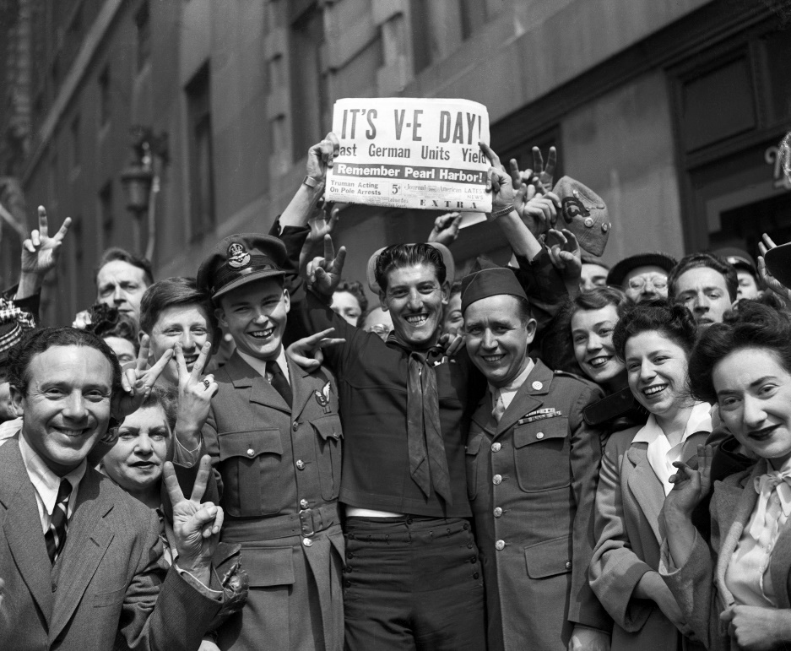
VE Day celebrates Victory in Europe Day – the day that Nazi’s in Germany officially surrendered, marking the end of the Second World War.
VE Day takes place on 8th May, commemorating the same day back in 1945 when the war finally ceased. On that day, people from across the globe flocked to the streets for parties and get-togethers, enjoying their freedom for the first time in six years.
This year marks the 75th anniversary of VE Day, so it’s set to be a very special moment indeed.

VE Day for children: VE Day 2020 school ideas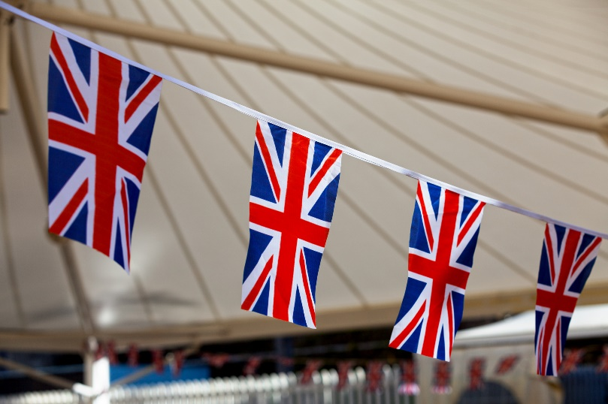

Before the long Bank Holiday weekend, it could be a good opportunity to switch up your home schooling and teach your children a little about VE Day – or, take part in some fun arts and crafts to mark the occasion. Here are some VE Day 2020 school ideas.
- The BBC has a short video on VE Day that you can watch here, explaining the events that led to the end of the war, for some context on VE Day. This does include information about the atomic bomb that dropped on Japan though so you may want to watch it first to make sure you are happy with the video.
- Hold a 1940's dance party. Dress up in your best clothes, put some big band music on and have a dance, or if you are feeling ambitious, try and learn a genuine dance from the time!
- Ask your adult to help you use google to research and write 3 facts about VE day.
- Write a letter or story pretending you are a child from 1945, how are you feeling? What are you doing to celebrate?
- Twinkl, a home learning hub, have also provided an online VE Day resource pack, with power points and word searchers for your kids, to help make home learning just that little bit easier.
- And when you’re done with the schoolwork and fancy some light relief, get a little crafty and create your own patriotic bunting to hang in the windows over the weekend.
- And if you’re having a VE Day self-isolating street party under lockdown, you might also like to enjoy some baking as a family – why not try these delicious cake recipes?

Facts about VE Day
Did you know…
- The then Princess Elizabeth (now Queen Elizabeth II), and her sister Princess Margaret slipped out and joined the crowds outside Buckingham Palace celebrating the end of the war on VE Day! Under the darkness, the Princesses were able to celebrate unnoticed. The Queen allegedly called it “one of the most memorable nights of my life”.
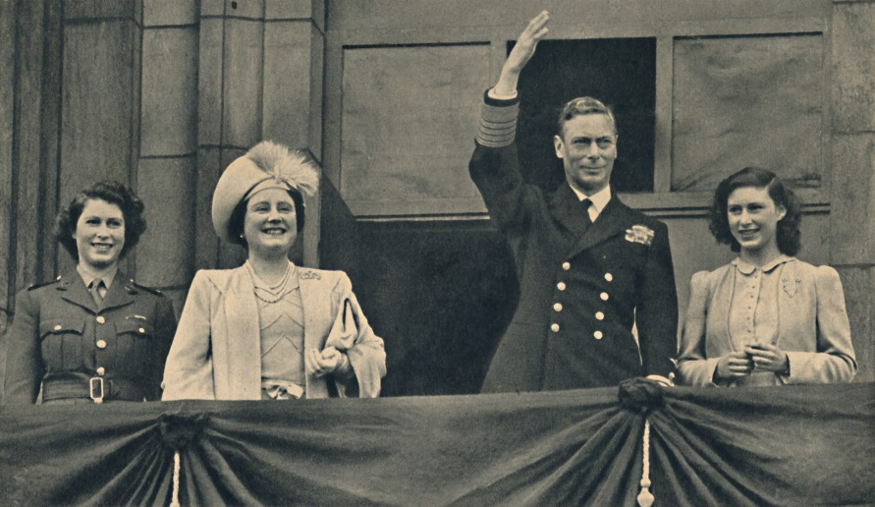
The entire royal family – as well as Prime Minister Winston Churchill – also came out to greet the public on the balcony of Buckingham Palace as celebrations continued.
- VE Day wasn’t actually the final day of fighting in the way – after 8th May, soldiers were still required to fly out and fight Japanese soldiers, who hadn’t surrended yet. They surrendered on 15th August of that year – which is now called VJ Day – Victory over Japan Day.
- At 3pm on VE Day, Winston Churchill addressed the nation in a radio broadcast.
- King George VI also gave a radio speech. He famously said, “Let us remember those who will not come back…let us remember the men in all the services, and the women in all the services, who have laid down their lives. We have come to the end of our tribulation and they are not with us at the moment of our rejoicing.” Listen to the speech at the end of this video here https://www.youtube.com/watch?time_continue=573&v=NEavcsrMoMw&feature=emb_title

