Miss Eckett’s Easter Challenge
Hello everyone! I hope you are taking care of yourselves and those around you. As Easter is fast approaching, I have an Easter Challenge for you…
If you’re like me and you’ve missed being creative at school, I have some Easter crafts for you to have a go at. Hopefully, you will have most of the resources in your home.
Please send any photos of your Easter crafts to the Year 3 teachers – we would love to see your creations!
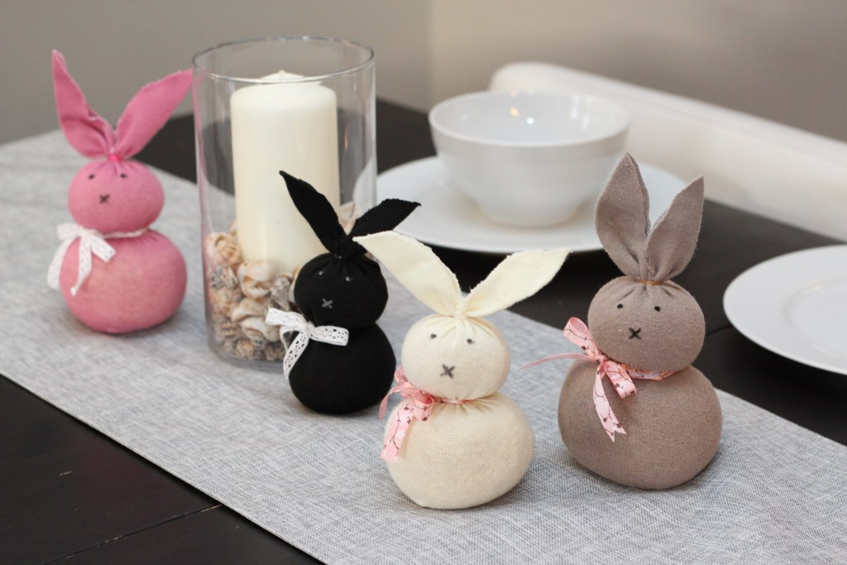
No Sew Easter Bunny

Materials you will need:
- Unmatched socks
- Uncooked rice (around 1 cup per bunny)
- Rubber bands
- Black Sharpie Marker (or any black marker)
- Pretty Ribbon (Optional)
- Scissors
Instructions for the No Sew Easter Bunny:
https://feelingnifty.com/easter-bunny-craft/ - Here is a link to the easy to follow instructions
- Take the sock and place it over a tall glass so it’s easier to pour the rice into.
- Pour the rice into the sock. I used a measuring Pyrex cup to make it easier to pour, but you can use anything.
- Take the rubber band and tie the top.
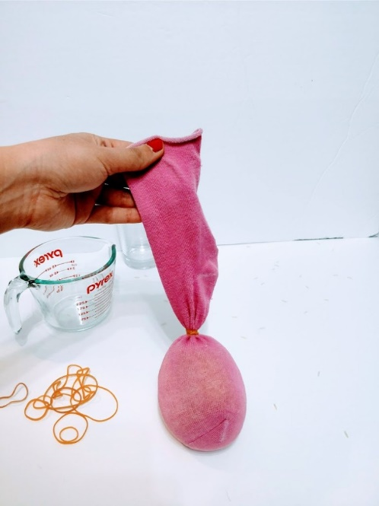
- To make the head and body shape, take another rubber band and tie it between the head and the body.
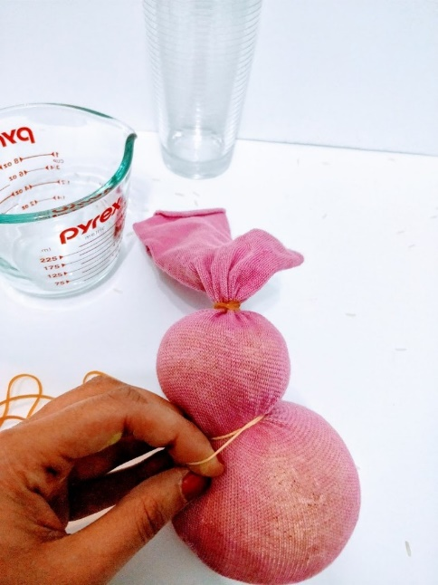
- Use another rubber band and make the bunny tail.
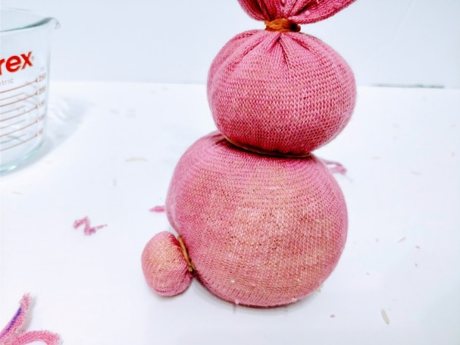
- To make the ears, cut any excess sock so that there is a couple of inches for the ears. If you want floppy ears that flop down, then leave them a bit longer. Once the excess is gone, cut the top portion down the middle. Using a marker, draw on a bunny ear shape. Take your scissors and cut along the marker line. Once done, your bunny ears should stand up straight (or flop down if you want floppy ears)
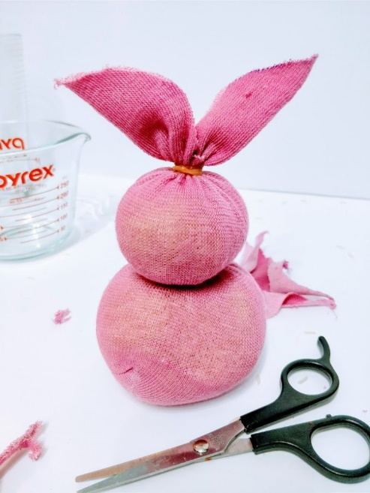
- Use the Sharpie to draw the bunny eyes and nose. To make the eyes, simply colour in two dots with the marker. Alternatively, you could sew or glue on some eyes.
- This part is optional but it really adds a nice decorative touch to your bunny craft. Cut a long enough piece of ribbon and tie a bow around the bunny’s neck. I used both fabric and plastic ribbon. You can also use bakers twine, instead of ribbon if you have some lying around.
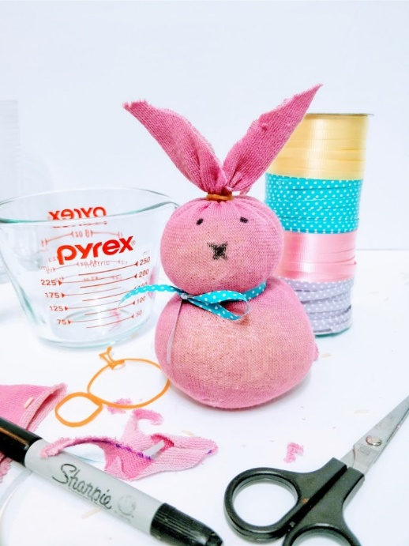

Easter Handprint Cards
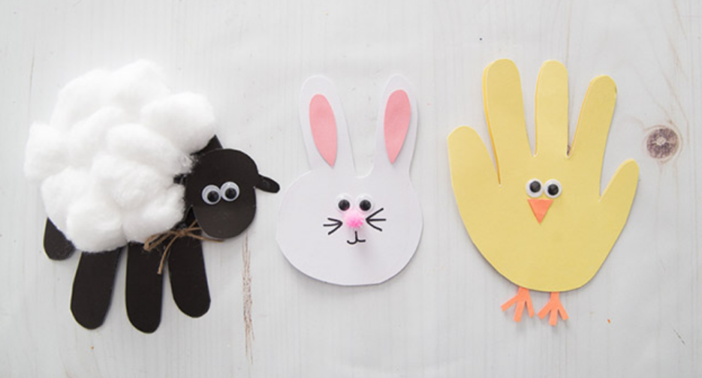

https://www.thebestideasforkids.com/easter-handprint-cards/ - Follow this link for step by step instructions on how to make these cards for your loved ones!
What you will need:
Easter Chick

– Yellow and Orange Card
– Small Googly Eyes

Easter Bunny
– White and Pink Card
– Small Pink Pom Pom
– Small Googly Eyes
– Black Sharpie
– Extra strong glue

Sheep
– Black Cardstock
– Cotton Balls
– Small Googly Eyes
– Twine

