Summer 2  Week 6 – 6.7.20 | Monday | Tuesday
 | English – A pirate’s life for me  Today, we would like you to kick start your pirate themed week by completing a reading comprehension about a pirate’s life. Remember to answer the questions in full sentences and underline where the answer is in the text to help you.  Maths -  We are looking at addition this week; today can you remind yourself of the formal method that we have used in school. Look at the example to remind yourself.  You can always make your own questions up.  Topic Work – Seascapes  Look at the well-known seascapes artwork in your packs.  What can you see?  What do you notice?  What do you like / dislike?  Now choose a piece of artwork and complete an observational drawing. Think about the lines, shades and textures used. | English – Using direct speech  Log in to Education City and complete the ‘Be a Good Sport’ activity all around using inverted commas and punctuating speech correctly.  After you have done this, complete the direct speech worksheet in the back.  Maths - Maze 100  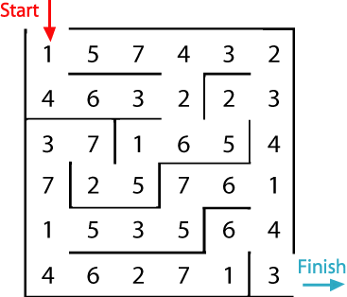  In this maze there are numbers in each of the cells. You go through adding all the numbers that you pass. You may not go through any cell more than once.  Can you find a way through in which the numbers add to exactly 100?  What is the lowest number you can make going through the maze?  What is the highest number you can make going through the maze? (Remember you may not go through any number more than once.)  Topic Work – RE  In the bible, Christian people are given 10 commandments to follow in order to help them live in harmony with one another.  Discuss: do you think rules are important? Why/why not? What could happen if there were no rules?  Now, talk about any rules that might be appropriate for pirates. These could be things like how to ensure they don’t go overboard or why it is important for them to maintain good communication when they are out at sea.  Have a go at writing some ‘Pirate Commandments’ using the sheet provided.
 | Wednesday | Thursday
 | English – Can I use inverted commas and punctuate speech correctly?  Today, use your knowledge of using inverted commas to correctly punctuate your own speech sentences.  Use the pirate picture to inspire your sentences. What could all the people in the picture be saying? What might the parrot say?  Maths – Super shapes  Use your addition knowledge to find out the value of each shape.  Topic Work – English/Art  Today, we would like you to have a go at writing a ‘message in a bottle’. In order to do this, have a think about what a pirate might like to write – they might need recusing, they might send a treasure map to someone or might they might write a letter to a friend or family member to update them on how they are doing.  Using the sheet provided, or some of your own resources, write up this message in a bottle.  Top Tip: If you wanted to make it look more realistic, you could colour your paper with tea stains and burn the edges to create a pirate effect. Make sure this is done with an adult!  Top Tip 2: You could also roll up your message and pop it in a real bottle to float on some water and see if it works! | English – Job Advert  This morning, have a go at writing a pirate job advert. There are a range of roles that you might like to apply for (more details on these can be found in the pack).  Which of the pirate roles do you think you would be best at?  Maths – Monster Maths  Addition speed challenge: How quickly can you answer all of the questions on the monster maths?  Try challenging someone else to race against your time.  Topic Work – Pirate PE  Play the Pirate PE game – instructions in pack.
 | Friday
 | English – Publish your job advert  Now that you have written your first draft for your pirate job advert. you might like to have a go at a neat copy to add more detail and decoration. You could create a pirate themed border or draw your own pirate!  Maths – Problem solving  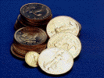  Ben has five coins in his pocket.  * How much money might he have?  ** Are there any other amounts?  *** How many amounts are there?  Play Live – Come and challenge a teacher on year 4 multiplication!  Time: 11:00am  Topic work – Pirate slime!  In school recently, we have had a go at making pirate slime and have really enjoyed it. So, we thought we would give you the chance to have a go at this too! Below are links to some simple slime recipes but please feel free to adapt them as you wish.  https://www.bbcgoodfood.com/howto/guide/how-make-slime  https://www.netmums.com/activities/how-to-make-slime-easy-recipes-no-glue  Top Tip: to make it more pirate-like, add some ‘golden treasure’ sequins or coins to your slime as well as anything else that you like the look of. Enjoy! | Extra Activities  Look at the PE section for a daily activity  Felt parrot sewing activity  http://littlebuttondiaries.com/2015/05/12/how-to-turn-your-toddler-into-a-pirate/  Pirate hats  http://krokotak.com/2013/09/leaflet-pirate-hats/  Sunset pirates  http://www.busybeekidscrafts.com/Sunset-Pirates.html

